Selfie boost for rebuild Crooked House campaign

08/08/2025 by Timothy Hampson

Campaign

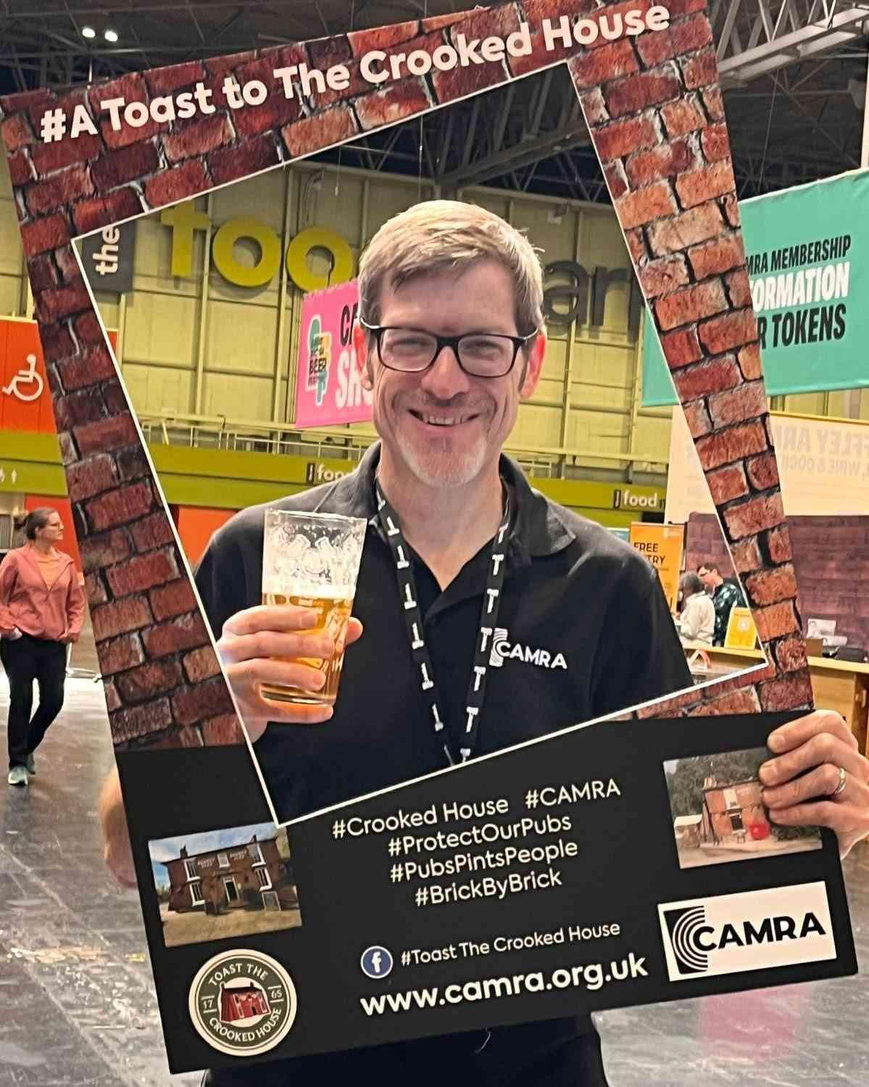

Two years ago, an iconic Black Country pub was ravaged by a fire and illegally demolished in the following days. Now a new initiative has been officially launched to keep the pressure on for it to rise from the ashes. Campaigners from across the country have joined forces to kick-start the Toast to The Crooked House social media campaign in honour of the second anniversary of the tragedy, calling for people to post a selfie of themselves raising a glass to the pub to raise awareness about the campaign. Organiser of #ToastToTheCrookedHouse campaign Ian Sandall said: “Two years on and the Crooked House rebuild has been bogged down in legalities, it’s really important to keep this loss front and centre, and not be allowed to be consigned to just to memory. “Let's break the internet raising a glass to the Crooked House, wherever you are, whoever you are with, post your selfie in support and #ToastToTheCrookedHouse.” CAMRA pub and club campaigns director Gary Timmins said: “Trying to ‘break the internet’ might seem like a bit of fun, but it’s to raise awareness of a really serious issue. I’m proud to be working alongside these dedicated campaigners, and I just hope that we won’t be marking another anniversary of the tragedy without a rebuild order in place. “The scandalous demolition of the Crooked House was a tragedy, and CAMRA wants the government to bring in new rules so that people who flout the law and destroy pubs face serious consequences.” Pictured: CAMRA chief executive Tom Stainer holding a selfie cut out for #ToastToTheCrookedHouse campaign