Women top bottled beer contest

08/08/2025 by Timothy Hampson

Campaign

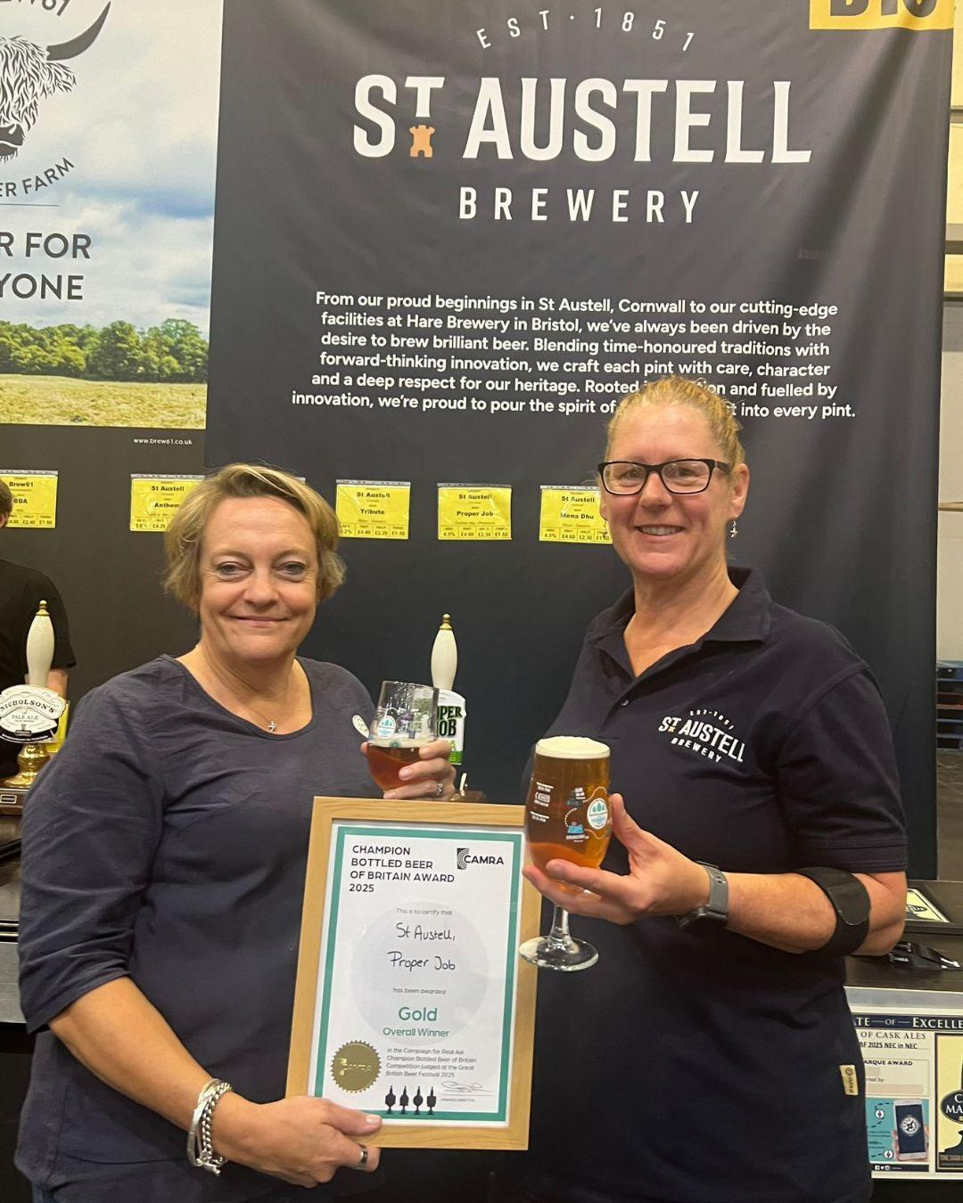

Two women-led brews have taken the top honours in CAMRA’s Champion Bottled Beer of Britain 2025 competition during the Great British Beer Festival at the NEC Birmingham. St Austell's Proper Job (5.5 per cent ABV), brewed under the guidance of brewing director Georgina Young, claimed Gold. Young said: “We are honoured and delighted to be recognised in this category with our amazing Proper Job IPA, which was first brewed in 2004, created using original new style hops made with Chinook and Cascade. It’s incredibly rewarding to see it still standing out two decades later.” Silver went to Monty’s Mischief, (5 per cent) designed by brewery co-founder Pam Honeyman in Powys. Imperial Brown Stout by Kernel brewery in London took Bronze. CAMRA’s people director Laura Emson said: “Winning awards for producing excellent beer is just one way to help shake the perception that the industry isn’t for women. “Pioneers like Georgina and Pam have followed in the footsteps of generations of women making beer and are inspiring a new generation. Hopefully their success will spark others’ interest and have more breweries benefit from the talent out there waiting to be tapped into.” Pictured, from left, St Austell’s Georgina Young and Su Stafford