Brewers’ cultured celebration

08/08/2025 by Timothy Hampson

Industry

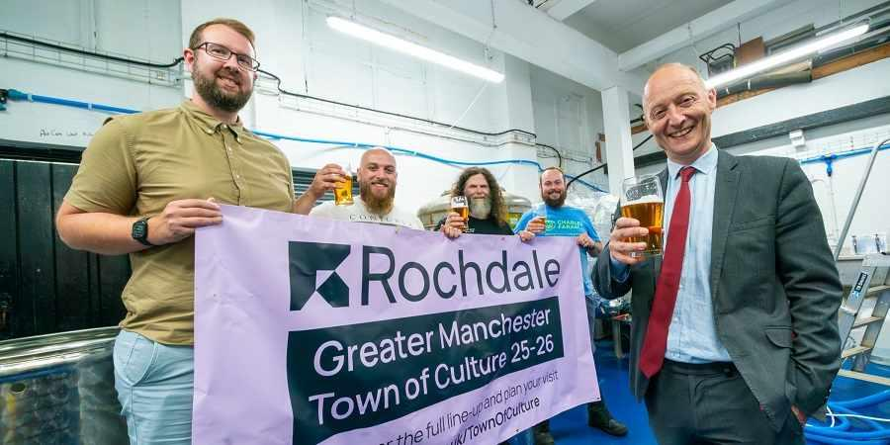

Brewers in Rochdale are teaming up to create a beer celebrating its year as Greater Manchester Town of Culture. The cask ale will be in pubs and bars across Rochdale from mid-August, with bottles also available in the coming months. It could be reaching drinkers in the capital too with MP Paul Waugh hoping to get it on tap in London at Strangers’ Bar at the House of Commons. Waugh said: “This new beer will help us raise a glass to our roots, our pride, creative spirit and creativity as our wonderful town takes centre stage during this special year and I’m looking forward to trying the finished product when it’s ready.” Details of the new beer including its name are still to be agreed, but it is likely to be a pale or golden ale, brewed with all-British hops. The brewers joining forces to make the beer are Wakey Wakey Brew Company, Twisted Mule brewery, Brid’s Cross Brewing, Serious Brewing Company and Flying Horse Hotel. The award by the Greater Manchester Combined Authority highlights the creativity and diversity of one of its towns, putting a spotlight on art, culture and heritage across the region. Rochdale’s year is building on the town’s cultural history and reputation as the home of the co-operative movement with more than 35 arts organisations bringing together an ambitious programme of festivals, exhibitions, events and performances. Rochdale Mayor Janes Emsley said: “It’s great to see the spirit of co-operation alive and well here, with local brewers working together to create a new beer in honour of our status as Greater Manchester Town of Culture.” Pictured from left: Jon Hudson, Flying Horse Hotel; Domenico Lannidiaardi, Twisted Mule; Shaun O’Reilly, Brid’s Cross Brewing; Anthony Jones, Wakey Wakey Brew Company and MP Paul Waugh