Place in our Herts pubs campaign launched

07/08/2025 by Timothy Hampson

Campaign

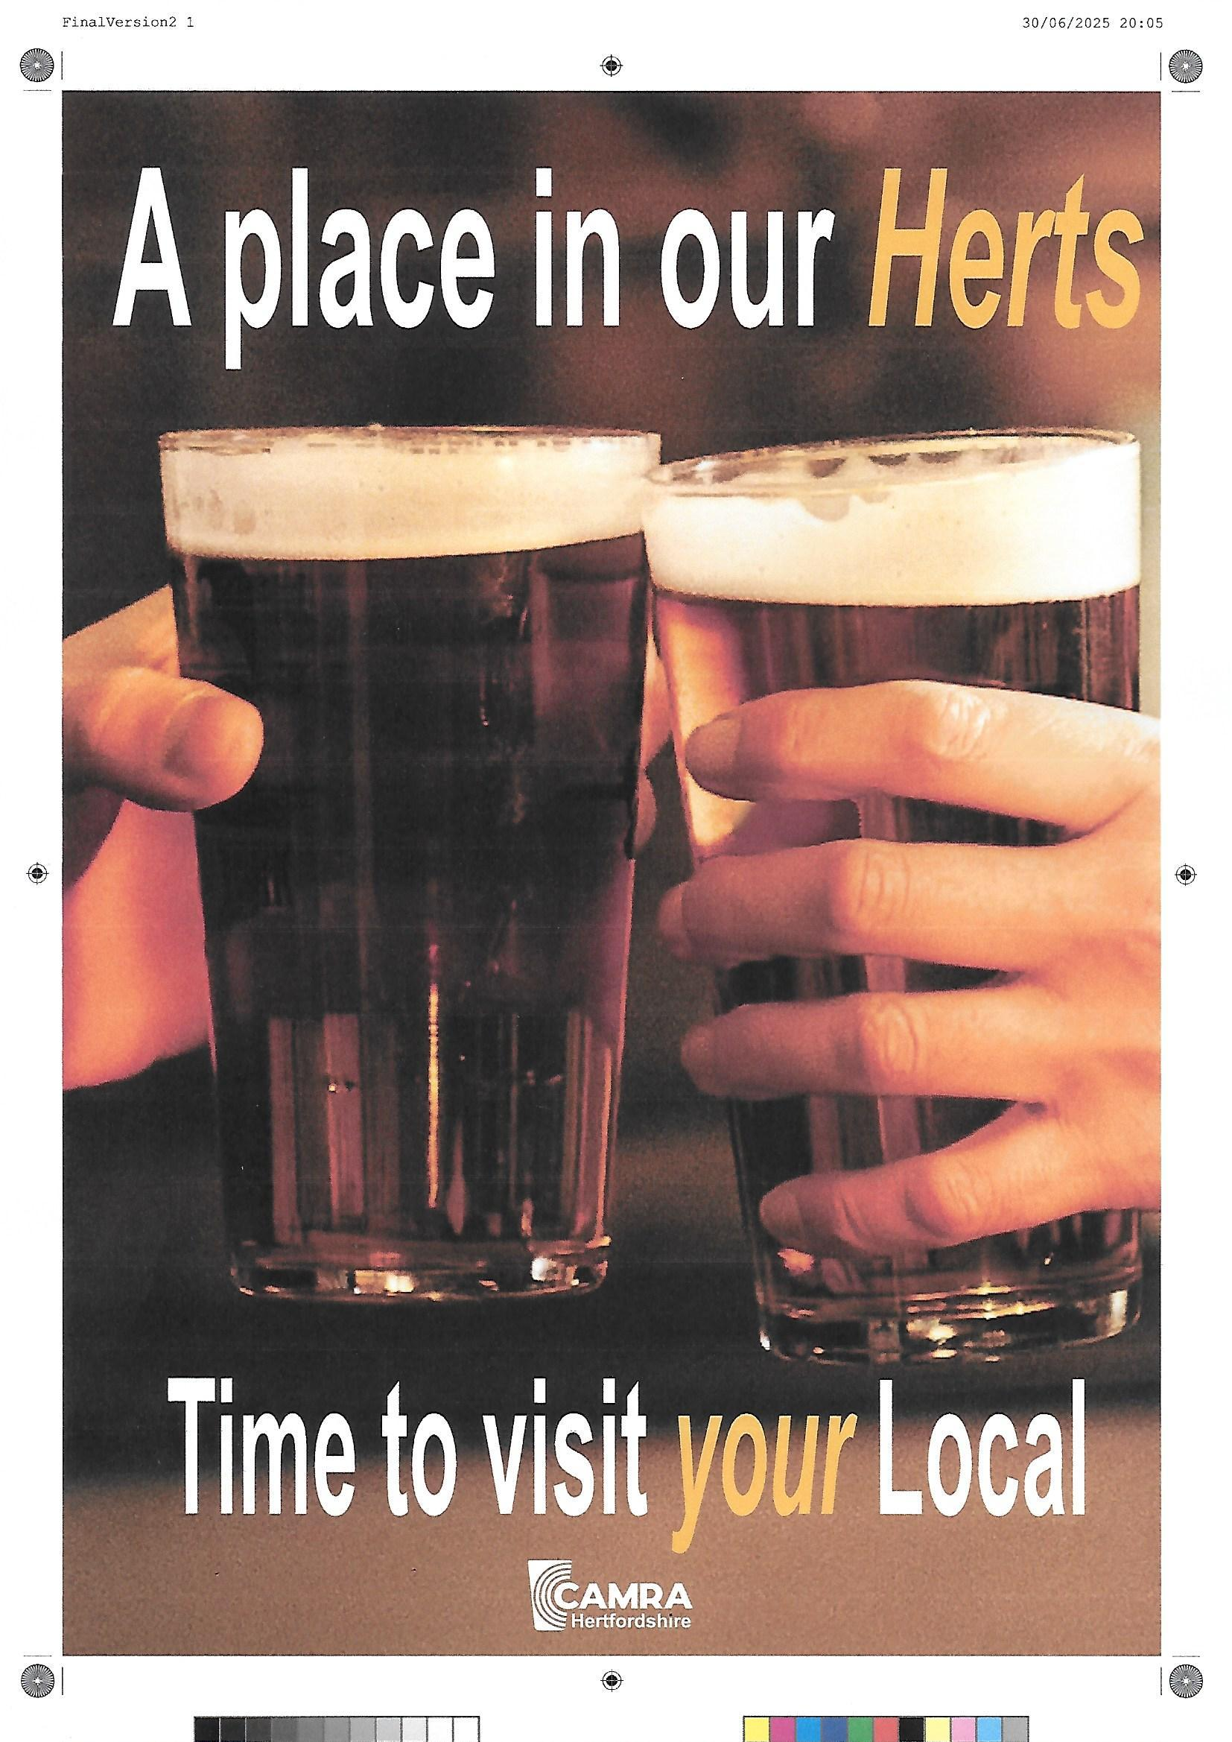

Hertfordshire CAMRA branches have launched a campaign urging people to regularly visit the county’s pubs. The initiative is being promoted through posts in pubs and the next edition of the county’s Pints of View magazine, at local tourist offices and at Hertfordshire CAMRA beer festivals. South Hertfordshire branch’s pub protection officer Les Middlewood said: “Well-publicised national economic pressures have negatively affected so many pubs nationwide, resulting in closures, sometimes permanent or for extended periods.  “As the financial noose tightens the queue of new publicans for tenancies is short. And high costs for landlords have often led to an inevitable increase in bar prices which seemingly has dissuaded many people from regularly crossing the pub threshold for a pint. It is a difficult squeeze for landlord and drinker alike. “Nevertheless, pubs are at the very heart of Hertfordshire’s tradition, remain great social centres for conversation and fun and are on our agendas for meeting friends in moments of celebration and commemoration. But if they are going to survive and prosper we need to convince more people to see it that way and to visit more regularly. “While CAMRA nationally continues to petition government for beer duty relief, changes to Business Rates and seeking VAT fairness, in Hertfordshire we feel it is also time for our locally led pub-supporting campaign, visual on the ground at pub level and for as many people as possible to see.”