And the Champion Beer of Britain 2025 is….

05/08/2025 by WB Reporter

Campaign

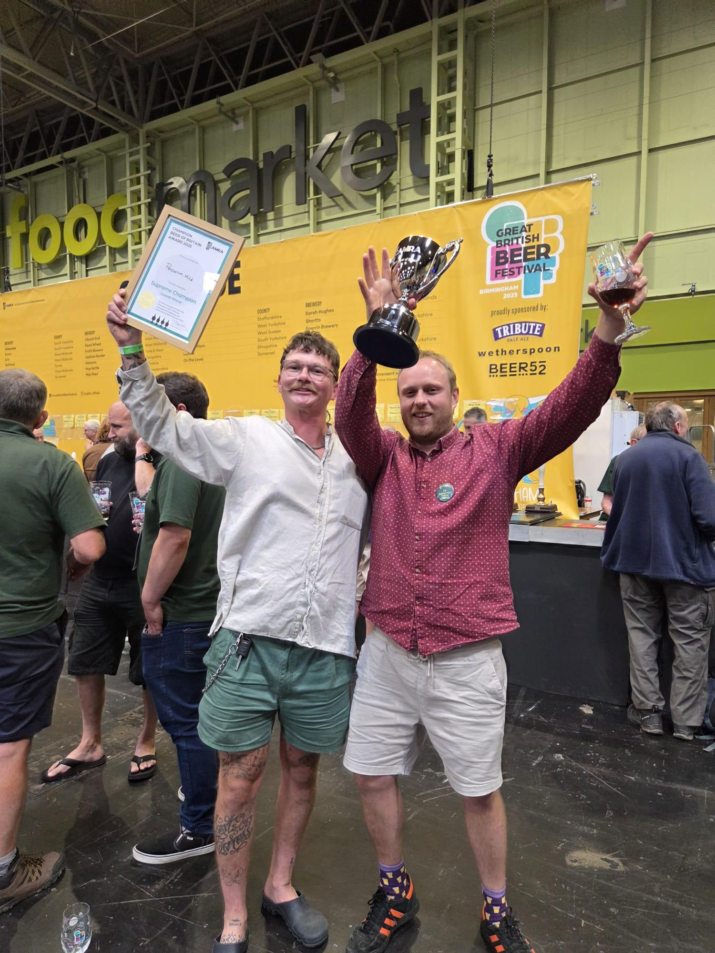

Mild by Penzance Brewing Co has been crowned CAMRA’s Champion Beer of Britain 2025 at the Great British Beer Festival in the NEC Birmingham, today.   A dozen finalists were whittled down to the Gold, Silver and Bronze winners by the expert judging panel.  The long-standing CAMRA award is one of the most coveted and well-respected cask beer competitions in the world, putting the winner firmly in both the UK-wide and international spotlight.  The competition is fiercely independent, with judging taking two years to complete. Each year kicks off with individual nominations from CAMRA members and volunteer tasting panels, then regional competitions. Every round of judging uses a strict blind tasting policy.  Richard Hickman and Lewis Elliott of Penzance (pictured, from left, above) said: “It’s quite overwhelming. I’m really glad the style has come back. It’s down to the founder of our brewery Peter Elvin and his nephew Rob, who showed me the ropes. I can’t believe we are here right now, its mad!”  Judging coordinator Christine Cryne described Mild as: “The aroma of this classic dark mild has all the enticing aromas one would expect. Chocolate and sweet cocoa on the nose. Chocolate, sultanas and dry roast on the palate where the gentle pleasant sweetness is balanced by a roasty, subtle, dry bitterness. Packs a lot of flavour for a 3.6 per cent beer!”  Silver went to Snowflake from Sarah Hughes which was described by judges as: “A gorgeous barley wine and a classic example of the style. The flavour is complex, with sweet, bitter marmalade on a smooth palate.”  Fallen Angel by Church End took Bronze and was described by judges as having: “A sweet honey toast, butterscotch aroma with a little spice. It’s a rich pale ale with bitter spicy hops that are balanced by notes of honey.”  CAMRA awards director Gary Timmins said: “I’m over the moon for Penzance, with Mild being a deserving Champion Beer of Britain. From CAMRA members nominating their favourites, through to those tough regional rounds, to the final panel of judges, this is a vigorous and fiercely independent competition, and Mild has come out on top.  “I hope everyone will join me on the Great British Beer Festival floor where you can try all our final 12 beers, each one is top quality, and each brewer deserves a congratulations in their own right.”   All the finalists in this year’s competition are on sale while stocks last at the festival, which runs until Saturday 9 August. Tickets start at £6 for CAMRA members and £9.50 for the public. To buy go to: greatbritishbeerfestival.co.uk/tickets   The winners of the Champion Bottled Beer of Britain were also announced with St Austell’s Proper Job claiming Gold.   Brewing director Georgina Young said: “We are very honoured and delighted to be recognised in this category with our amazing Proper Job IPA, which was first brewed in 2004, created using original new style hops made with Chinook and Cascade.”  Judges described it as: “The forerunner of many New World IPAs. A gorgeous looking gold coloured IPA with strong, fruity nose and a perfect balance of biscuit, citrus fruits and bitter hops, with an ABV of 5.5 per cent this is a beer to savour and enjoy.”  Silver was won by Monty’s Mischief and Bronze by Kernal’s Imperial Brown Stout.  WHO WON WHAT Overall  Gold: Penzance, Mild  Silver: Sarah Hughes, Snowflake  Bronze: Church End, Fallen Angel  Category winners  Mild  Penzance, Mild  Session Bitter  Butcombe, Butcombe Original  Premium Bitter  Cairngorm, Wildcat  IPAs  Elusive, Oregon Trail  Session Pale, Blond and Golden Ales  Track, Sonoma  Premium Pale, Blond and Golden Ales  Church End, Fallen Angel  Brown and Red Ales, Old Ales and Strong Milds  Tintagel, Caliburn  Session Stouts and Porters  Cairngorm, Black Gold  Strong Stouts and Porters  Grain, Slate  Specialty, Differently Flavoured  Siren, Broken Dream Breakfast Stout  Specialty, Differently Produced  Allendale, Adder Lager  Barely Wines and Strong Old Ales  Sarah Hughes, Snowflake