Top honour for St Austell brewer

05/08/2025 by Timothy Hampson

Industry

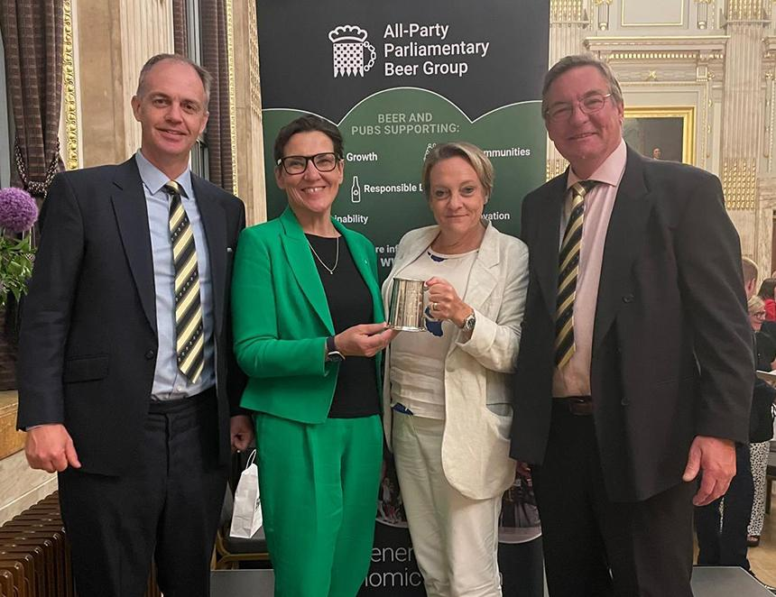

St Austell’s brewing director has been named Brewer of the Year by the All-Party Parliamentary Beer (APPBG). Georgina Young, who has led the production team at St Austell for the past five years, was recognised at the APPBG’s annual dinner. The award recognises not only brewing expertise but also the individual’s wider contribution to beer, brewing, people and the community. APPBG honorary secretary Rita King said: “Georgina was a standout candidate and a truly deserving winner of this year’s award. “Her dedication to brewing, her innovative spirit, and her passion for educating and welcoming others into the industry are highly respected across the beer community. “When we speak to people about influential brewers, Georgina’s name is often mentioned as an inspiring figure whom many admire.” Georgina joined St Austell in May 2019, leaving her role as head brewer at Fuller’s to return to the West Country, where she grew up. She was promoted to brewing director in 2020 and oversees production at both the St Austell site and Hare brewery in Bath. Last year, she launched St Austell’s first no-and-low beer, Proper Job 0.5 per cent, which has already scooped awards, as well as releasing a canned version of her pale ale made with 100 per cent British ingredients, Anthem. Georgina said: “I’m incredibly proud to have been given this award, which I was truly not expecting. It is a real privilege to be a brewer at St Austell brewery and to be able to collaborate with such talented individuals across the industry. “Together, we are committed to celebrating great British beer, inspiring the next generation of brewers, and advancing sustainable practices in an ever-evolving world." Pictured, from left, St Austell Brewery’s external relations director Piers Thompson , chair of the All Party Parliamentary Beer Group Tonia Antoniazzi MP, Georgina Young and St Austell Brewery’s commercial director Paul Harbottle