Judge gets Scottish cider verdict

04/08/2025 by Timothy Hampson

Campaign

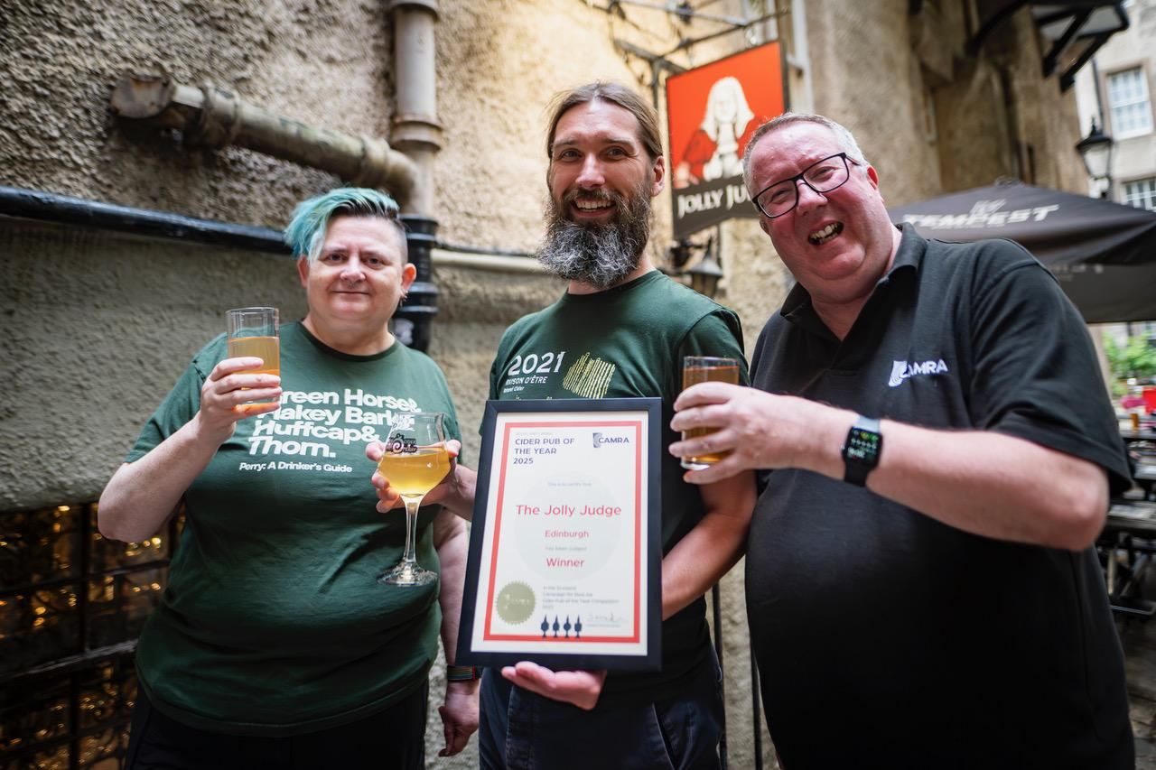

Famed Edinburgh local, the Jolly Judge was presented with CAMRA’s Scottish Cider Pub of the Year Award as the Campaign’s Cider and Perry Month kicked off alongside the first day of the pub’s cider festival. Director of CAMRA Scotland Stuart McMahon said: “There was a good turnout and the evening was enjoyed by all. “The Jolly Judge will now be judged against the other regional winners with the overall winner being announced in the autumn.” Pictured from left: CAMRA’s Scottish regional cider coordinator Karen Hetherington, Adam Neil from the Jolly Judge and Stuart McMahon