Prepare for your next festival trip

01/08/2025 by George Robbins

Campaign

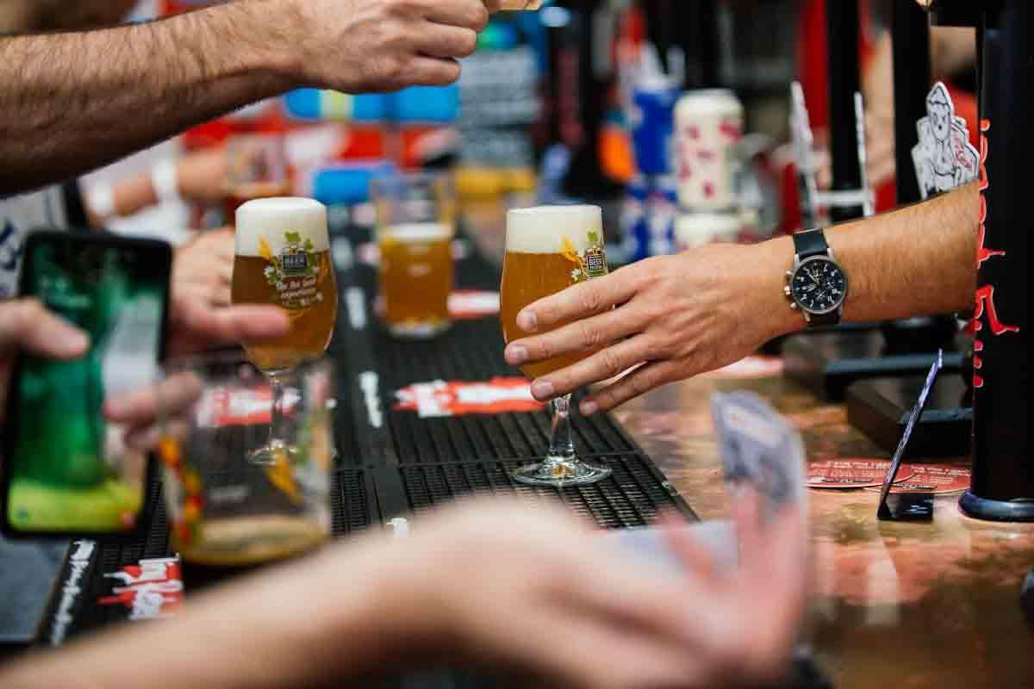

Make the most of the end of summer and then go into autumn with a festival trip or two. Just pick from the list below. To see all upcoming CAMRA events, visit the events webpage.    Great British Beer Festival, 5-9 August  NEC Birmingham, Pendigo Way, Marston Green, Birmingham, West Midlands, B40 1NT  greatbritishbeerfestival.co.uk/    Worcester Beer, Cider and Perry Festival, 14-16 August The Grandstand, Worcester Racecourse, Worcester, WR1 3EJ festival.worcester.camra.org.uk/   Peterborough CAMRA Beer Festival, 19-23 August  Embankment Road, Peterborough, Cambridgeshire, PE1 1EF  pborobeerfest.camra.org.uk    Clacton-on-Sea Real Ale and Cider Festival, 20-23 August  St James Hall, Tower Road, Clacton-on-Sea, CO15 1LE  tendringcamra.org.uk/clactonfest.html    33rd East Anglian Beer and Cider Festival, 20-25 August  St Edmundsbury Cathedral, Angel Hill, Bury St Edmunds, Suffolk, IP33 1LS  burystedmundsbeerfestival.com/    Swansea Bay Beer and Cider Festival, 21-23 August Brangwyn Hall, Swansea, SA1 4PE swanseacamra.org.uk   43rd Durham Beer Festival, 27-30 August Durham City Rugby Football Club, Hollow Drift, Green Lane, Racecourse, Durham, DH1 3JU durhambeerfestival.org.uk   Barnsley Beer Festival, 28-30 August St Peter Church, Brinkman Street, Barnsley, S70 1JQ alexandrawalton.wixsite.com/mysite   Harbury Beer and Cider Festival, 29-30 August Harbury Village Hall, South Parade, near Leamington Spa, CV33 9JE how.camra.org.uk/   CAMRA Bar at Faversham Hop Festival, 30-31 August  East Street, Faversham, Kent, ME13 8AF  kent.camra.org.uk/viewnode.php?id=258408   31st Tamworth Beer Festival, 4-6 September Assembly Rooms, Corporation Street, Tamworth, B79 7DN lst.camra.org.uk/beerfestival.htm   Basingstoke Beer Festival, 5-7 September Basingstoke Sports and Social Club, Fairfields Road, Basingstoke, RG21 3DR hantsnorth.camra.org.uk/viewnode.php?id=201850   East Malling Beer and Cider Festival, 6 September East Malling Research Centre, New Road, ME19 6BJ mmk.camra.org.uk/festival   18th Moreton Beer and Cider Festival, 12-13 September Moreton in Marsh Cricket Club, Moreton in Marsh, Gloucestershire, GL56 9QA northcotswoldcamra.org.uk/Festival18.htm   York Beer and Cider Festival, 17-20 September St Lawrence Parish Church, Lawrence Street, York, YO10 3WP yorkbeerfestival.uk   Booze on the Ouse Beer and Cider Festival, 18-20 September Comrades Club, Godmanchester, 58 Cambridge Street, Godmanchester, PE29 2AY hunts.camra.org.uk/festival   St Albans Beer and Cider Festival, 24-27 September St Peter's Street, St Albans, AL1 3LD stalbansbf.org.uk   Ayrshire Real Ale Festival, 2-4 October Municipal Buildings, South Beach, Troon, KA10 6EF ayrshirebeerfestival.co.uk   13th South Woodham Ferrers Beer and Cider Festival, 2-4 October South Woodham Ferrers Village Hall Social Club, 25 Hullbridge Road, CM3 5PL maldonanddengiecamra.org.uk/swfbeerfestival   Carmarthenshire Real Ale and Cider Festival, 2-4 October St Peter’s Civic Hall, 1 Nott Square, Carmarthen, SA31 1PG carmarthenshire.camra.org.uk/index.php/carmarthenshire-beer-festival   Steel City Beer and Cider Festival, 15-18 October Kelham Island Museum, Alma Street, Sheffield, S3 8RY sheffield.camra.org.uk/festival   Carlisle Beer and Cider Festival, 23-25 October Station Hotel, Court Square, Carlisle, CA1 1QY solway.camra.org.uk/   15th Gainsborough Beer Festival, 23-25 October Blues Club, Northolme, North Street, Gainsborough, DN21 2HU fenland.camra.org.uk/viewnode.php?id=5964   27th Worthing Beer and Cider Festival, 24-25 October Rooms, 44 Guildborne Centre, Worthing, BN1 1LZ aaa.camra.org.uk/wbf   Redhill Beer Festival, 30 October-1 November Merstham Village Hall, Station Road North, Merstham, RH1 3ED ems.camra.org.uk/festival