Cider and perry highlights at flagship festival

31/07/2025 by Tori Wood

Campaign

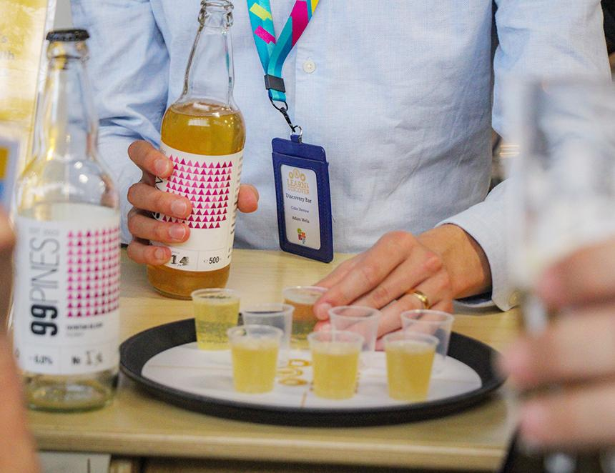

The Great British Beer Festival kicks off next week at its new NEC Birmingham home and on the final day of CAMRA’s Cider and Perry Month we’re highlighting what lovers of the drinks can expect at the event.  A list featuring the ciders and perries available at the NEC is now online and has search filters to help festivalgoers find their preferred style.   Visitors can sample and learn about the ingredients behind some top ciders at the Discovery Zone in partnership with Brewser.   Meet Dorset’s Temple Cider team on Tuesday 5 August for a showcase of six unfiltered, unpasteurised, naturally sparkling ciders, aiming to make full-juice, live ciders more accessible for pubgoers.  Newt Cyder‘s cold-fermented, 100 per cent juice ciders, made in a state-of-the-art cidery, will join the Discovery Zone on Wednesday 6 August.  Expect Blackmoor Orchards and Gospel Green Cider on Thursday 7 August with ciders made from 100 per cent handpicked apples.   Cidentro will discuss orchard planting from scratch and offer a six-cider tasting including its Rosé, plus wild-fermented and low-alcohol alternatives on Friday 8 August.  On Saturday 9 August, Hogan’s Cider will showcase its range of ciders and perries, experimenting with innovative processes including using different yeasts and even hops. Tasting sessions will take place every day, including Exploring Modern Artisan Cider with Alison Taffs on Wednesday.   CAMRA members can get tickets from only £6, so grab yours here: greatbritishbeerfestival.co.uk/tickets  Photo: Helen Anne Smith