Census backs best beer city claim

31/07/2025 by Dave Pickersgill

Campaign

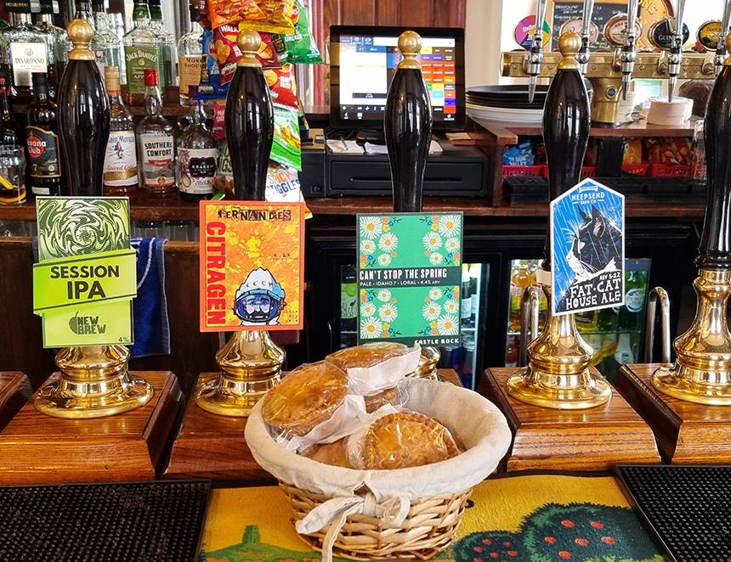

Sheffield CAMRA’s latest beer census provided further support for claims it is the best beer city in the world. The branch carried out its latest census on 31 May aiming to gather up-to-date information on the amount, range and cost of cask beer across the city. Starting points for the eight daytime pub routes were from Bradfield to Bradway and from Walkley to Woodhouse followed by an evening focus on the city centre. In addition, members logged visits elsewhere using an online tool. The 158 pubs visited was similar to previous years – 2019, for example, saw 154. The final total of 375 cask beers from 159 breweries was not quite as high as the pre-Covid 2019 record (407 from 189). By comparison, 2017 saw 360 from 148 breweries, and 2023 saw 309 cask beers from 129. Pete Brown’s 2024 Beer Report found, on a daily basis, Sheffield had more than 400 beers available. This figure included indie keg. Hence, the branch’s 2025 count suggests the number of beers available now is more than 500, many more if the myriad range of bottled and canned beers are included. Evidence that Sheffield continues to be the best beer city in the world. Interestingly, in 2017, the cheapest pint was £1.79, and this year saw the same beer at the same price - Ruddles Best Bitter at the Rawson Spring. During the census members also noticed some lack of pricing and other information at point of sale. It was also surprising how many bar staff had to use tills to provide the price of a pint. In addition, few pubs clearly display their opening hours. It was also felt that the standard of toilet cleanliness could be improved.  Graphic provided by Sheffield and District CAMRA

