Grab your Octoberfest ticket now

30/07/2025 by Timothy Hampson

Campaign

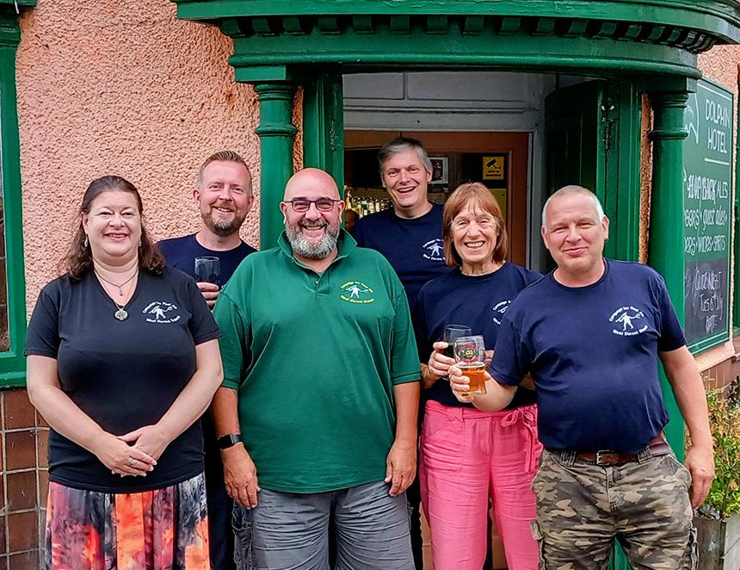

Tickets for Weymouth’s Octoberfest in the town’s Pavilion Ocean Room on 3-4 October go on sale this Friday.  The four-session event is organised by CAMRA’s West Dorset branch and is now in its 19th year. At the ticket launch event at the Doghouse in Weymouth tomorrow people joining CAMRA will get free entry including a pint, glass and programme to a session of their choice at Octoberfest. West Dorset chairman Bruce Mead will be at the Doghouse between 6-8pm prior to the annual branch pub walk welcoming new potential members. The branch will also be running a prize draw as part of the build up to its 50th anniversary celebrations in 2026. The first 100 people to place an order for Octoberfest 2025 via the branch’s website will be entered into a prize draw, with a ticket to a session of their choice at both Dorchester Beerex and Weymouth Octoberfest 2026 up for grabs. Visitors producing an NUS card will be able to claim two extra beer tokens from the CAMRA stand at the festival and on the Saturday evening session anyone with a Blue Light Card can also claim a pair of vouchers. As always there is a theme to the beer selection and this year it’s East Anglia. Attendees can expect to sample more than 55 cask ales from breweries in Cambridgeshire, Norfolk and Suffolk along with a selection of ciders from the east of the country. Mead, who grew up in Norwich, said: “When I grew up in East Anglia in the 1970s, Watneys had turned much of it into a beer desert. “The beer scene in that part of the country is unrecognisable from those days, and I’m really excited that we’re able to showcase some of the best real ales and ciders that the area has to offer.” This year Copper Street brewery of Dorchester in conjunction with the Dead Brewers Society will be resurrecting six beers from long-shut breweries in East Anglia. Festival bar manager Rich Gabe said “I am looking forward to selecting beers from East Anglia, some I have sampled many times before and others which will be a new taste experience, in particular the recipes revived from closed breweries long before my time, it’s always good to offer customers something different.” For details and updates visit camrawdorset.org.uk or follow on West Dorset CAMRA Facebook. Pictured, from left, Octoberfest committee Kylie Stroud, James Bennett, Bruce Mead, Alex Bardswell and Rich Gabe