Pre-order your 2026 Good Beer Guide now

29/07/2025 by WB Reporter

Campaign

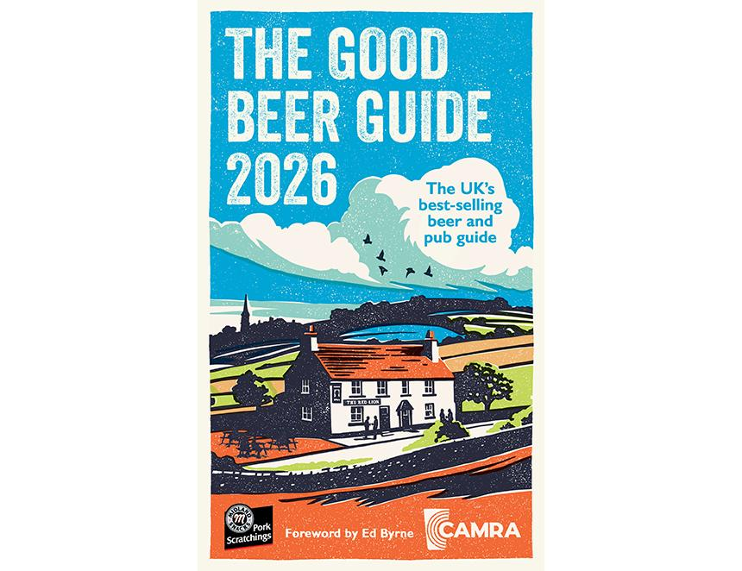

Now is the time to pre-order your 2026 Good Beer Guide to ensure you stay up to date with the UK’s best pubs and breweries.  It is the complete book for beer lovers and anyone wanting to experience the UK’s finest pubs as the Good Beer Guide is independent, with listings based on evaluation by CAMRA members. You can pre-order your copy of the new Guide from shop1.camra.org.uk/product/good-beer-guide-2026 before 24 September. The foreword has been penned by comedian and beer lover Ed Byrne. Known for his #preshowpints on social media, he posts about the beers he samples in various bars and breweries around the UK prior to his shows. The guide is sponsored by Midlands Snacks Pork Scratchings, which has stayed true to the original recipe and method of cooking which has earned them a Great Taste Award.