New look for Whitstable Bay

28/07/2025 by Timothy Hampson

Industry

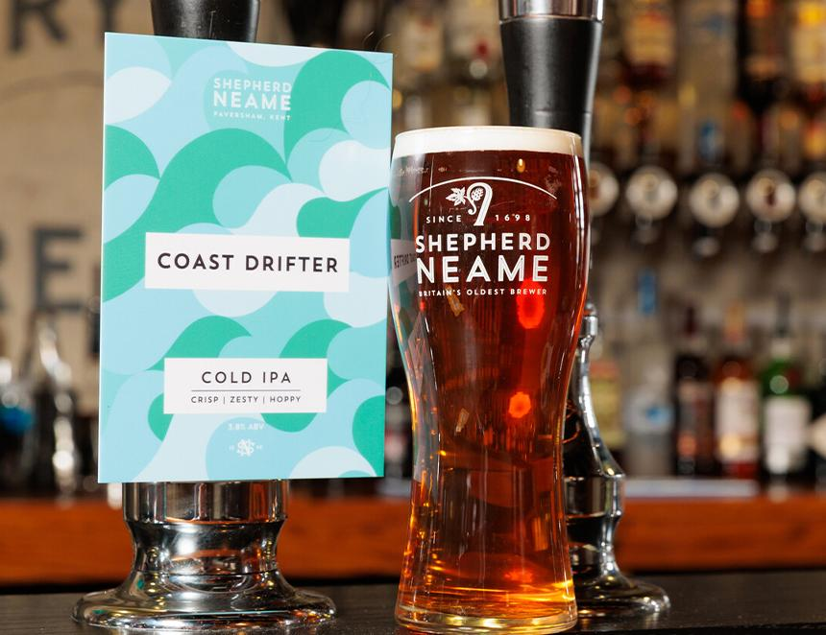

Shepherd Neame has unveiled a new look for its Whitstable Bay beers. Named after the Kentish coastal town near Shepherd Neame’s historic brewery in Faversham, the range was launched more than a decade ago. The new-look range consists of Whitstable Bay Pale Ale, available on draught and keg, in 440ml can and 500ml bottle, and Whitstable Bay Lager, available on keg and in 330ml bottle. The cask variant, Coast Drifter, at 4 per cent ABV, is brewed with Challenger and Styrian Goldings hops while Whitstable Bay Pale Ale is balanced with fresh pine notes and a touch of sweet malt for a crisp, thirst-quenching beer. Shepherd Neame’s Kathryn Tye said: “We are confident that this contemporary design development really brings the brand story to life, and will encourage current drinkers to rediscover Whitstable Bay while inviting new drinkers to set sail with our award-winning collection.”