Time for the Crooked House to stand tall again

27/07/2025 by Timothy Hampson

Pub

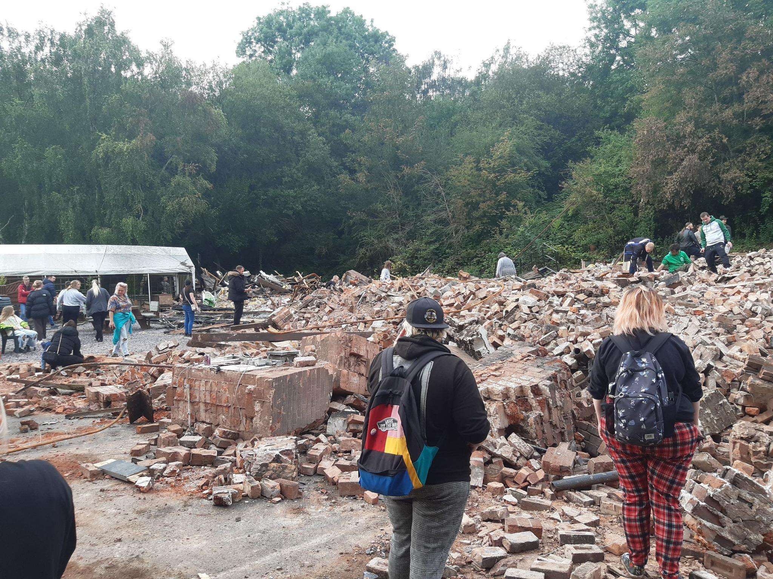

Campaigners who want to rebuild the Crooked House, razed in 2023, have written an open letter to the authorities approaching the two-year anniversary of its destruction as they battle to keep the plight of the famous wonky pub in the spotlight. There is growing frustration among members of Save the Crooked House (Let’s Get it Re-Built) group at what it sees as a lack of action in the investigation by the police and Crown Prosecution Service (CPS) into the events on Saturday 5 August 2023 when the Himley pub was destroyed by fire and then bulldozed just two days later. Six people were arrested on suspicion of arson with intent to endanger life and conspiracy to commit arson with intent to endanger life. They were bailed while the police investigation continued and were then freed from that bail. South Staffordshire Council issued an enforcement notice ordering those responsible for the demolition of the pub to rebuild it and a public inquiry was planned in February this year but postponed following a High Court appeal. Now Paul Turner, who started the Save the Crooked House campaign in the wake of its demise, has penned an open letter to the Express & Star this week calling for answers and action. In the letter he said: “The case appears to remain open but attempts to find out what progress, if any, has been made towards a decision, have been unsuccessful. “We are a campaign group with over 37,000 supporters who are angry and upset that our heritage was attacked in this way and wish for the process to be expedited. “This cannot happen while either the CPS or Staffordshire Police are allowing such a long unexplained delay in the process. We would like some information about the timescales involved and if, indeed, anything is happening at all.” MP Mike Wood has pledged his support for the group as part of his pub bill campaign. Wood said: “Nearly two years after the devastating fire at the Crooked House, and we need those responsible to be held accountable for this attack on our local heritage. “But we also need to make sure that other historic pubs are protected so that other communities don’t lose their iconic boozers. “I’m disappointed that instead of working with me to change the law, government whips chose to kill off my Heritage Public Houses Bill. It shows how little the government understands or cares about our local heritage.” A spokesperson for the Crown Prosecution Service said no charges had been brought and the matter was still under investigation by the police.