Tuns of trouble
26/07/2025 by Laura Hadland
Industry

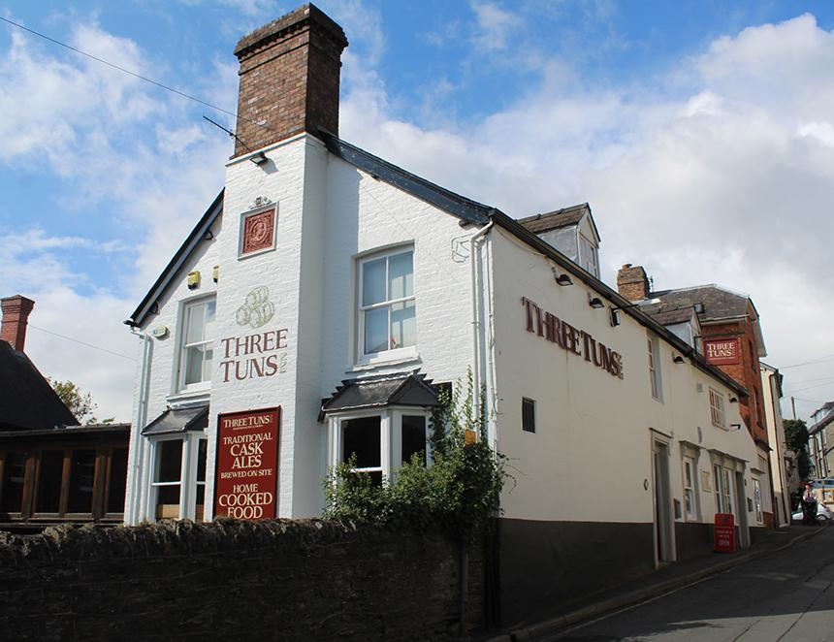

The Three Tuns Inn at Bishop’s Castle in Shropshire closed its doors unexpectedly this month. Unspecified issues at the venue have led to the search for a new licensee. The Grade II-listed building started life as a dwelling in the late 16th century before becoming part of the brewery of John Roberts & Son in 1642. The brewery adopted the name the Three Tuns in the late 1700s and has stuck with it ever since. The business came into the hands of a group of investors in the 1990s which enjoyed the pub but had little interest in the brewery. After looking to convert it into holiday homes, a groundswell of protest saw it instead purchased by newcomers to Shropshire – Bill Bainbridge, Samantha Edwards and John Russell. The business remains under the custodianship of the Russell family and has been visibly thriving in recent years. The pub, meanwhile, came under the control of Heineken’s Star Pubs by way of Scottish & Newcastle. Despite its past good reputation, concerns have been raised in recent years about the upkeep of the building as well as a regular absence of beer and poor service. A public meeting of the Bishop’s Castle Town Council in March discussed “the neglect, by Heineken, owners of the iconic and historic Three Tuns Inn” sparked by complaints from local residents. As a result, a property surveyor from Star Pubs assessed the building. “The property is sound,” the council meeting minutes state. “But the Salop Street exterior needs attention and the living accommodation needs better fire escapes.” Councillors appeared satisfied that Star Pubs was “keen to invest in the property and maintain it as a tourist attraction”. Indeed, speaking to the BBC this week, town councillor Tim Halford described the pub as the “biggest tourism attraction in this town” so it seems surprising that the pub has been allowed to fall into disrepair at all. A spokesperson for Star Pubs gave the following statement about the pub’s closure: “Due to unforeseen circumstances the previous temporary operator has had to close the Three Tuns. We want to reopen the pub as soon as possible and are looking to recruit a new licensee. We’re also very keen to undertake a major transformational internal and external refurbishment of the Three Tuns once a suitable candidate has been identified to take the pub forward.” The Three Tuns Inn garnered unwelcome publicity in July 2023 because there were no Three Tuns cask beers available on the bar. Apparently in response to public pressure, much of it from the Shrewsbury and West Shropshire branch of CAMRA, Star Pubs relented and allowed its licensee to offer one Three Tuns beer, out of five handpulls, on the bar. When asked whether a new incumbent would be permitted to stock a range of the beer made in the adjoining brewery in the future, the Star Pubs representative said only that “licensees have access to national and local cask ales through the Society of Independent Brewer and Associates Beer Flex scheme”. Star Pubs is promoting an Investment Tenancy opportunity at the pub. The particulars state “the full Heineken range complemented by a Three Tuns brewery ale” can be offered.

