Oasis gets beer flowing in Manchester

25/07/2025 by Timothy Hampson

Industry

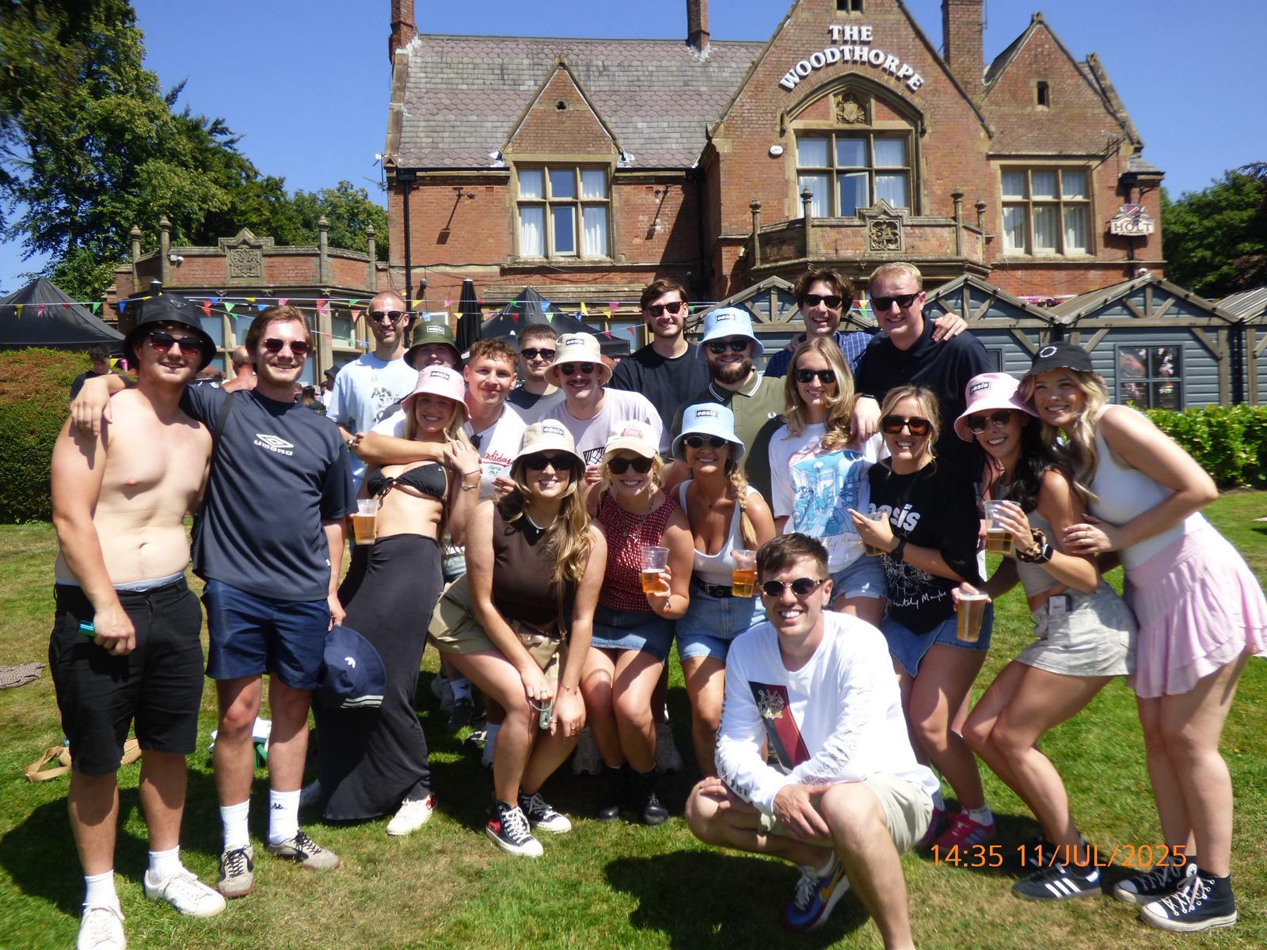

Joseph Holt marked the Oasis reunion concerts in Manchester by brewing more beer and staging events at its pubs close to the venue. Three of the brewery’s pubs near the Manchester venue Heaton Park - the Ostrich, Woodthorpe, and Welcome Inn - hosted events during the gigs, giving fans a place to gather and enjoy the music, whether or not they had tickets. The ring of three pubs in Prestwich and Whitefield all embraced Oasis mania and pulled more than 100,000 pints during the band’s residency. The trio of pubs – all just a stone’s throw from Heaton Park – became the epicentre of unofficial Oasis-themed parties, drawing fans from across the globe. “We had visitors flooding in from Spain, Italy, America – everywhere,” said Gaynor, manager of the Woodthorpe. “They just loved the vibe – from the music and barbecues to the electric atmosphere before the gigs kicked off. “And they are now keeping up with us on social media too because they loved the pub so much. Not only for the Oasis parties but because of its history, its grounds and the authentic Manchester atmosphere.” Each pub hosted all-day events on concert days, offering fans a chance to soak up the mood even if they hadn’t scored tickets. Free bucket hats – a nod to Liam’s signature look – were handed out, while Manchester anthems blasted long into the night, all within earshot of the main stage. Even Radio 2’s Vernon Kay made a pre-show appearance, arriving at the Woodthorpe at 7.30am on the day of the first gig. “Unfortunately, we weren’t open yet so couldn’t offer him breakfast or a coffee, but he gave us a lovely shout out on air. We were thrilled!” “We were thrilled to see sales rocket during Oasis week,” added Joseph Holt area manager Niall McCloskey. “But what really stood out was how our pubs became true community hubs. Locals, tourists – everyone felt the warmth of a Joseph Holt welcome. It was amazing to see two great Manchester family names come together for something so special.”