Still time to champion cider and perry

25/07/2025 by Tori Wood

Campaign

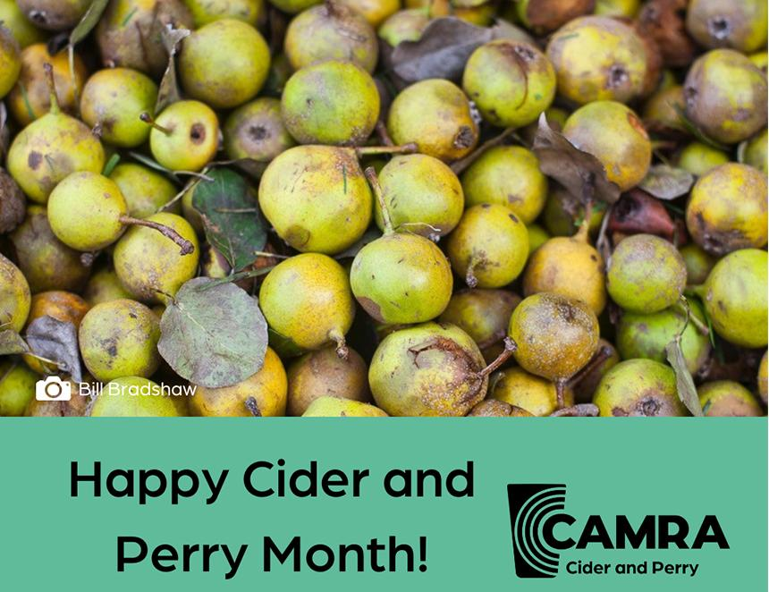

The final instalment in this producer series champions makers across the UK to celebrate CAMRA’s Cider and Perry Month.  Publicans can contact producers to get real cider and perries on the bar, with the full producer list available on CAMRA’s website.     Borderlands Cider  Type: producer   Contact: info@welshcider.co.uk  Wales SY16 2RA    Cefynan Perry  Type: producer   Contact: cefynanperry@gmail.com   Wales SY20 8ER     Dee Ciders  Type: producer   Contact: 07803 715375  89 Uplands Avenue, Connah’s Quay, Deeside, Wales CH5 4LF     Mac Ivors Cider  Type: producer  Contact: info@macivors.com   65A Ardress Road, Portadown, Northern Ireland BT62 1SQ     Flemings Fife Cider  Type: producer  Contact: 01334 652787   St Bunyans Place, Leuchars, St Andrews, Scotland KY16 0HT     Hamilton Cider Company  Type: producer  Contact: hamiltoncider@gmail.com   Scotland G40 2UZ     Brew Shed Cider  Type: producer  Contact: steven@brewshed.scot   Wellheads House, Sandilands, Limekilns, Dunfermline, Fife, Scotland KY11 7ER     Cairn O'Mohr Fruit Wines and Ciders  Type: fruit/flavoured real ciders  Contact: us@cairnomohr.com   East Inchmichael, Errol, Perthshire, Scotland PH2 7SP      Dunkertons Cider Company  Type: producer  Contact: info@dunkertonscider.co.uk  Dowdeswell Park, The Barlands, London Road, Charlton Kings, Cheltenham, Gloucestershire, England GL52 6UT     Grazed Knee Cider  Type: producer  Contact: team@grazedkneecider.co.uk  Isle of Wight, England PO38 1DX     New Forest Cider  Type: producer  Contact: enquiries@newforestcider.co.uk  Pound Lane, Burley, Ringwood, Hampshire, England BH24 4ED     Little Pomona  Type: producer and fruit/flavoured real ciders  Contact: wassail@littlepomona.com   Little Pomona Cider House, Brook House Farm, Avenbury Lane, Bromyard, Herefordshire, England HR7 4LB     One Tree Hill Cider   Type: producer  Contact: ikwcider@icloud.com   Honor Oak Park, London, England SE23 3LH     Ashover Cider Co Ltd  Type: producer  Contact: sales@ashovercider.co.uk  The Wheatcroft, Butts Road, Ashover, Chesterfield, Derbyshire, England S45 0AX     Leeds Urban Harvest Cider  Type: producer  Contact: leedsurbanharvest@gmail.com   Yorkshire, England LS2 3AD