Cream of Manchester heads home

24/07/2025 by Timothy Hampson

Industry

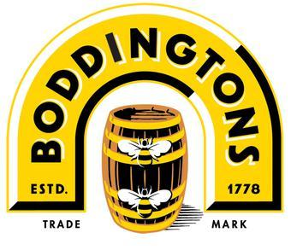

The Cream of Manchester is heading back to the city as JW Lees is to brew and distribute it under licence from Budweiser Brewing Group (BBG). This partnership will see Boddingtons Cask at 4 per cent ABV being positioned in the growing premium cask beer category under the leadership of JW Lees head of national sales Matt Savage, who joined JW Lees from Heineken in April this year. Henry Boddington started brewing at Strangeways brewery in Cheetham Hill in 1778. In the 1990s, the beer was promoted as the 'Cream of Manchester'. Whitbread bought the brewery in 1989 and Boddingtons Bitter received an increased marketing budget and nationwide distribution. Boddingtons achieved its peak market share in 1997 and at the time was exported to more than 40 countries. Production of the cask-conditioned beer moved to Hydes brewery in Moss Side, Manchester, until it was discontinued in 2012, ending the beer's association with the city. William Lees-Jones, sixth generation MD of JW Lees, said: “When I joined JW Lees in 1994, Boddingtons was the Cream of Manchester and we were in awe of their position in leading the cask beer revolution and we are planning to put Boddingtons back where it rightly deserves to be as one of the leading premium UK cask beers particularly in our heartland of the North-West.  “We also look forward to working with Budweiser Brewing Group with their portfolio of market-leading lagers and premium packaged beers in our pubs.” AB InBev Western Europe president Brian Perkins said: “We are excited to relaunch Boddingtons Cask ale in partnership with JW Lees, combining one of the UK’s most iconic beer brands with one of its most respected brewers.  “We see real growth potential for Boddingtons in the UK on trade, and this is a great example of how strategic partnerships can unlock value for both businesses and beer lovers alike.”