Brighton Bier lives on in Lewes

23/07/2025 by Timothy Hampson

Industry

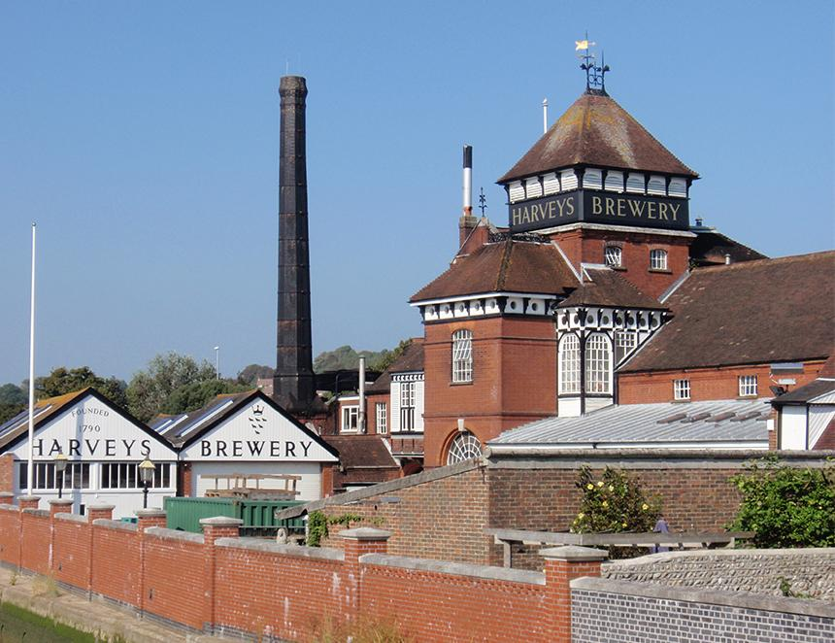

Harvey’s has taken over the intellectual property of the closed Brighton Bier brewery including its trademarks and recipes. Brighton Bier, which closed last month citing rising costs, was established in 2012 and described itself as the city’s "original craft brewers". A website statement said: “We are sad to announce that Brighton Bier has ceased trading. “This does not affect Brighton Bierhaus, Haus on the Hill, The Drop or West Tap. “These are all separate businesses and will continue to trade as normal. “Sadly market pressures with reduced margins, high costs, and increases in price of materials, combined with the current economic conditions has forced us to close the brewery.” Brighton Bier operated a 15-barrel brewery close to the city centre. Now, Harvey’s of Lewes has bought the brands to protect their future. Harvey’s head brewer and joint MD Miles Jenner said: “While we won’t be marketing Brighton Bier brands, we’re planning to undertake occasional collaborative brews with them. “These might pay tribute to some of their most popular beers or be something entirely new. They’ll be clearly labelled as collaborations and made available for a limited time in both Brighton Bier pubs and our own. “If Brighton Bier ever chooses to return to brewing, we’ll be more than happy to sell the intangible assets back to them at the same price we paid.” Brighton Bier director Stephen Whitehurst said: “After over a decade of brewing it was heartbreaking to have to close the brewery. It has been a pleasure to serve our wonderful customers. “When we first started who would have known we’d be winning international awards and exporting across Europe and into Japan. That Harvey’s, with their proud history and wonderful beers, saw fit to step in and protect this legacy is very humbling. “We are very grateful to Miles and his team and look forward to exploring ways of collaborating in the future. “Both companies are excited about this novel approach, and we hope fans of Brighton Bier will support us in keeping that creative spirit alive.”