Pubco lays out Budget wish list

21/07/2025 by Timothy Hampson

Industry

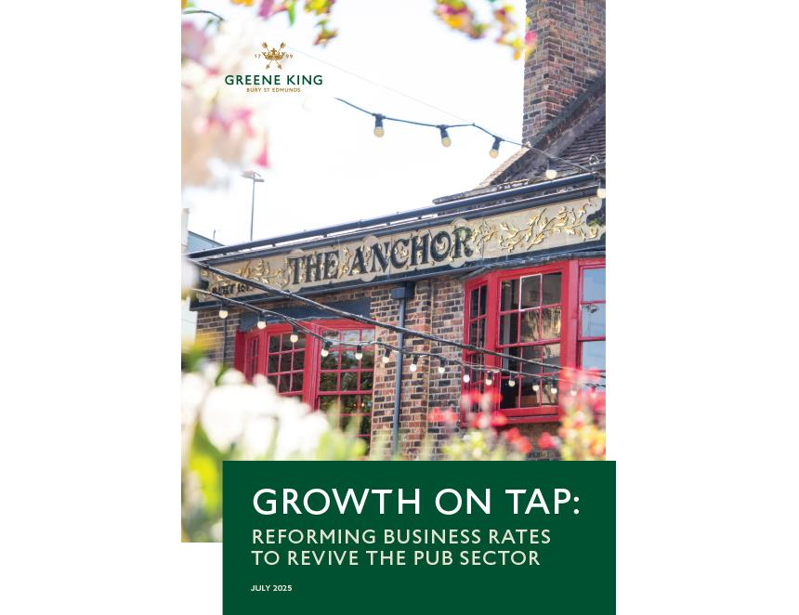

Greene King has unveiled policy proposals on business rates that could unlock millions of pounds to drive growth through investment in communities across the UK. In a new report, the pubco and brewer lays bare the growing financial challenges facing pubs – from escalating National Insurance contributions to unsustainable business rates – which are limiting the sector’s ability to invest in communities. Five months before the chancellor delivers her Budget, Greene King is calling for an overhaul of business rates as an urgent priority, to create a fairer system. With a business rates bill of almost £60m across its close to 1,500 managed pubs in England, Greene King is asking the chancellor to introduce a specific, lower business rates multiplier for all pubs at the Autumn Budget, giving them a 20p discount on their current rate. This change would deliver immediate relief for the whole sector in England in the next financial year. For Greene King it could realise £13.7m in immediate annual savings. Across the group’s managed pub estate, this equates to £10,000 per pub, or: – 1.1m hours of work per year, providing employment opportunities in Greene King pubs across the UK – 3,250 Level 2 apprenticeship positions, supporting careers within the hospitality sector – more than 30 pub investments in Greene King’s managed estate, driving economic growth at a local level – 60 Pub Partner investment projects, helping grow small business and creating social spaces in communities across the country. In the longer term, Greene King is also calling for a fundamental reform to the system so rates are calculated based on a pub’s profits, rather than its turnover. Currently, the rateable value of a property is based on the turnover a pub is expected to achieve, whereas profit is a much fairer measure to base it on due to the high running costs of a pub. Together, these changes could unlock in excess of £20m a year from Greene King alone and create a fairer system that accurately reflects the social and economic contribution of pubs to communities as both employers and hubs for people to meet and socialise. Nationally, the 39,989 pubs in England and Wales account for just 0.4 per of business turnover but pay 2.1 per cent of the national business rates bill. If taxed proportionately, the pubs sector would pay £130m instead of the £637m it currently pays. Greene King CEO Nick Mackenzie said: “The government has made growth its number one priority, and the chancellor now has the opportunity to make changes that will immediately unlock millions of pounds to do just this. “We will be able to go even further and faster with our investments – creating new jobs, refurbishing pubs and breathing life back into communities up and down the country. “While we welcome the commitment for long-term reform, this now needs to happen to ensure the system is fair and fit for the future, rather than stuck in the past.” British Beer and Pub Association CEO Emma McClarkin said: “This report lays bare the financial struggles pubs and brewers are enduring thanks to policies which stifle growth and undermine investment, jobs, and vital community spaces. “It has never been more urgent for government to overhaul the outdated and unfair business rates system as our sector, which makes huge economic contributions and has priceless cultural value, is one of the most highly taxed industries in the UK. “These real stories should make government and policy makers sit up and face the reality that unless they act now, they could oversee irreversible damage to our beloved pubs and brewers.”