The gastropub lives

19/07/2025 by Laura Hadland

Opinion

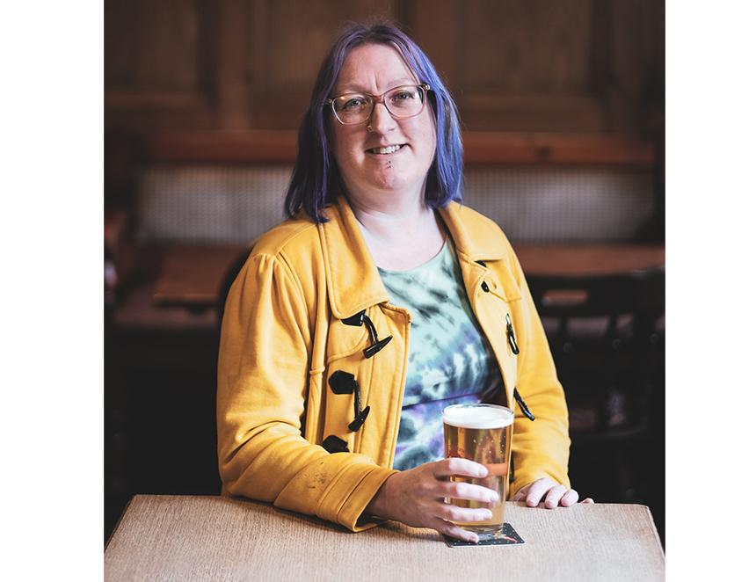

I’ve been organising my thoughts on the gastropub concept ever since I read the wonderful Katie Mather’s thoughts on the subject in her excellent newsletter, The Gulp. She talked about slow death in a gastropub, and while much of what she said resonated with me, I have always been a keen devotee of the concept. Since the term was coined in the mid-nineties, and popularised from the 2010s, I have sought to find the unicorn – a great pub with excellent beer and an uncommonly high level of food quality. There’s nothing wrong with standard pub grub, I enjoy it regularly, but sometimes I like a little bit of fancy. But finding a genuinely excellent example has been next to impossible, because I care about my beer. While there are many venues out there who offer an elevated menu, I have almost universally found their beer lists are distinctly lacking. You can have all of the locally foraged ingredients and nose-to-tail eating you want, but if you can’t choose a quality pint or bottle to pair with it, disappointment ensues. Practically every gastropub I have ever visited in my life appears to have worked hard to curate a decent wine list but afforded approximately seven seconds to making sure their beer and cider offering passes muster. Imagine my surprise to encounter two brief-fulfilling pubs in the course of one day. Fittingly enough, they were both in London – the birthplace of the gastropub in the form of the Eagle in Farringdon (which I have to confess I have never visited). I started off with lunch at the invitation of the William IV in Shoreditch, a pub which was rescued and beautifully restored in 2023. If you had asked me to describe my ideal gastropub to you before my visit, I would accidentally have described this pub precisely, without even knowing it. It is cosy and welcoming – a friendly space for the many local residents but fitted out to a high standard. It has a phenomenally well thought out pub menu, and in the evenings there is an even bigger menu in the upstairs Dining Room. And it has a fine selection of beers and ciders. I counted 44 options on the list, including a good range of low-and-no alcohol products. Had I been dining with a friend, I would certainly have chosen one of the Little Pomona 75cl sharing bottles to enjoy with the meal. A pint of Siren’s Mesmerist kept me company as I browsed the menu instead. The William IV is still finding its way around what actually sells, so not everything I wanted to try was in stock. The Pohjala sours that caught my attention had taken so long to sell that they had not been replaced, for example, but there were plenty of more than satisfactory alternatives. The pub does an excellent line in pies, served with the most incredible triple-cooked chips, but those in the know only countenance the chalkboard of daily specials. It is written each morning just before opening, when the chef has picked up the best fish from Brixton and the choicest Swaledale cuts of meat have been delivered. I had the chalk-stream rainbow trout with a caper and sundried tomato sauce, roasted new potatoes and fennel. It was a joy. Crispy skin atop perfectly moist fish that was still a gleaming red within. An encapsulating orchestra of flavour that was only improved by the addition of a bottle of Boon’s classic Mariage Parfait. If you want a lighter snack, then I recommend the homemade Welsh rarebit crumpet, which I think may be the most satisfying thing to pair with a pint that I have ever eaten. None of this food was fussy. It was simple and uncomplicated. Fresh, carefully chosen ingredients were left alone to sing their own song. The presentation and portions were good – everything invited you to dive straight in – but there were no smears of sauce or micro herbs or any similar fripperies that can scream pretension. Even more remarkable in many ways was the pricing, with most main courses not costing anything more than I would expect to pay for a (significantly lower quality) meal in a chain restaurant here in the West Midlands. After this wholesome lunch, I had an evening soiree with brewer Anspach & Hobday. As part of its tap takeover at the Lore of the Land in Fitzrovia, it had arranged a special five-course pairing menu, showcasing its beers with new dishes developed by the kitchen team. Again, it was a privilege to attend, despite the fact that I was incredibly full. A sea bream crudo with pickled fennel danced on my palate alongside the Anspach & Hobday Blonde. We were treated to a homemade stout fudge with Maldon salt and – what else – a small glass of London Black. These are the things that dreams are made of. I know I am not alone in enjoying good food just as much as I enjoy good beer. I am heartened to see that fantastic gastropubs do exist and that they are well patronised. Rejuvenated, I will continue my quest to find, and share, more of the great ones in the hope that it encourages the others to pull their socks up and ensure they get their beer offer up to standard.