Champion local producers for Cider and Perry Month

18/07/2025 by Tori Wood

Campaign

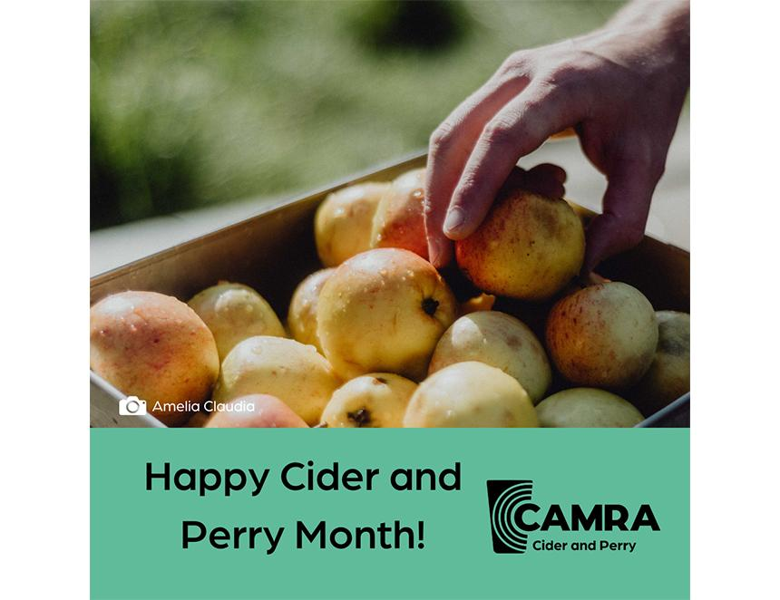

This cider and perry producer list returns for its third instalment spotlighting makers for CAMRA’s Cider and Perry Month.  Get involved in campaigning for real cider and perry this July by trying new drinks from our lists and using #NotFromConcentrate and #CiderandPerryMonth on your social media channels.  Publicans, if you see a real cider and perry that you think your customers will love, you can find contact details by each listing.    Monnow Valley Cider  Type: producer  Contact: monnowvalleycider@outlook.com  Abergavenny, Wales NP4 0AN    Orchards Cider and Perry Co  Type: producer  Contact: info@orchardsciderandperry.com  Underhill House, Underhill, Brockweir, Wales NP16 7PE    Shed Head Cider  Type: producer  Contact: shedheadcidergower@gmail.com   Mill Shop Gower Heritage Centre, Parkmill, Gower, Swansea, Wales SA3 2EH    NOVAR Cider  Type: producer  Contact: info@novarcider.com  Novar Estate, Evanton, Dingwall, Scotland IV16 9XL    Steilhead Cider  Type: producer  Contact: steilheadcider@gmail.com  1 Steilhead Cottages, Auldgirth, Dumfries, Scotland DG2 0TN    Lost Orchards Cider  Type: producer  Contact: hello@lostorchards.co.uk  East Adamston Farm, Dundee, Scotland DD2 5QX    Armagh Cider  Type: producer  Contact: info@armagcider.com  Ballinteggart House, 73 Drumnasoo Road, Portadown, County Armagh, Northern Ireland BT62 4EX    Tempted Cider  Type: producer and fruit/flavoured real ciders  Contact: hello@temptedcider.com   2 Agars Road, Lisburn, Northern Ireland BT28 2TQ    National Association of Cider Makers  Type: producers association  Contact: info@cideruk.com  The Bounds, Much Marcle, Ledbury, Herefordshire, England HR8 2NQ    Thornborough Cider  Type: producer  Contact: thornboroughcider@gmail.com   White House, Thornborough, Bedale, North Yorkshire, England DL8 2RE    Trenchmore Farm – Silly Moo Cider  Type: producer  Contact: rachel@trenchmore.co.uk   Trenchmore Farm, Burnt House Lane, Horsham, Sussex, England RH13 8DG    Perry’s Cider  Type: producer  Contact: 01460 55195  The Cider Mills, Dowlish Wake, Ilminster, Somerset, England TA19 0NY    Brick Lock Orchard Ltd  Type: producer  Contact: bricklockisland@gmail.com  Birck Lock Cottage, Roydon, Essex, England CM19 5EW    Crone's Cider  Type: producer  Contact: crones@btconnect.com  Crone’s, Fairview Fersfield Road, Kenninghall, Norfolk, England NR16 2DP    Grasmere Brewery Cider  Type: producer  Contact: sales@grasmeredistillery.com  Lake View Farm, Grasmere, Cumbria, England LA22 9TD    Tamworth Cider  Type: producer  Contact: info@tamworthbrewing.co.uk   Staffordshire, England B79 7LR    Torn Plant Cider and Blends  Type: producer  Contact: cider@tornplant.co.uk  Cherry Orchard, Farm Abbey Lane, Oakmere, Northwich, Merseyside, England CW8 2HU    Traction Cider  Type: producer  Contact: will@tractioncider.co.uk  Cheshire, England CW5 5BA