Best Bonkers beer?

17/07/2025 by Timothy Hampson

Campaign

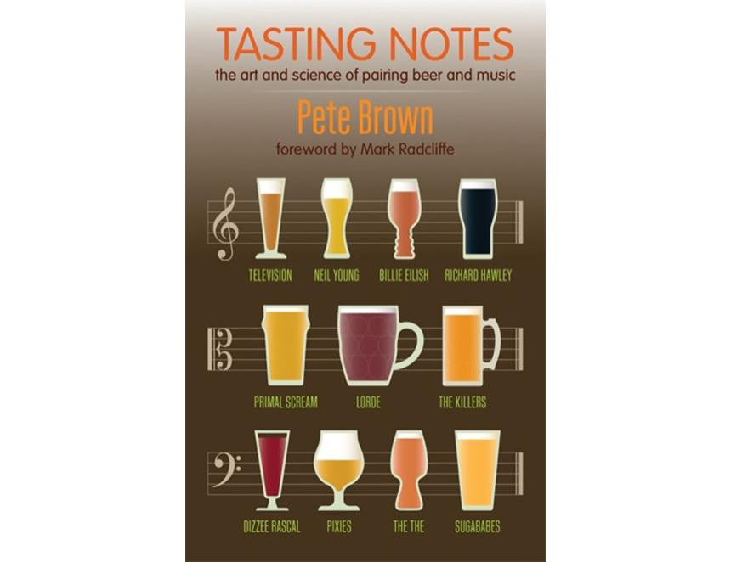

Scientists understand less about how we hear music than they do about the birth of the universe, but a new book by beer writer Pete Brown is set to accelerate that understanding – simply by going to the pub. Published by CAMRA, Tasting Notes: The art and science of pairing beer and music is the latest book by Sunday Times beer columnist Pete Brown. What started as a fun event above a pub turned out to be an accidental cornerstone of one of the latest areas of neuroscientific research. Pete combines popular science with a music fan’s perspective to explain how our senses work, how we appreciate flavour, music and the world around us. He shows our senses interact in ways we don’t even realise and proves how you can change the way your beer tastes by changing the music around you. Across 45 beer-and-song pairings, Pete’s experimental journey continues with genres covering rock, grime, jazz, alt pop, country, folk rock, electronic and progressive trance, with songs from Primal Scream, Joy Division and more matched with an eclectic list of beers. Pete, whose last book Clubland: How the working men’s club shaped Britain was a BBC Radio 4 Book of the Week, describes how surprised he was when a notable professor of neuroscience approached him after one of his beer and music events and explained that the talk covered similar ground to cutting-edge experiments already underway at Oxford University. The experiments were exploring how different senses affect each other – how colour or shape affect our perception of sweetness, or much of what we hear is profoundly influenced by what we can see. Pete said: “To be fair, pairing music and beer sounds like a bit of a joke and it started off as one. But realising that I’d inadvertently stumbled across something serious, I read academic papers and started to learn about retronasal olfaction and cross-modal correspondences. “Modern neuroscience is in its infancy. Here, in the third decade of the 21st century, we know more about the birth of the universe than we do about how our brains interpret information. Most of us enjoy listening to music and savouring a beer, and this is a fun way to understand how the relationship between the two is closer than you think.” Pete’s talks at festivals about the art and science of pairing beer and music have already become cult events. Now, this book is the definitive guide to why guitars taste of hops, why you’ll need a lager to listen to the Sugababes’ cover of I Bet You Look Good on the Dancefloor and what to drink with Dizzee Rascal’s Bonkers. The book costs £16.99 from shop1.camra.org.uk/product/tasting-notes