Revamped Learn and Discover launched

16/07/2025 by Harri Knight-Davis

Campaign

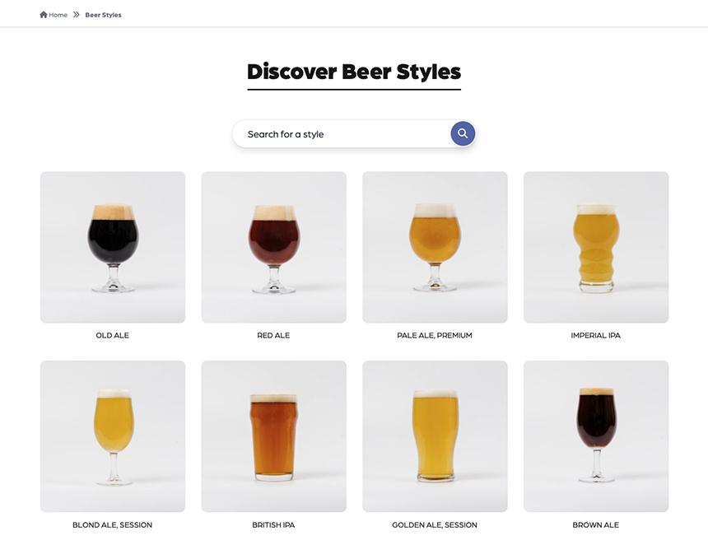

CAMRA’s award-winning Learn and Discover platform has been relaunched promising a new experience and helping expand knowledge of beer, cider, pubs and clubs.  The improved platform hosts a range of new features designed to make learning more accessible.   These include:   upgraded beer dictionary

beer styles guide (pictured)

linked series of content

ability to curate your own content.  The updated platform comes with new articles from drinks writers, including Rachel Hendry, Ruvani Da Silva and an in-depth series on pub companies by CAMRA’s planning policy advisor Paul Ainsworth.  British Guild of Beer Writers’ Beer Writer of the Year 2024 Ruvani de Silva said: “CAMRA’s Learn and Discover platform offers exciting and engaging content for beer and cider lovers of all levels who are keen to explore the stories and science behind the beverages they enjoy. The platform is also an invaluable space for writers to dig deep into different aspects of beer and cider and share our love for hidden histories and stylistic nuances with CAMRA members.”   Writer Rachel Hendry said: “Intuitive and accessible education is vital to the future of beer and cider and Learn and Discover has grown into an invaluable resource in the sharing of knowledge amongst those working in all aspects of the drinks industry. It's a platform I am proud to contribute to and one I look forward to learning from.”  The new Learn and Discover platform can be found here: learn.camra.org.uk/home