Solar power for Sun City

16/07/2025 by Timothy Hampson

Industry

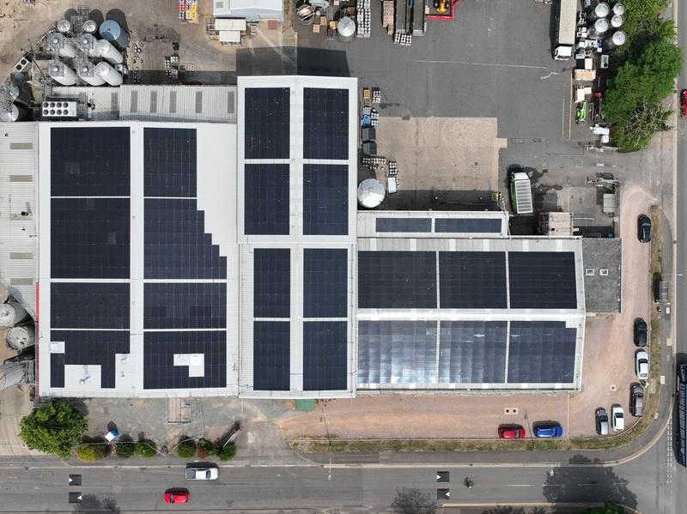

Oakham Ales is now brewing with the power of the sun, following the installation of a rooftop solar system by Electron Green. Like many legacy industrial sites, Oakham faced a key obstacle to solar adoption: an ageing roof. Electron Green solved this by installing a steel overclad roof and the solar system at zero capital cost to the brewery. Electron Green owns and manages the system and supplies the brewery with discounted, fixed-rate solar electricity via a power purchase agreement. To mark the move, Oakham is launching a new seasonal release – Sun City – the brewery’s first beer made using solar power. The 3.7 per cent ABV blonde ale features Nelson Sauvin and Nectaron hops from New Zealand, offering tropical fruit, gooseberry, and citrus notes with a refreshing herbal finish. Sun City will be available on cask from August. “This is a huge step in making Oakham Ales more sustainable,” said former head brewer Mark Tetlow, who was the driving force behind the switch, his last project before retirement. The 458.85 kWp solar array covers 2,084 square meters of the upgraded roof area with just over 1,000 photovoltaic (PV) panels. The installation is expected to reduce Oakham’s reliance on grid electricity by 15 per cent saving close to £11,000 in the first year. The system will also prevent more than 2,200 tonnes of carbon emissions over its lifespan. “Providing a free solar system with ongoing management to Oakham Ales has allowed it to cut its carbon footprint and energy costs in one glorious swoop,” said Daniel Green, CEO and co-founder of Electron Green. “We’re here to provide businesses with flexibility in how they manage and pay for electricity. As energy demands are expected to rise by 50 per cent over the next decade, businesses need confidence in their energy supply and greater control over their costs.” Oakham head brewer Ed Sharman added: “Electron Green managed the whole project with no disruption to our brewing schedule over the spring. “It’s great that our business has upgraded its environmental credentials so massively without us having to offer a penny in capital expenditure and we’re all looking forward to raising a glass of Sun City in celebration.”