Campaign backs Women In Beer awards

15/07/2025 by Timothy Hampson

Campaign

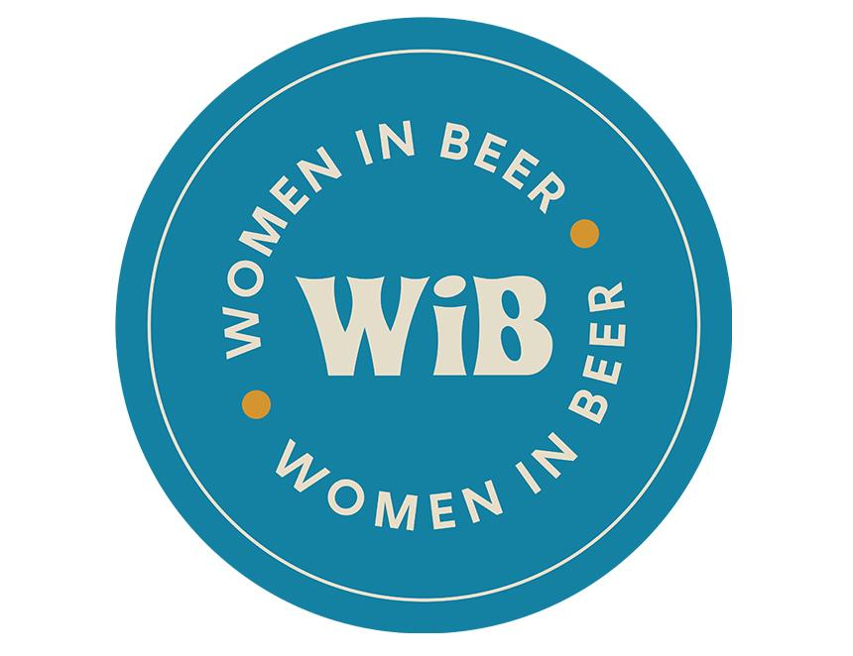

CAMRA is backing the Women in Beer community by supporting its awards celebrating those who shape the brewing industry. With only 23 per cent of management roles in craft beer and eight per cent of all brewers being filled by females, the importance of representation and visibility for the many talented women who work in the beer industry is essential. The mission for Women in Beer in organising these awards is once again creating role models and showing young women that a career in beer can be something for them too. Sponsoring the Women in Beer 2025 – Industry Icon award, CAMRA vice chair Gillian Hough said: “Celebrating and congratulating those nominated for the Women in Beer Awards is something really special and close to my heart. “From managers, directors, consultants, owners, writers, teachers, journalists, judges and campaigners, women are no longer 'just' a part of the industry – they are swaying opinion and driving trends as industry influencers. “At CAMRA, we are proud to support and champion what the Women in Beer Awards stand for and welcome greater diversity across the beer and pub industry. To every nominee and winner, thank you for inspiring the next generation.” With 10 categories across all parts of the industry, the Women in Beer Awards are open to anyone who identifies as a woman, regardless of background, age, or role and includes those working professionally, independently, or as a volunteer. Women in Beer founder Amélie Tassin said: “It’s very scary to see that according to the latest SIBA Beer Report, gender equality in brewing has gotten worse compared to previous years. “We desperately need to attract more women into the industry, retain those who are already here, and also help them to access managerial positions. “With the awards, we’re highlighting their work, celebrating them, and hopefully making the industry a better place for everyone.” Taking place in London on 28 October, the awards aim to become an annual highlight for the industry and the event welcomes everyone connected to beer, whatever their gender. The awards have already received overwhelming support from the industry with only two left to sponsor, thanks to CAMRA, SIBA, Simpsons Malt, SSV, Charles Faram, Yakima Chief Hops, WHC Lab, and HIT Training which are backing eight of them. For information, visit womeninbeer.co.uk