Pub closures set to rise to one a day

14/07/2025 by Timothy Hampson

Industry

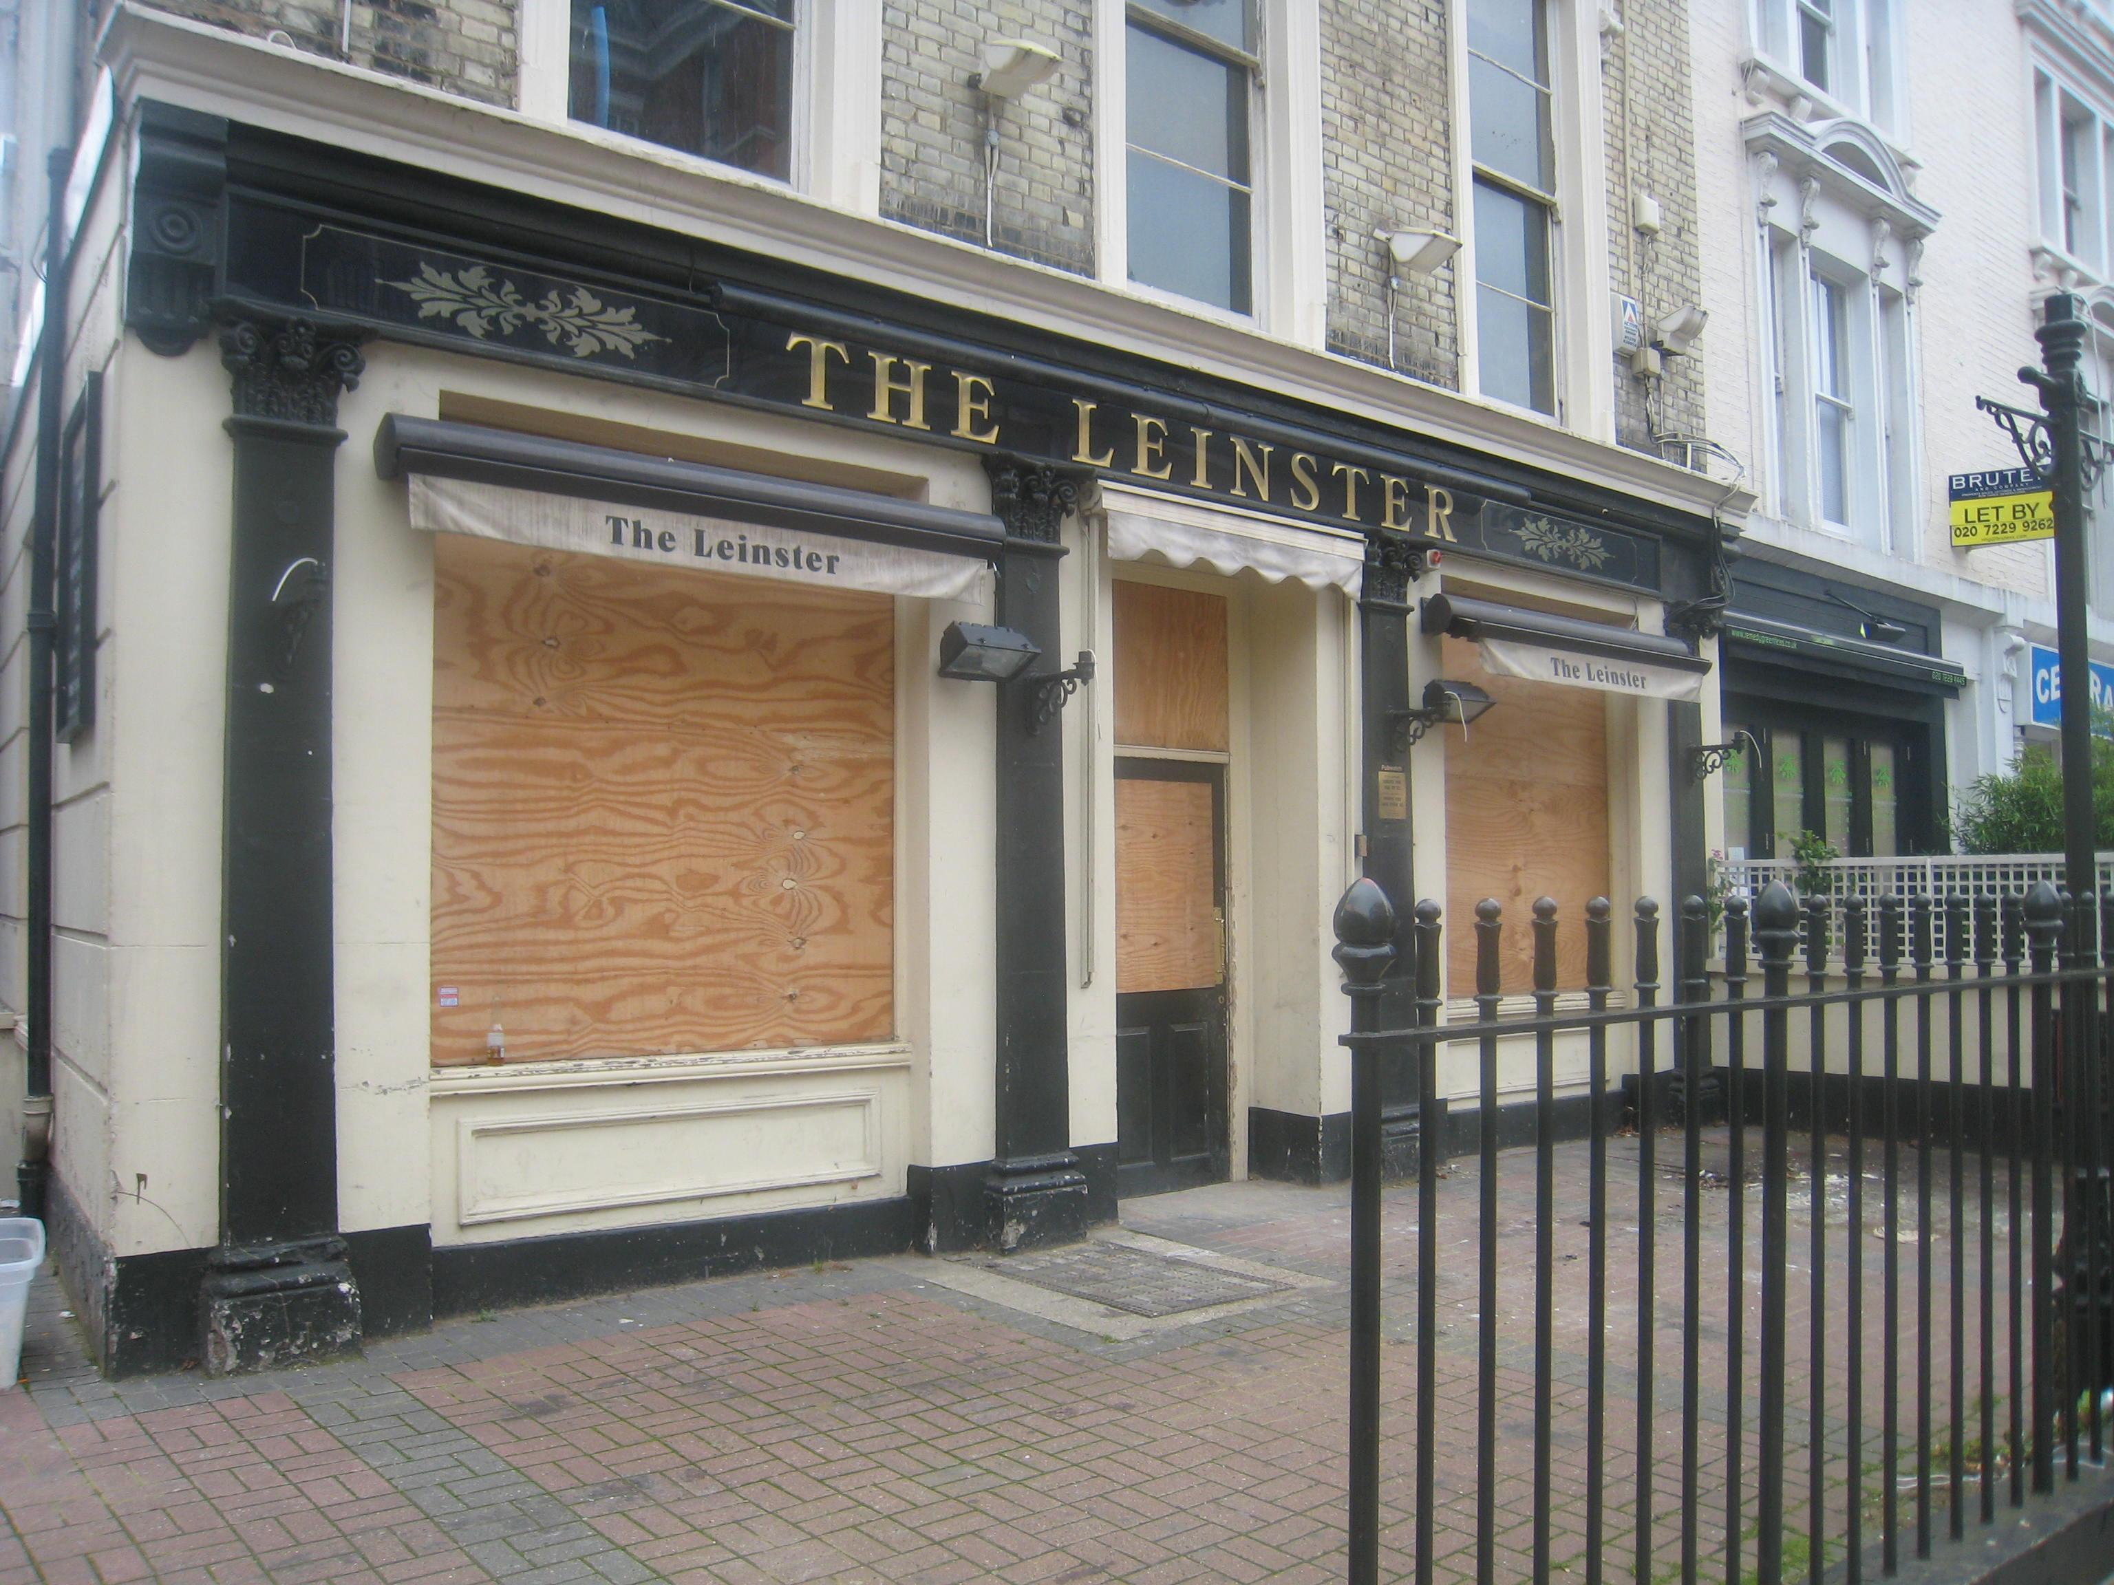

The beer and pub industry will face huge economic pressures over the next 12 months as closures are expected to rise to one a day, according to latest figures from the British Beer and Pub Association (BBPA).   The industry body, which represents more than 20,000 pubs, estimated that 378 of them will close this year across England, Wales and Scotland, which would result in 5,600 direct job losses. The BBPA claimed government can help solve the problem by overhauling business rates for brewers and pubs, as they are one of the most highly taxed sectors. The trade association said reducing the cumulative tax and regulatory burden would help more pubs stay open, leading to more investment and jobs while also protecting spaces that, for many communities, are the only places left to gather.  BBPA chief executive officer Emma McClarkin said: “Pubs are trading well but most of the money that goes into the till goes straight back out in bills and taxes. For many it’s impossible to make a profit which all too often leads to pubs turning off the lights for the last time. “When a pub closes it puts people out of a job, deprives communities of their heart and soul, and hurts the local economy.  “However, it’s not too late to change this sad state of affairs. We know government recognises the economic and social value of pubs and we’re not asking for special treatment, we just want the sector’s rich potential unleashed.”  The BBPA warned pub closures will have a further impact on those in the supply chain, including farmers, brewers and other industries which form part of the sector’s wider ecosystem.