Visiting the AI pub

13/07/2025 by Laura Hadland

Opinion

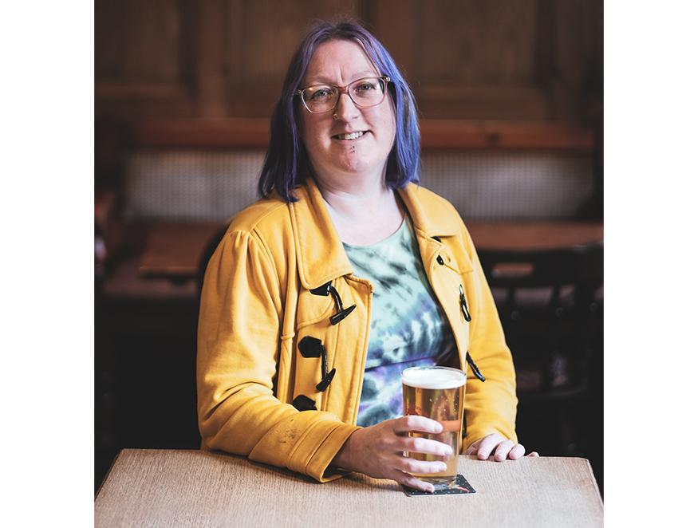

I like to try and keep abreast of the news, particularly if it pertains to beer and pubs. This morning, my feed was assaulted with the same cookie cutter headline: “I asked AI what the best pubs are in XXXX – here’s what it came up with.” There were no less than six such stories from different local papers, all within the National World group. Each featured a very short introduction, explaining to us how the writer concerned had deftly asked ChatGPT to make a list of the best pubs in the area. Then the list was reproduced. The pubs’ contact details were lovingly cut and pasted in, accompanied by an image painstakingly sourced from Google. A couple of these articles had a sentence, presumably also AI generated, about what the pub offered. Others featured nothing but the address. I thought things were bad when we were seeing “best of” lists in the newspapers that were lifted straight from TripAdvisor, but this is quite the step down. At least harvesting TripAdvisor recommendations uses the opinions of folk that have actually visited an establishment. This isn’t really the place to talk about the fall of local journalism, but What's Brewing is a platform where I can highlight how pubs are being overlooked, despite their proven social and cultural importance, time and time again. All of us have our favourite pubs. The reasons that we love them are usually deeply personal. If you’ve had the same local for 30 years, I’d wager that it’s mainly your favourite because it’s familiar and you know there’s always going to be a friendly face there. You might, like me, be smitten by the most traditional of boozers – which is why the All Nations Inn, Madeley features high up on my own list of favourites. Perhaps the cosy environs of a more modern taproom may appeal to you the most. Subjectivity to one side, we all have the capacity to consider what makes a pub great and agree to measure different venues against certain criteria to find the best. That’s what happens each year when CAMRA crowns the Pub of the Year, of course. While not everyone will agree with the outcome of a competition like that, we can definitely all agree that it is impossible to judge the quality of a pub without first visiting it. What, then, is the purpose of these National World articles? No one in their right mind (I hope) is going to read them and think to themselves: “I am definitely going to visit the Red Lion, since it’s at the top of this list!” None of the pubs (I assume) are going to boast about being featured, since it’s basically just arbitrary that the algorithm selected them for inclusion. They might encourage a bit of a flurry below the line, as readers scurry to comment on why the list is wrong. Herein lies the real problem. These articles are generated not to inform the reader about pubs. There’s no real information in there anyway. They are purely aimed at getting clicks and increasing dwell time on the newspaper’s website to up their ad revenue. Articles in this vein make up, by far, the majority of press coverage that is being given over to UK pubs at the moment. Computer-generated word salads that bring inspiration or education to no one at all. That is a pretty sobering thought. I considered asking AI to generate a list of the best pubs in my local area, so I could form an idea of how useful its “opinions” are. But of course that would be just as much of a waste of energy and water as it was for the journalists who wrote (“wrote”?) these articles in the first place. AI has its place in the world. It can compare large datasets quickly, for example, or instantly analyse the patterns in images. What it cannot do is experience the beauty of a pub in all its multi-sensory glory. The feeling of welcome as you arrive at the bar. The sense of belonging when surrounded by familiar faces at the weekly quiz. The unbridled joy of that first sip of your pint after a tough day. I don’t know how to convince the media that pubs are important and compelling. I don’t know how to persuade editors that their stories are worth investing in because people want to read about them. If I did, I’d be getting a lot more commissions, that’s for sure. But I do know that letting AI guess which pubs are the most worthy of our time and money does the whole industry a great disservice.