Support your local producers during Cider and Perry Month

11/07/2025 by Tori Wood

Campaign

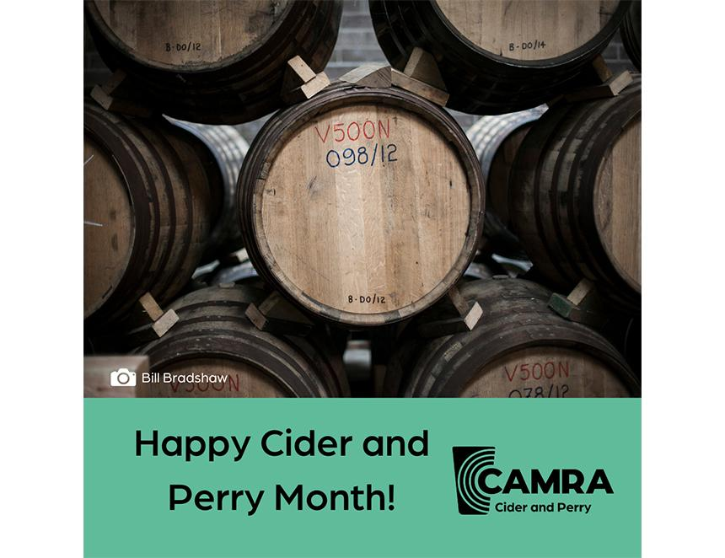

Our cider and perry producer list returns with a second batch of makers for CAMRA’s Cider and Perry Month.  Champion real cider and perry by trying new flavours this July. Publicans, seen a drink your regulars would like to see on the bar? Get in touch below.     Afal Y Graig Welsh Artisan Cider & Perry  Type: producer  Contact: afalygraig@gmail.com   Neath Road, Fforest Goch, Rhos, Neath SA8 3EB     Gethins Pembrokeshire Cyder  Type: producer  Contact: geth@gethinscyder.co.uk  Hendy Orsaf, Maenclochog, Pembrokeshire SA66 7LG     Seider The Wee Scottish Cider Company   Type: producer  Contact: christian@seidear.com  Kingcausie House, Aberdeen AB12 5FR     Falkland Estate Cider  Type: producer  Contact: enquiries@falklandestate.co.uk  The Stables, Falkland Estate, Falkland KY15 7AF     Long Meadow Cider  Type: Producer  Contact: info@longmeadowcider.com   Long Meadow Farm, Loughgall Road, Portadown, Co. Armagh BT62 4EG     Ripe Cider  Type: producer  Contact: ripecider@gmail.com   Cornwall PL22 0PA     Tricky Cider  Type: fruit/flavoured real ciders  Contact: info@trickycider.com   Netherham Farm, Low Ham Somerset TA3 7RL     Chapel Sider  Type: producer  Contact: chapelsider@gmail.com  The Old Hall, Chapel Road, Fiskerton, Lincoln LN3 4HD     Long Mynd Cider  Type: producer  Contact: info@longmyndcider.com   The Cider Barn, Colebatch, Bishops Castle, Shropshire SY9 5LW     Grumpy John’s Cider  Type: producer  Contact: grumpyjohncider@hotmail.co.uk   Station Road, Bradford, Yorkshire BD15 0BS