East heads West for Octoberfest

10/07/2025 by Timothy Hampson

Campaign

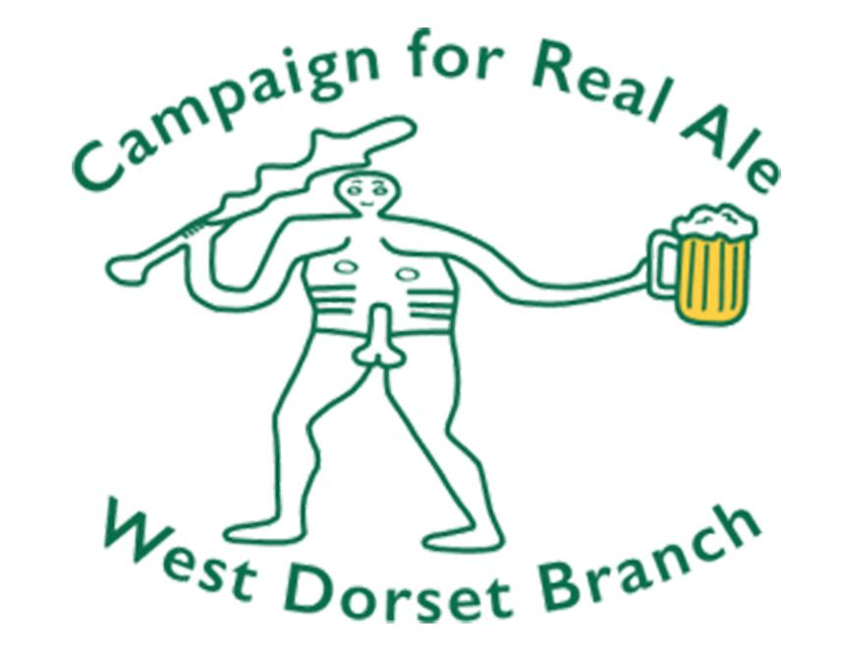

East goes West at this year’s West Dorset 19th branch beer festival. This year Weymouth Octoberfest will take place in Weymouth Pavilion’s Ocean Room from 3-4 October over four sessions. As always there is a theme to the beer selection and this year it’s the turn of East Anglia to be highlighted. Customers can expect to sample more than 55 cask beers from breweries in the counties of Cambridgeshire, Norfolk and Suffolk along with a selection of ciders from the east of the country. CAMRA bar manager and committee member Rich Gabe said: “In the past Octoberfest has featured breweries from all parts of the UK, from Scotland to Wales; from London to Cornwall alongside one year a Drink Dorset theme. “East Anglia is often a part of the country overlooked, yet it has a deep tradition of brewing which is reflected by the vast number of breweries in the region, we hope to bring some of the best to Weymouth in the largest ever Anglian grouping in Dorset.” This year Copper Street brewery of Dorchester in conjunction with the Dead Brewers Society will be the guest sponsor resurrecting six beers from long-shut breweries in East Anglia. This will give customers a once in a lifetime chance to sample original recipes from breweries long shut. Tickets will go on sale 1 August with a launch in Weymouth. To keep up to date with future announcements visit camrawdorset.org.uk