Pubco’s solar-powered tills

09/07/2025 by Timothy Hampson

Industry

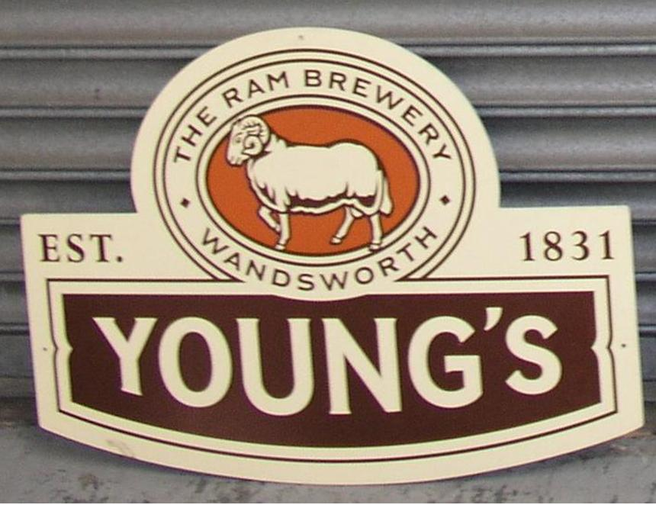

Young’s has reported strong trading momentum in the first quarter of its new financial year, driven by the warm weather in the last few months. In a trading update prior to its AGM for the 14 weeks from 1 April 2025 to 8 July 2025, the London and the South-East pubco said revenue was up 6.6 per cent in total and 7 per cent on a like-for-like basis against last year. “This performance has benefitted from long periods of warm and sunny weather during spring and early summer, supporting growth particularly in our beautiful gardens and riverside pubs,” the statement said. “These results are even more pleasing when measured against the prior year comparator, which benefitted from the significant positive impact of Euro24 Championship on performance in June and early July. “We remain confident about the year ahead, despite the well-publicised challenges faced by our industry. We continue to invest in our estate and have already completed several schemes to take advantage of the summer trading period. “The strong performance demonstrates that our proven strategy of operating premium, individual, and well-invested pubs and bedrooms, consistently delivers industry leading results.” Young’s chief executive Simon Dodd added: “We are delighted to be reporting excellent trading over the first quarter of the new financial year, particularly against such a strong comparator. “Young’s pubs are thriving, and our strategy of employing the very best teams, and maintaining a premium, well-invested and differentiated estate, continues to deliver industry leading results. Our business is performing well, and we are confident about the year ahead.” In June, Young’s reported like-for-like revenue growth of 5.7 per cent for the 52 weeks ended 31 March 2025. Total revenue for the period was up 24.9 per cent to £485.8m. Adjusted operating profit increased £14.1m to £71.4m, with “a sector-leading margin” of 14.7 per cent.