Capital competition renamed to support cask beer

08/07/2025 by Timothy Hampson

Campaign

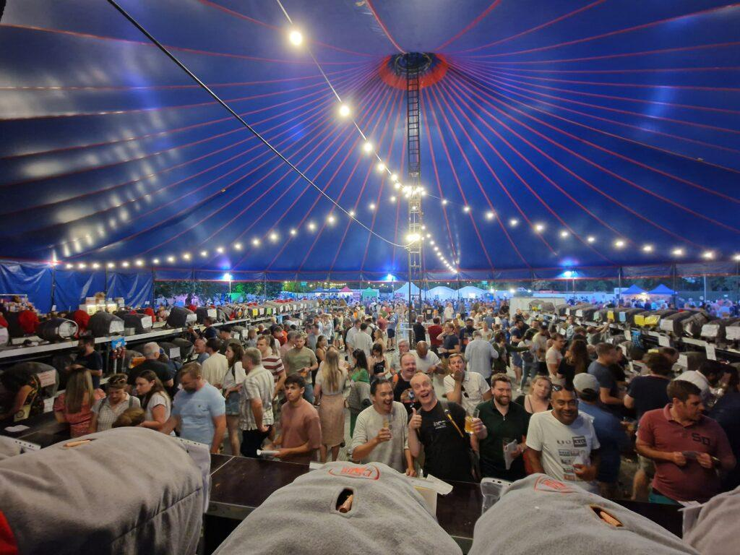

For a few years now the Ealing Beer Festival in Walpole Park has run the Champion Beer of London judging but 2025 has seen a name change. Festival organiser Ben Hart said: “CAMRA is aware that cask beer is under threat but it really is the crème de la crème when we are talking about beer. “We have decided to rename the competition to the London Cask Beer Awards to promote cask beer and support the many great brewers that brew it in London. We are really proud to host the only beer judging competition to be just about London cask beer.” More than 30 judges will be picking the winners on Thursday 10 July. The results will be revealed that afternoon during the trade and public session. Past winners have included London Brewing Company’s 100 Oyster Stout and Anspach & Hobday The IPA. Entrance to the session (from noon) is free for those in the trade but proof of identity is required. For more details, see: ebf.camra.org.uk The festival runs from 9-12 July and features more than 340 cask ales, ciders, perries, craft keg, wines and world beers. Soft drinks and low-alcohol beers will also be available.