Pubs honoured at Plunkett Awards

08/07/2025 by Timothy Hampson

Industry

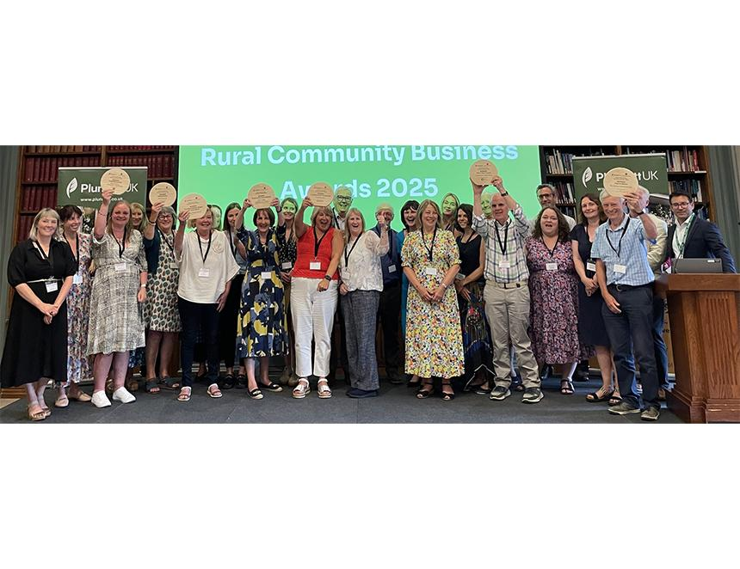

Three community pubs were among nine winners at Plunkett’s 2025 Rural Community Business Awards (pictured) at the Royal Society of Chemistry in London. A community which raised more than £350,000 to buy and reopen a derelict village pub won Plunkett’s Connecting the Community Award. The Rising Sun, in Woodcroft in the Forest of Dean, was sold to a developer in 2011 with a view to turn it into housing, but planning permission was denied. The pub closed in 2011 and ex-patrons led a campaign to reopen it, achieving their aim in October 2022. In 2023 the efforts of the pub was recognised by CAMRA's Pub Saving Award. The latest award recognises the pub’s efforts to attract 50 older people to its monthly 4Cs coffee morning, organise litter picks, create a community wall for artists and spaces for workers and groups to meet. The Going Green Award went to the Locks Inn, Geldeston on the Norfolk/Suffolk border. Located in a very remote location, the community-owned pub has recently installed a kilometre long pipe to access the mains sewerage. Not needing to empty tanks is a carbon-saving initiative. It is now considering a glass crusher machine which can be profitable and offers numerous environmental benefits through repurposing material. The pub has installed 86 solar panels, with more planned, and has a cold room which means there are no fridges on site – again a carbon saving. A travel plan encourages people to walk, bike and come by river, resulting in less traffic through the village. The main outcome is getting towards net zero goals and to save money. The George Community Pub, Wickham Market, Suffolk won the One to Watch award. Damaged by fire in 2013 and the last remaining pub in the village, a property developer’s planning application failed and a Community Benefit Society was formed in 2016. Around £2.5m has been raised to restore and rebuild the pub, including community shares, attracting 470 shareholders, the Community Ownership Fund, and the National Lottery Heritage Fund. As a 16th-century, Grade II-listed pub, the project has secured the survival of many historically significant structural elements, incorporating them sympathetically into a new structure. More than 50 volunteers have taken part within excess of 10,000 volunteer hours put in to date. When open, the George plans to provide about 18 jobs for the community. Restoration of the building allows the first floor to be an activity space, not previously available to the public.