New direction for low-alcohol beers

07/07/2025 by Timothy Hampson

Industry

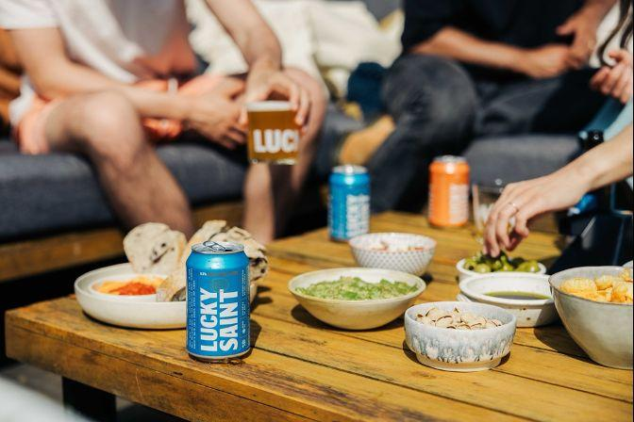

The government’s newly published NHS 10-year plan includes measures to address alcohol-related harm, primarily focusing on mandatory health warnings on alcoholic drinks and a consultation on the definition of “alcohol-free”. The government is also committing to nutrition labelling for alcoholic beverages. Portman Group chief executive Matt Lambert said: “We do not believe there is a case for wider health warning labels which may be disproportionate when overall alcohol consumption is falling and the majority of people already drink within the chief medical officer’s low-risk guidance. “As the alcohol industry regulatory body for marketing, we ensure that adults who choose to drink have actionable and evidence-based information to make informed choices. “The vast majority of alcohol products in the UK already carry our best practice standards including pregnancy warnings, unit information, the chief medical officer low-risk drinking guidelines and a link to information from Drinkaware. The industry is also making great strides in adding calorie and other nutritional labelling to packaging. “We welcome the chance to work with government to further the uptake of low-and-no alcohol alternatives as a useful tool to aid moderation, and clear up consumer confusion around product descriptors, including raising the alcohol-free threshold in line with our international peers for which we have long advocated. British Beer and Pub Association chief executive officer Emma McClarkin welcomed calls to change the definition for low-alcohol products to be amended. She said: ”We are pleased government has heard our calls for descriptions to be changed, and we applaud this progressive step. “Changing the no-alcohol definition to 0.5 per cent will not only unleash growth but means new products which will help people choose moderation and support public health goals. “This shows a progressive approach by government and, if the definitions change, opens the door to greater investment, means we are on par with international markets, and there are more options for people who choose to moderate – everyone wins.” The alcohol-free beer category is seeing record sales as it continues to rise in popularity, according to producer Lucky Saint. Lucky Saint founder Luke Boase said: “People are making deliberate decisions about how they use their time, how they take care of their physical and mental wellbeing, and what they choose to eat and drink. “It’s resulted in a huge take up of alcohol-free drinks – alcohol-free beer has grown by 125 per cent in two years in the pubs, bars and restaurants. “As more and more people consciously choose to drink less alcohol, alcohol-free drinks are playing a major role in positively impacting the health of our nation.” According to research 82 per cent of UK adults cite improving overall health and lifestyle as their main reason for reducing alcohol intake And 71 per cent now consider the health impact when choosing drinks in pubs, bars, and restaurants – rising to 90 per cent among 25-34-year-olds Low-and-no beer is now the second most popular choice for non-drinkers in pubs, up from seventh place just last year at 31 per cent from 23 per cent last year.