The greatest long drink in the world

05/07/2025 by Roger Protz

Opinion

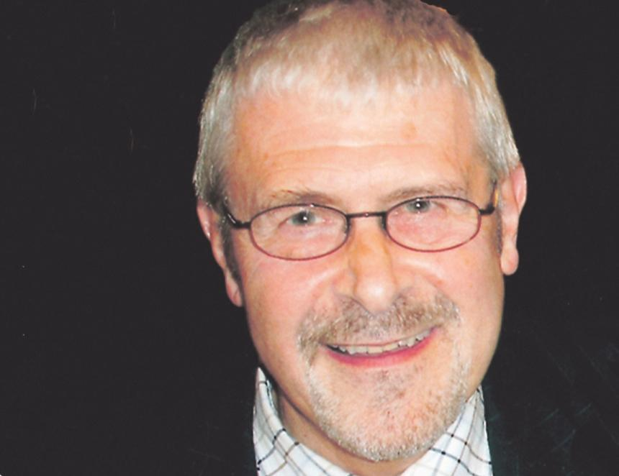

Have Carlsberg, Heineken and other global brewers been rereading George Orwell’s dystopian novel 1984 where the truth is consigned to a memory hole and incinerated? I pose the question as the giant brewers’ views on the state of the cask beer market are in sharp contradiction to the evidence from smaller producers. Heineken says it shuttered the Caledonian brewery in Edinburgh as a result of the slump in cask beer sales. The same argument can be heard from Carlsberg for its closure of four breweries when it was running the Carlsberg Marston’s Brewing Company. It’s now Carlsberg Britvic but that may have changed by the time you read this. One of the breweries it axed, Jennings in Cockermouth, has been bought and reopened by local entrepreneurs who have faith in such fine beers as Cumberland Ale and Sneck Lifter. I wish them the very best of luck and look forward to visiting them soon. I’ve mentioned before that Theakston, the family brewery in Yorkshire, has recorded strong sales for its cask beer. That news has been underscored by the publication of its annual results for the past financial year. MD Richard Bradbury reports a third year of growth and singles out for special attention his cask beers Best Bitter, Old Peculier and XB along with a new low-gravity beer Quencher (3.4 per cent). “Volumes are up eight per cent,” Bradbury said. “Demand for high quality cask ale is on the increase and consumers have renewed interest in the category.”  Carlsberg sees the opposite. As well as closing cask beer breweries it has inflicted Fresh Ale on long-suffering consumers. This is keg beer served using handpumps to confuse customers. The Danes said they have introduced Fresh Ale as a result of “low footfall” in pubs for cask. They have told me in detail how the beer is produced and they helpfully call the end result “brewery conditioned” to ensure it falls outside CAMRA’s definition of real ale. At the end of fermentation, the beer is filtered to remove the yeast and is then run into kegs that are carbonated with a low level – they say – of CO2. The beer has a shelf life of 14 days compared to three or four days for a cask once it’s tapped in a pub cellar. It’s possible the reason for “low footfall” in pubs serving Carlsberg’s beer is that punters are not too excited by the thought of drinking Hobgoblin IPA, Wainwright’s Gold and Wainwright’s Amber, the three beers getting the Fresh Ale fizz treatment. In sharp contradiction, Wye Valley brewery on the Hereford/Welsh border has recorded a record trading year for 2024. The brewery was founded in 1995 by Peter Amor in outbuildings at the Barrels pub in Hereford before moving to its present site at Stoke Lacy. It delivers to some 1,200 pubs and its cask beers include HPA, Butty Bach – Welsh for Little Friend – and Wholesome Stout. Relishing the big jump in profits, Vernon Amor, Peter’s son who now runs the brewery, said: “It’s our busiest ever year of trading.” The income from beer sales has enabled him to buy the Barrels pub, which had previously been leased. In the Black Country, Batham’s brewery has recorded sales and income that exceed pre-Covid levels. The brewery, founded in 1877 and run by the sixth generation of the family, runs 12 pubs and also delivers to the free trade throughout the Midlands. Demand for its Bitter is so high that it delivers to some pubs in 54-gallon hogsheads. There’s more positive news from Brewhouse & Kitchen, Britain’s biggest brewpub group, with 22 outlets, each one with its own in-house micro plant. Chief executive Kris Gumbrell, reporting last year’s trading results, said sales are up two per cent and are improving. “Our brewing remains strong,” he added, “especially cask – sales have never been stronger.” In Cornwall, the major brewery St Austell recorded profits up 15 per cent for the past trading year and is engaging in the biggest rebranding of its ales in its 174-year history. The beers include the flagship Tribute and Proper Job while sales of Arctic Ale, produced by Harbour brewery in which St Austell has a minority stake, have increased by a remarkable 78 per cent. When I read Theakston’s results, I sent a message of congratulations to chairman Simon Theakston. Even though he was abroad on holiday he found time to pen an eloquent response: “We are custodians of a great tradition. We can inspire future generations to love and cherish one of our country’s greatest and most enduring institutions, cask-conditioned ale, the greatest long drink in the world.” In 2027 Theakston will celebrate 200 years of brewing. It must be doing something right.