CAMRA Pub Heritage Group update – June

04/07/2025 by Tom Chapman

Campaign

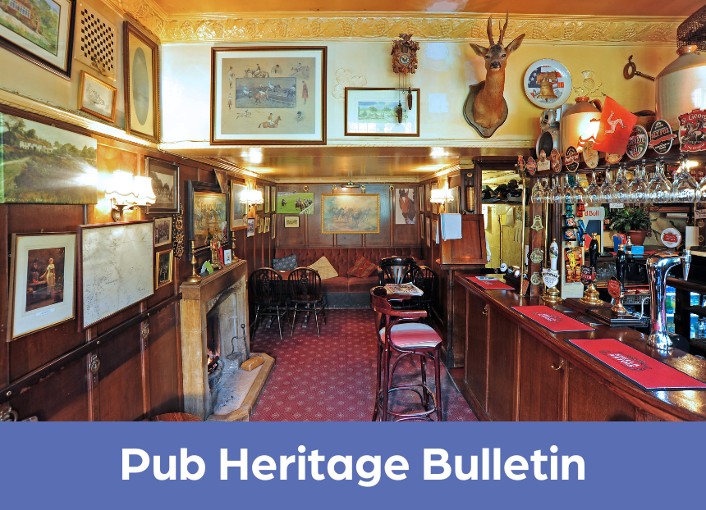

CAMRA’s Pub Heritage Group shares news and updates about pubs with historically significant interiors across the UK. For further news, see the Pub Heritage Group webpage here.   Three Star Heritage Pubs Bell, Walton-on-the-Hill, Surrey (above) The planning application for change of use to residential, which was covered in May, has been approved by Reigate and Banstead Borough Council. Approval was granted despite numerous passionate objections from the local community. This unique pub known locally at the Rat is included on the inventory for its intact two-room interior which dates to the rebuilding of the pub in around 1955. It is still currently operating but, barring a dramatic change of fortune, it seems inevitable that it will be lost.

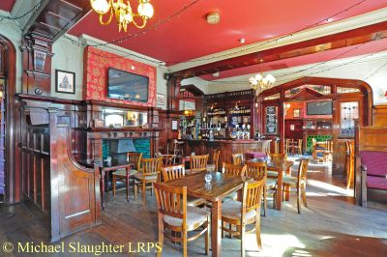

Forester, West Ealing, Greater London (above) The Forester was awarded the Community Local Award in CAMRA 's Pub Design Awards 2025. The Forester is a great example of a suburban Edwardian pub which retains a four-room layout and many features of the period. The award celebrates the sympathetic refurbishment undertaken by owner Fuller’s in early 2024.

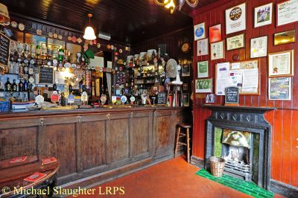

Blue Bell, York, North Yorkshire (above) The Blue Bell has been awarded Pub of the Year by CAMRA’s York branch. For anyone who hasn’t visited this national treasure, it’s a wonderfully atmospheric pub with an intact two-room interior from 1903 and is one of the few pubs graded at II\* primarily for its interior.

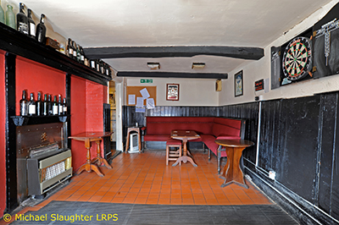

Red Lion, Rugeley, Staffordshire (above) The Pub Heritage Group reports that the Red Lion is closed with a sign displayed saying “asbestos works in progress”. The grade II-listed Red Lion occupies a circa 16th-century, timber-framed building and consists of three rooms which were last refitted in the 1930s.

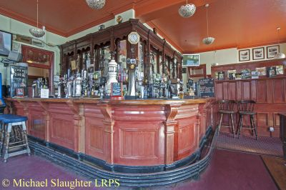

Anchor, Birmingham, West Midlands (above) The Anchor, a red brick and terracotta pub from 1902, is currently closed with the licensee blaming spiralling costs. It is anticipated by the Pub Heritage Group that the owner will be seeking new tenants soon.   Two Star Heritage Pubs

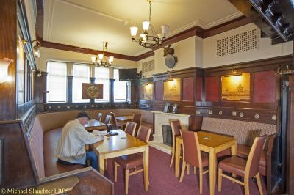

Ramsden Arms Hotel, Blackpool, Lancashire (above) This Brewers’ Tudor pub built in 1939 is closed, and there are concerns that it is earmarked for redevelopment as part of the wider regeneration of this area of the town. The pub is not listed, and it is owned by Heineken. Read more in the Blackpool Gazette here.   Other newsLocal Inventory ProjectThe Pub Heritage Group is encouraging the development of Local Inventories (LIs) of pub interiors that retain elements of historic interest but which do not possess sufficient original layout or historic features to qualify for the national listings.This initiative was introduced at the 2023 CAMRA Members’ Weekend in Dundee. Since then, several CAMRA branches have taken steps towards producing such listings (see link below). Local Inventories are driven and controlled by branches and the inclusion criteria is up to them. For example, a branch could include pubs:– which are already on the national listings– which were previously rated as pubs of “some regional interest” (SRI) but do not qualify as One Star pubs on the national listings– which have original features, but insufficient to qualify for the national listings– where the interior has no historic features, but the exterior is either of high quality or has specific features of interest.The group encourages all branches to create these lists and to publicise their work. More information and detailed resources are available on the Pub Heritage Group website here.Thanks to Dave Pickersgill for his work developing and promoting the Local Inventory Project.BEER Magazine The summer edition of CAMRA’s BEER Magazine is available here. (CAMRA membership login required). This edition includes an article on CAMRA's Heritage Award (see January bulletin) by Paul Ainsworth. If you have news on our heritage pubs send updates to: info@pubheritage.camra.org.uk Please feel free to forward this bulletin to your friends who are also interested in visiting pubs like these. If you wish to receive the bulletins directly, sign up by sending an email to bulletin@pubheritage.camra.org.uk with “subscribe” as the subject or “unsubscribe” if you wish to stop receiving bulletins.