Town’s first festival of pubs revealed

02/07/2025 by Timothy Hampson

Campaign

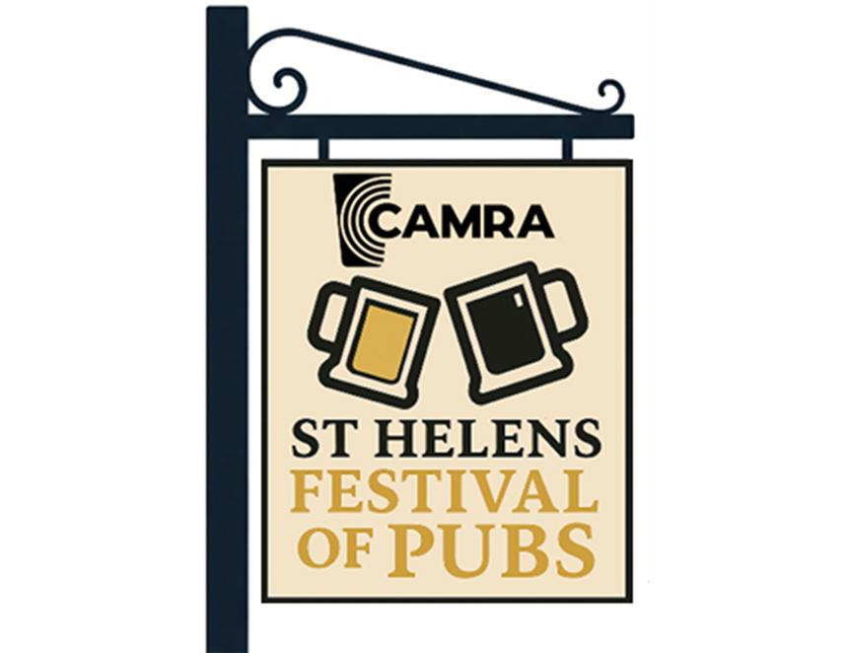

CAMRA St Helens & Districts branch has launched the inaugural St Helens Festival of Pubs, a town-wide celebration of cask beer, community, and locals which runs 20-25 August. The festival will stage more than 30 events spread across some of St Helens’ best-loved pubs, including live music, chess tournaments, CAMRA’s treasure hunt, meet the brewer sessions and quizzes. Participating pubs include the Cowley Vaults, Cricketers Arms, George, Glass House, Lamb, Little George Quarter, Royal Alfred, Sefton, Tipsy Tap and Turks Head. Festivalgoers will also have the chance to sample more than 50 cask beers from in excess of 25 breweries across the weekend. A highlight will be the fourth annual treasure hunt on the Sunday starting at the Turks Head at 12pm. St Helens and Districts pubs officer Ian Pye said: “The St Helens Festival of Pubs is a true celebration of our town’s thriving pub community. It isn’t just about great beer, it’s about bringing people together, supporting local pubs, and creating lasting memories. “We’re incredibly proud to partner with Willowbrook Hospice this year, and we’re grateful to our sponsors, SSO Logistics and PSD, for helping us bring the festival to life. “Whether you’re a seasoned ale enthusiast or simply curious to explore, this is your chance to raise a glass, support a worthy cause, and be part of something special.” For more information and live festival updates, visit: sthelens.camra.org.uk/