Members’ Weekend 2025 Round Up chief executive's speech

01/07/2025 by WB Reporter

Campaign

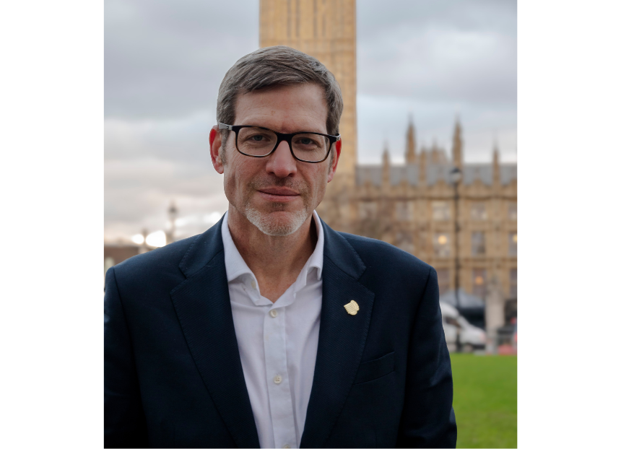

What’s Brewing is rounding up key moments from Members’ Weekend 2025 in Torquay with videos and transcripts. Watch the video below to see CAMRA chief executive Tom Stainer’s (pictured) speech. Tom Stainer: It’s a challenging time for CAMRA. Covid aside, it’s possibly the most challenging time that the organisation has faced. And certainly, it’s the most challenging time in the almost 20 years that I’ve worked for CAMRA. So yesterday you heard about financial challenges that we’re facing and almost everything we do costs more money, and we have fewer members than before and therefore we have lower income than we had before Covid. You and your fellow volunteers have done a remarkable job in relaunching our festivals both locally and nationally. And you’ve been working incredibly hard to sign up new members. We’ve heard about some of the things you’ve been doing this morning, but despite that hard work that you and your colleagues have put in, we’re still seeing fewer visitors to festivals, we’re seeing slower membership growth and we’re generating less income. And it’s clear the world has changed. Ian [Hill] made reference to this yesterday, but I’ll reinforce that. People are facing their own challenges out there; we’re facing those challenges. There are the financial strains and people are having to make choices about spending less on the nice to have things so they can afford the must have things. Before Covid, before the cost-of-living crisis, before the geopolitical turmoil that we’ve been seeing over the last five years, CAMRA’s organisation was pretty fortunate. We had the luxury to do the nice to do things. But now we’re going to have to make difficult decisions about how we generate income and what we spend that income on. We need to focus on the things that we must do to campaign effectively. And we need to focus on how we secure the future of this organisation. We know there’s loads of things that we would like to do, but the harsh reality is that if we do everything we like to do, we can do that for a few years, and then we’re not going to be doing anything at all. That is the harsh reality of this. It’s also a hugely challenging time for the pub club, beer and cider industries. They’re already struggling with the cost-of-business crisis, including business rates, taxation and energy prices. The new Government have added to these problems with further increase in staff costs, you heard about National Insurance yesterday, and also more regulation. We were already fighting battles against closures, against planning and those challenges do continue for us. And you also heard yesterday that a really important battle at the moment is the access to market for independent producers, and you heard a bit more about that this morning as well. And that’s become even more vital in these difficult and challenging times, not just for those breweries and producers that we support, but also for us as consumers because we want good consumer choice. It’s because of the challenges that they’re facing out there and the people that we support are facing that we’ve not withdrawn or stepped back from our campaigning, as you’ve heard from Nick this morning. It would have been easier, it would have been less risky for us as an organisation to cut our costs massively, to curtail all campaigning activity, to sit quietly, look after our funds and hope things improve in the future. But we’ve continued to invest in what we do. We’ve continued to invest in festivals, in branches and branch activities and in our campaigning. And I’ve continued to lead our staff team to deliver on the National Executive strategic steers and priorities. So, we’re looking to the future with positivity despite the challenges. We’ve invested in a new office for instance, you heard about that yesterday from Ian, to make sure that I and my staff can continue to serve the organisation in the way that we do. And despite the challenges you also heard yesterday, we’ve kept a tight control on those central accounts. So, before consolidation with the wider branch accounts, and Ian went in detail into this, we’ve been within budget and we’ve returned the surplus for the last seven of nine years. So the funds that we’re looking after, we’re keeping control of those for you. We’ve maintained a small staff team. Especially if you compare it to other comparable organisations, we have a very tight, very focused team. We don’t have a huge number of staff per number of members. Despite that relatively small size, we’re delivering a huge amount of work. In the last year we launched the brand-new CAMRA website, which you’ve heard a lot about already, we brought all our data together in one place and we’re seeing a huge increase in the traffic using that website. This will achieve our aims of driving membership, commercial activity and campaigning. The more people who use our website, the more they see what we do, the more chance there is they’re going to join or they’re going to do something that contributes to our finances. So, since launch, 2,000 trips have been planned on the new site with 3,200 pubs marked as “want to visit”. 10,000 venues have been favourited by users of our website and a massive 45,000 pub visits have been recorded so far in 2025. Over 30,000 members have logged in to the new site so far. That’s more members than logged in to the previous site in its whole lifetime. Beer scoring is up, and we’ve launched more brewery data displays on the site, and we’ve included the option for people to update brewery data for the first time ever, live on the site. Our teams rolled out FOCUS, the festival planning tool for volunteers. It makes it easier and more consistent to plan your festivals. It helped us reduce costs and increase income at festivals. We’ve now had 134 festival business plans created and the 62 of those have been approved through the system. Staff have developed and launched Paladin, our new e-lobby campaigning tool that allows you to email your MP in a very easy and accessible way. This replaced an expensive third-party service that we used to provide that to us previously. Now we’ve developed our system, we control it inhouse, we can adjust it and amend it in ways that we want. Really importantly, it gave us the ability to e-lobby politicians in Wales for the first time. No other system appears to be able to do that, but our inhouse development team actually found a way. You’ve heard about the fact we’re rolling out our Learn and Discover platform. It’s currently being tested, and I’d really urge you to give feedback on that. We’re getting some great feedback from Discourse, so please continue that. It’s a huge step in promoting Learn and Discover content. There’s great content that’s being put together by Alex and by the volunteers, and this is delivering it in a way that really pushes our campaigning objectives to promote and educate more people about beer, cider, perry, pubs and clubs, and gives us another channel to promote membership and generate income. Some of the things you’ve heard from Tim [Webb] today about educating more people about what we do can be delivered through that platform in a very effective way. You’ve also heard about that the staff have supported the launch of the new CAMRA brand that’s on a lot of shirts this weekend and it’s brilliant to see it on the beach as well in Torquay. Really good to see that the beach in Torquay stuck to the brand guidelines as well, so well done for the people in control of the rakes. So, the staff supported that launch of the new CAMRA brand. It’s been really important in repositioning us as a modern and inclusive organisation that more people will want to join. The staff also launched a new marketing campaign and materials for you to use in branches and at festivals. And we’ve launched the new CAMRA Raffle. There is no way to describe how complex and stress inducing launching a raffle is. Tony [Lewis] used to look young and vibrant and happy, and if he doesn’t anymore, it’s entirely down to the fact that he’s been trying to run this CAMRA Raffle. But he’s done it. Its live. Please support it. It’s just a way of getting extra CAMRA funds and possibly ending up with a little bit of the cash bonus yourself or some other prizes. There’s a pull up in the reception of the conference, so have a look at that and find out how you can get involved in the raffle please. We ran a hugely successful and important General Election campaign, which connected members with candidates for parliament and telling them how important beer and pubs are. It ensured our voices were heard with a really hefty new intake of MPs, and with the help of you and your members back in branches, we reached more than 90 per cent of candidates in the General Election and we made sure that they knew who CAMRA were, and we made sure they knew what the huge issues were facing the pub and the beer world. You’ve heard a lot about the Campaign and Communication Team organising a drop-in event ahead of the Autumn Budget, and we keep mentioning it because of how hugely successful that event was. We got 70 MPs there. That was massive, absolutely massive. We usually get a handful of MPs to drop-in events. They were queuing up out the door to talk to us and get photos with us with our pledge cards. It was a record number. We also make sure that we take part in the All-Party Parliamentary Group events and political conferences, which again make sure that our voice is heard by the people who have making the decisions about the industry that we’re supporting. Our staff take our message all over the UK. From campaigning activities in the Discovery Bar at the Belfast Beer Festival, which included a round table with members of the Northern Ireland Assembly, to events and work with members of the Welsh and Scottish Parliaments. We regularly take part in industry steering groups, we meet trade associations, we meet campaigning groups and people running beer, cider and hospitality businesses to understand the issues and join forces where our interests align. Just this week, the team have picked up Welsh government plans to further weaken planning protections for pubs, and they’re now working with our campaigning committees and with the Welsh Regional Director to agree a campaigning planning response. We also launched a new reporting tool for pub closures, which is giving us live and up-to-date figures to help our campaigning, and secure more media coverage for the Campaign. If we can point the media towards something which in a live basis tells us how many pubs are closed in our area, that’s really powerful. So being able to do that going forward is a really important tool for us. Your staff and I are going to be supporting the National Executive in tackling and solving our current challenges. We’ve got really robust and effective financial processes and a really, really strong financial team back in the office. They spotted that there might be trouble ahead for the Campaign, but they spotted it far enough in advance to actually do something about it. If we do nothing and we change nothing, then CAMRA will be in trouble. But we’re not intending to do that. The staff have already been working on measures over the last six months to maximise income and improve efficiency in the short and medium term. We’re now going to support the National Executive in setting a new and focused strategy to make sure we’re running an organisation which is suited to our current number of members, our level of income and delivers our key objectives. As I said, that new focus will mean we do fewer things. It means we’ll be doing the important stuff, not just the ‘nice to do’, and it will mean you and your fellow volunteers have to accept that we can’t do everything that we want, and we can’t do everything that you want, but we will do what we need to do to campaign for our members and the wider beer and cider drinking, pub and clubgoing public. We know the next few years are going to be challenging, but myself and my staff are more than ready for that challenge. We’re ready to support your elected leadership in taking that challenge on. Almost two decades of working for this organisation has taught me there is little that our motivated volunteer supported by our dedicated and skilled staff can’t overcome. Thank you, Conference.