Pub of the Year archives - 1989

30/06/2025 by George Robbins

Campaign

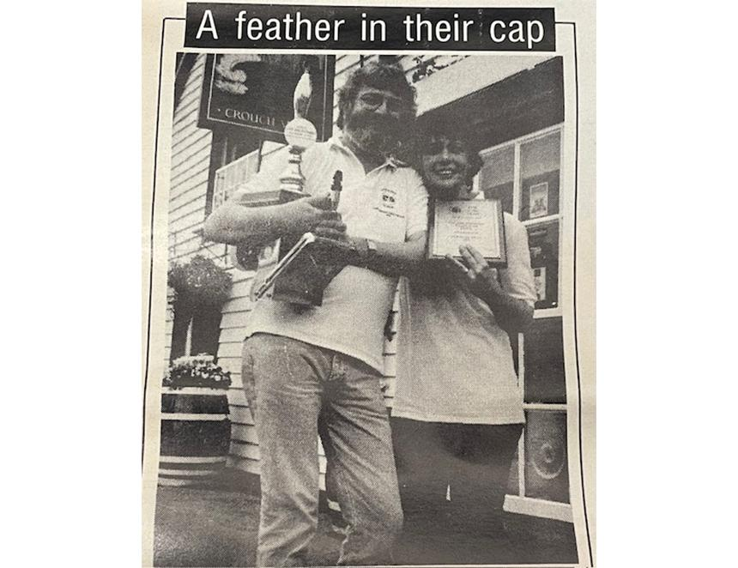

CAMRA’s Pub of the Year is the annual competition to find the very best in the UK. The award is the highest honour the organisation can give a pub, running since 1988, it showcases the top places to enjoy a great pint of cask beer with great atmosphere.  The Boars Head in Kinmuck was crowned the first winner of the prize in 1988 (see here) and continuing the journey into the Pub of the Year archives, the Cap and Feathers in Tillingham became the award’s second recipient in 1989.   Unlike the Boars Head, the Cap and Feathers is still very much a pub, and since winning the award has had a history of CAMRA recognition. Recently, the pub has gone on to win Maldon and Dengie CAMRA’s Most Improved Pub of the Year in 2023 and Rural Pub of the Year in 2024.  Originally managed by longstanding CAMRA member Ollie Graham and his wife Carol (pictured), Crouch Vale brewery acquired the pub in 1986, and the Cap and Feathers was its only tied house. Steve Cox (then CAMRA head of communications) handed Ollie and Carol their plaque and gold-plated beer engine.  The brewery offered Ollie and Carol the chance to run the pub, and they began transforming the venue. The day Crouch Vale took over “they threw out all of the keg beers” Ollie told our reporter Roger Protz at the time. “How many pubs are there in the country that don’t sell any keg bitter?”   Out too went the pool table and canned music. In came a billiards table and nights of live music to accompany the full range of Crouch Vale’s cask beers. The food was one of the pub’s major selling points, leading to its inclusion in the CAMRA Good Pub Food guide for 1989.   According to Ollie the pub was “chest high in rubbish and the ceiling had fallen in one of the rooms”. That room was revamped and they introduced a small garden at the rear to attract families. The transformation was a roaring success and didn’t go unnoticed with the awards panel, with the pub coming second in the inaugural 1988 Pub of the Year competition before its victory in 1989.  The runners-up in 1989 were the Double Locks in Exeter, Old Dungeon Ghyll in Cumbria and Brunswick Inn in Derby. Refreshingly all the winning pubs from 1989 are all still going strong, with the Cap and Feathers, Old Dungeon Ghyll and Brunswick Inn all featuring in CAMRA’s Good Beer Guide 2025.