Members’ Weekend 2025 Round Up SIBA presentation

30/06/2025 by WB Reporter

Campaign

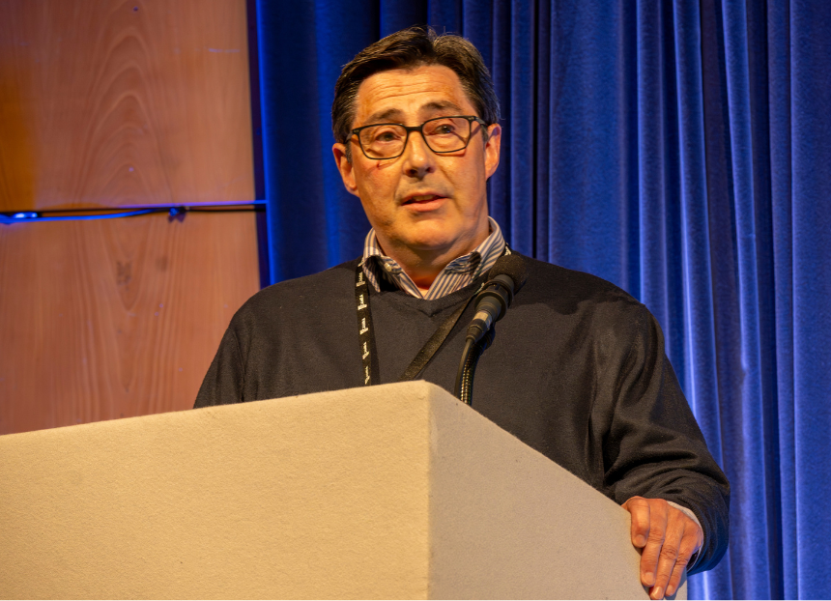

What’s Brewing is rounding up key parts from Members’ Weekend 2025 in Torquay with videos and transcripts. Watch the link below to see the Indie Beer presentation by Ian Ward (pictured) from the Society of Independent Brewers and Associates (SIBA) plus read his speech and CAMRA chairman Ash Corbett-Collins’ introduction. Ash Corbett-Collins: Our next speaker was a late, but very welcome, addition to our Conference agenda today.  Hopefully anyone who has been to the Members’ Bar has seen that we’re proudly supporting the Indie Beer campaign, run by the Society of Independent Brewers and Associates.  This week is also SIBA’s Indie Beer Week, and I spoke earlier about why this is the one of the strongest consumer-facing beer campaigns in years.    I’m really happy to say that Ian Ward is here to speak to us about the campaign today.  Ian has 40 years of brewing experience with Bass, Molson Coors and Marston’s, before becoming an independent commercial and marketing consultant in 2018.   It’s in that role that he now advises SIBA, including on Beerflex, other commercial activities and customer relations.  Please welcome, Ian Ward.  Ian Ward: Thank you, Ash. Thank you, Conference. Before I start, I’d like to associate myself with Ash’s address before lunch and the absolute importance at this point in time about the investigation into market access. It hasn’t happened for 40 years. We haven’t got the government’s attention in this area since 1989, and we’ve got to get it right. So we’ll all be working together to make sure that we do get this market access consultation working correctly and it’s got to work for everyone. It’s got to work for brewers, it’s got to work for pubs, and it’s most importantly got to work for drinkers. So that’s the stuff we’ve got to do over the next six to 12 months. The most important thing as far as SIBA is concerned is to play its part in what is independent beer, because that’s the really important thing. There’s an awful lot of brands or beers saying they’re independent, saying they’re craft beer, but what does it really mean? So these are the real issues. We did some research about 12 months ago before we started to look at this campaign. It wouldn’t come to any surprise to the people in this room, you are very educated drinkers, but the majority of people that go into pubs aren’t. They will clearly not understand that a brand that was being built by and being brewed by an independent business one week, suddenly becomes part of a multinational business, but they will take all of that kudos, that brand, and credentials that are being built up, and actually turn those into craft beer. So we need to move the conversation on. The important thing is we talk about [Beavertown] here and we know this brand because it’s in a lot of pubs now, and we know why. But there’s lots more brands out there that cross that borderline. So we need a point of reference where we can tell all of those drinkers that need to know what is independent today, that wasn’t yesterday. The importance of this campaign is to make sure that we really get behind the growth of the brewing sector. There are small areas that are growing. It’s not all gloom and doom. There are some areas that are doing really well, and we help consumers find where those beers are and tell them what they are, and Ash actually said before, “How do we actually inform the consumer?” We’ve really got to get down to that granular detail. So you’ll see the branding. It’s very early days; we’ve been going about four months now. But you’ll see the Indie Beer branding more and more. It’s designed to actually move across can, bottle, cask and keg. You’ll see the logos as and when you move around pubs. It’s been adopted by lots more brewers. We want it to be adopted by retailers as well, where independent beer is vital for their sort of sales mix, and we want consumers to adopt it as well. So we’re about galvanising the brewers behind this. We’ve got lots of our own members, but we’ve got other independent brewers that are not SIBA members behind this. We want to be supporting pubs and retailers where independent beer is vital. If I give you another little bit of research that we did, access to market for independent beers at the moment is about six per cent of the market. If we just took the handbrake off, that is effectively blocking elements of access at the moment, it’s natural position would be around 20 per cent. So we’ve really got to help those retailers to argue the point about ‘I really want independent beer on my bar’, whether they are part of a bigger pubco or whether they’re independent. So we need pubs to be able to support this as well and providing consumers with the awareness where they see this is genuine independent beer. Most importantly, it’s informing, so if you’re able to go onto the website and I’ll give you a QR code in a minute, you’ll be able to see exactly what each brewer is owned by, whether it’s independent today, whether it’s not tomorrow, but you’ll be able to track it. And we want to be able to sort of give that information over to the trade and to the consumer all the time. These are the sort of branding elements that you’re starting to see on the back of packaging. You’ll see it on around the bar on beer mats, on bar towels, and where it’s appropriate on pump clips and keg lenses, and you’ll see it in other areas as well. It’s only been four months and we’re really proud of how well the campaign has developed already. The first week it went live, there was a lot of broadsheets and consumer press that picked it up and it ran pretty well. And we’re really proud as to the sort of numbers we’re getting already. We’ve had 52,000 people checking searches. It’s being updated all the time. Clearly from the day we started, there was lots of brands and beers that we didn’t know about. They’re being checked and validated as we go forward. So every week, every day, it gets sharper and sharper. We’ve got sort of around about half a million bottle tops, so you’ll start to see them on packaging. We’ve got 520-plus breweries already enrolled and they’ll be more and more invited. You don’t have to be a SIBA brewer to be part of this. The important thing is that it’s got a young slant to the campaign, and this is all about the social media interaction that you’re starting to see the way in which it’s working on and the platforms it’s running on, but it’s informing that group. It can be a little bit keg focused at the moment because a lot of the sort of crossover from independent into global brand can be kegged to start with. So we have got a young following to it, which is great. We need to inform these guys, they’re young drinkers, they’re drinkers of the future. And we’ve got a great deal of value around the press coverage that we’ve got. So it’s early days. I’m hoping that you’ll get behind it as much as the executive committee have got behind this. It’s really important to brewers, and I think we’re all on the same hymn sheet here. More information about SIBA’s Indie Beer campaign and the brewery checker tool can be found here.