Beer truffle mac ’n’ cheese

29/06/2025 by Christian Gott

Uncategorised

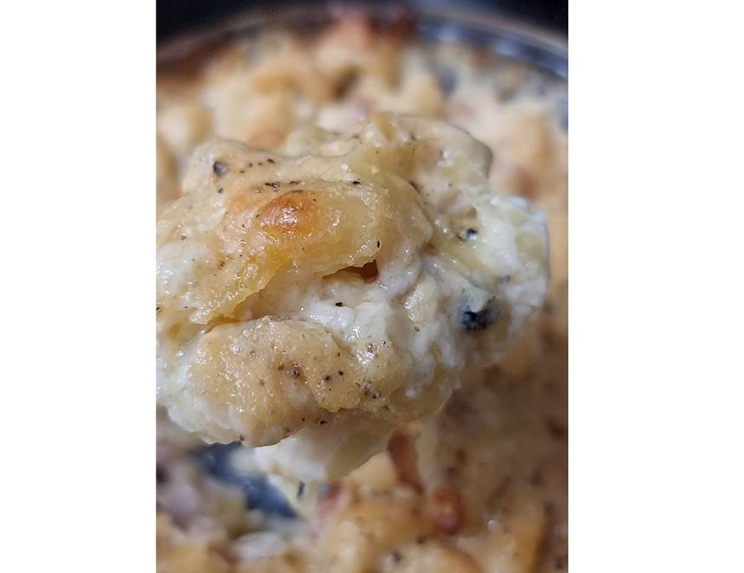

Today’s recipe is a little different as I’m going to recommend two beers. The first as an ingredient in the dish and the second to accompany it, as both bring something to the recipe. Truffle is a Marmite ingredient. You either love it or hate it and its pungent flavour is a challenge to pair any drink with. Perhaps the ultimate comfort food, macaroni cheese is now a staple dish worldwide. It is often glammed up with the addition of crab, lobster or truffle and this version is perfect for lunch, supper or as a side for my beer can chicken. The first beer is Theakston Old Peculier brewed in Masham, Yorkshire. Note the spelling of peculier which relates to a unique ecclesiastical court in the town. The brewery was bought back from the then Scottish & Newcastle by members of the founding family and continues to brew the distinctive, full-bodied, fruity, ruby red ale. It is great with a piece of cheese and delicious in this recipe. If you omit the leeks, it makes a great sauce for Welsh rarebit, a tasty snack called a savoury, traditionally served at the end of a meal to clean the palate. To accompany the truffle mac ’n’ cheese you need something to cut through the richness of the dish and not be overpowered by the earthy flavour of the truffle. The perfect choice is Saison Dupont a classic Belgian farmhouse ale brewed since 1844. Farmhouse ales were traditionally brewed by farmers during the winter and matured for several months in barrels before drinking. They are often bottle-conditioned and the resulting high level of carbonation is a great foil for the gooey cheesy sauce. Grapefruit and clove are big enough flavours to match the truffle, finishing with a pleasing bitterness. There are a lot of recipes for this mac ’n’ cheese that use truffle oil or powder; however, I don’t always like the artificial flavour of these products and prefer to use a good truffle cheese that contains pieces of it and is available in most supermarkets. If you are lucky enough to have a couple of whole truffles hanging around, then you can always use them. Beer truffle mac ’n’ cheese 250g macaroni 80g salted butter 1 leek, thoroughly cleaned, dried, and finely chopped 50g plain flour 300ml full fat milk 150ml single cream 150ml Theakston Old Peculier 250 gr truffle cheddar cheese 80 gr Parmesan cheese 40 gr panko breadcrumbs 1tsp Dijon mustard ½tsp fresh thyme Freshly ground nutmeg Sea salt and freshly ground black pepper Melt the butter in a medium-sized, heavy-bottomed saucepan. Add the leek and gently sauté without colouring until soft. In a second pan heat the milk and the cream until it is just about to boil and remove from the heat. Add the flour to the butter and leeks and cook for two minutes stirring continuously. The flour will take on a golden sandy texture. Add the mustard. Slowly pour in the heated cream and milk, whisking all the time, and bring to a gentle simmer. Stir regularly to prevent the mixture from sticking and burning. Add a generous grating of fresh nutmeg and pour in the beer. Preheat your oven to 350 F / 180 C / Gas mark 4 and boil a large pan of salted water. Cook the macaroni following the manufacturer's instructions, leaving plenty of bite as the pasta will continue to cook in the oven. Drain the pasta and set aside. Add the truffle cheddar and half of the Parmesan to the leek sauce and stir until the cheeses are melted. Remove from the heat. Add the thyme and check the seasoning. Mix the pasta and sauce and pour into an oven-proof baking dish. Sprinkle with the panko breadcrumbs and the remaining Parmesan and place into the oven. Bake for 30-35 minutes until brown and bubbling.