Members’ Weekend 2025 Round Up AGM and Finance

29/06/2025 by WB Reporter

Campaign

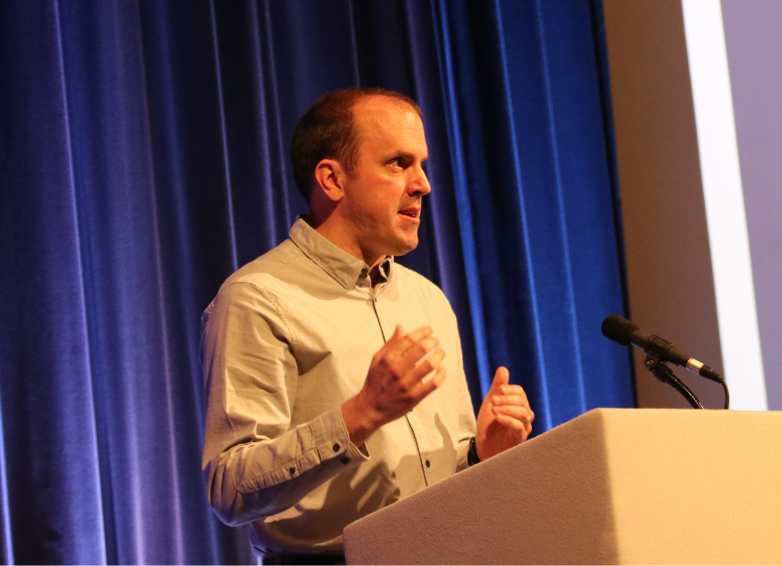

What’s Brewing is rounding up key moments from Members’ Weekend 2025 in Torquay, with videos of speeches, awards and debates at Conference. Watch finance director Ian Hill (pictured) present an overview of CAMRA's financial performance during 2024 below.