Members’ Weekend 2025 Round Up how the Motions fared

28/06/2025 by WB Reporter

Campaign

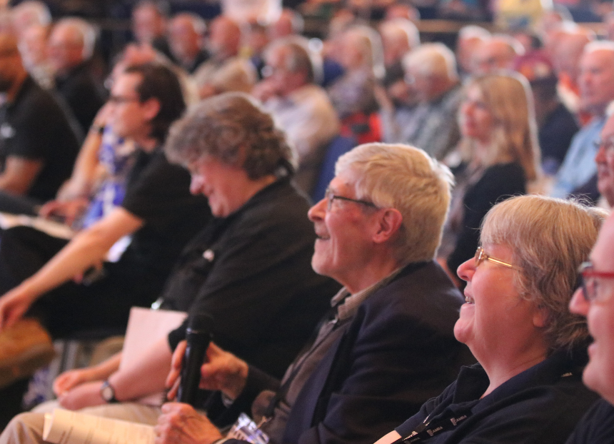

What’s Brewing is rounding up key moments from Members’ Weekend 2025 in Torquay.  Here you can see how the Motions fared, with a video for each one: Motion 1 – passed Proposed by: National Executive This Conference agrees to adopt the Policy Documents presented for adoption at Conference 2025, subject to any amendments to policy decided at this Conference. Motion 2 – passed Proposed by: National Executive This Conference agrees the Annual Membership Subscription rates will increase by £3.50 from 1 July 2025 to the following:  Single membership (British Isles and Overseas) Direct Debit £34 Non-Direct Debit £36 Single concessionary membership (British Isles) Direct Debit £25.50 Non-Direct Debit £27.50 Joint membership (British Isles and Overseas) Direct Debit £42 Non-Direct Debit £44 Joint concessionary membership (British Isles) Direct Debit £33.50 Non-Direct Debit £35.50.

Motion 3 – passed Proposed by: Real Ale, Cider and Perry Campaigns Committee This Conference agrees that UK beer lovers have been badly let down by the lack of leadership and imagination shown by the multinational brewers and large property firms that, between them, control the UK beer trade. Conference therefore instructs the National Executive to ensure that all relevant CAMRA publications and communications pledge preferential support to beer producers and suppliers that are independent of the influence of the multinational brewers, and to make the case persistently for this stance. Motion 4 – passed Proposed by: Real Ale, Cider and Perry Campaigns Committee This Conference instructs the National Executive to establish a self-funding opt-in Beer Group for members, to study and discuss all aspects of beer, viewed from the consumer perspective. The group should be of interest to consumers and the wider beer and pub trade. Motion 5 – passed Proposed by: Real Ale, Cider and Perry Campaigns Committee This Conference instructs the National Executive to investigate the logistics and funding of a specialist training course about the nature of beer in all its forms, the structure and ownership of the UK brewing industry and retail beer trade, the nature of real cider, and an introduction to the UK club trade, viewed from the consumer perspective. This should be self-funding and open to all. Motion 6 – passed Proposed by: Commercial Committee This Conference instructs branches to use the National Beer Scoring System as a significant factor when determining which pubs are considered for inclusion in the Good Beer Guide, from the 2027 edition onwards. Motion 7 – failed Proposed by: Commercial Committee Amendments to the Motion were accepted by the proposers, and it was debated and voted upon as: This Conference instructs the National Executive to reduce the number of pubs in the Good Beer Guide from the 2027 edition onwards.  The original motion wording was: This Conference instructs the National Executive to reduce the number of pubs in the Good Beer Guide from the 2027 edition onwards, to ensure only quality pubs are featured. Motion 8 – remitted Proposed by: Bradford Amendments to the Motion were accepted by the proposers, and it was debated and voted upon as: This Conference agrees the National Executive should take steps to ensure complaints and disciplinary processes and procedures, as well as the Code of Conduct, are clear and easily accessible to all members. The distinction between complaints and disciplinary matters must be clarified, particularly at what stage a complaint might become a disciplinary matter that needs escalating.   Wherever possible, and in line with the Disciplinary Policy, Branches and Regions should deal with issues locally in the first instance. Branches and Regions shall be empowered to impose commensurate penalties within relevant guidelines at local level. Proceedings shall be recorded appropriately and shall be monitored by the Regional Director.  The original Motion wording was: This Conference agrees the National Executive should take steps to ensure complaints and disciplinary processes and procedures, as well as the Code of Conduct, are clear and easily accessible to all members. The distinction between complaints and disciplinary matters must be clarified, particularly at what stage a complaint might become a disciplinary matter that needs escalating. At all times Branches and Regions to have autonomy, with Regional Director guidance, to deal with issues locally in the first instance and determine whether and when a complaint needs to be escalated. Branches and Regions to be empowered to impose commensurate penalties at a local level, but within the relevant guidelines, and as agreed with the Regional Director. Motion 9 – remitted Proposed by: Bradford Branch This Conference instructs the National Executive to publish the final submissions for all National, Regional and Branch festival business plans, with confirmation as to whether these were approved or rejected (with reasons provided where appropriate), on an appropriate part of the CAMRA website accessible to members.   Photo by Robert Hamnett-Day