Sort your summer festival fun

27/06/2025 by George Robbins

Campaign

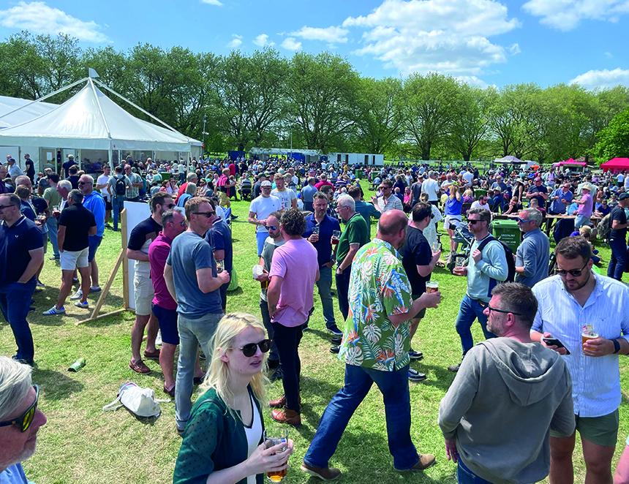

Make the most of summer with a festival or two. Just pick from the list below. To see all upcoming CAMRA events, visit the events webpage.    Totnes Beer and Cider Fest, 3-5 July   Totnes Civic Hall, High Street, Totnes, Devon, TQ9 5SF   southdevon.camra.org.uk/     Bromsgrove Beer and Cider Festival, 3-5 July    Bromsgrove Rugby Club, Finstall Road, Aston Fields, Bromsgrove, B60 3DH   bromsgrovebeerfestival.org.uk/     Chorlton Beer and Cider Festival, 3-5 July   Edge Lane, Chorlton, Manchester, M21 9AE   chorltonbeerfestival.org.uk/     Maidenhead Beer and Cider Festival, 4-5 July   Summerleaze Park, Off Summerleaze Road, Maidenhead, Berkshire, SL6 8SP   maidenheadbeerfest.camra.org.uk/     Devizes CAMRA 24th Beer and Cider Festival, 4-5 July   The Wharf, Devizes, Wiltshire, SN10 1EB   devizescamra.org.uk/    Ealing Beer Festival, 9-12 July  Walpole Park, Mattock Lane, London, W5 5EQ  ebf.camra.org.uk    Thanet Cider Festival, 12-13 July  Churchill Tavern, 19-21 Paragon, Ramsgate, Kent, CT11 9JX  thanet.camra.org.uk/viewnode.php?id=258978     Chelmsford and Mid-Essex Summer Beer and Cider Festival, 15-19 July   Admirals Park, Rainsford Road, Chelmsford, Essex, CM1 2PL   cbcf.camra.org.uk/    Hemel Old Town Beer Festival, 18-20 July St Mary's Church, High Street, Hemel Hempstead, Hertfordshire, HP1 3AE  hemeloldtownbeerfestival.co.uk/     47th Cotswold Beer Festival, 18-20 July   Postlip Tithe Barn, Postlip Hall, Winchcombe, Cheltenham, Gloucestershire, GL54 5AQ   postlip.camra.org.uk/    Wolverhampton Summer Festival of Beer and Cider, 24-26 July  Wolverhampton Arts Centre, Dunkley Street, Wolverhampton, WV1 4AN  facebook.com/events/1278590133432991    Market Bosworth Rail Ale Festival, 25-27 July  The Goods Shed, Station Road, Market Bosworth, Leicestershire, CV13 0PF  battlefieldline.co.uk/rails-ales    Epping Ongar Railway Beer Festival, 25-27 July  North Weald Station, North Weald, Epping, Essex, CM16 6BT  eorailway.co.uk/events/real-ale-and-cider-festival/    Solihull Beer and Cider Festival, 25-27 July  Oliver Bird Hall, Church Hill, Solihull, West Midlands, B91 3DH  solihull.camra.org.uk/viewnode.php?id=259635    Great British Beer Festival, 5-9 August  NEC Birmingham, Pendigo Way, Marston Green, Birmingham, West Midlands, B40 1NT  greatbritishbeerfestival.co.uk/    Peterborough CAMRA Beer Festival, 19-23 August  Embankment Road, Peterborough, Cambridgeshire, PE1 1EF  pborobeerfest.camra.org.uk    Clacton-on-Sea Real Ale and Cider Festival, 20-23 August  St James Hall, Tower Road, Clacton-on-Sea, CO15 1LE  tendringcamra.org.uk/clactonfest.html    33rd East Anglian Beer and Cider Festival, 20-25 August  St Edmundsbury Cathedral, Angel Hill, Bury St Edmunds, Suffolk, IP33 1LS  burystedmundsbeerfestival.com/    CAMRA Bar at Faversham Hop Festival, 30-31 August  East Street, Faversham, Kent, ME13 8AF  kent.camra.org.uk/    31st Tamworth Beer Festival, 4-6 September Assembly Rooms, Corporation Street, Tamworth, B79 7DN lst.camra.org.uk/beerfestival.htm   Basingstoke Beer Festival, 5-7 September Basingstoke Sports And Social Club, Fairfields Road, Basingstoke, RG21 3DR hantsnorth.camra.org.uk   Booze on the Ouse Beer and Cider Festival, 18-20 September Comrades Club, Godmanchester, 58 Cambridge Street, Godmanchester, PE29 2AY hunts.camra.org.uk/festival   St Albans Beer and Cider Festival, 24-27 September St Peter's Street, St Albans, AL1 3LD stalbansbf.org.uk