Members’ Weekend 2025 Round Up guest speaker Steve Darling MP

27/06/2025 by WB Reporter

Campaign

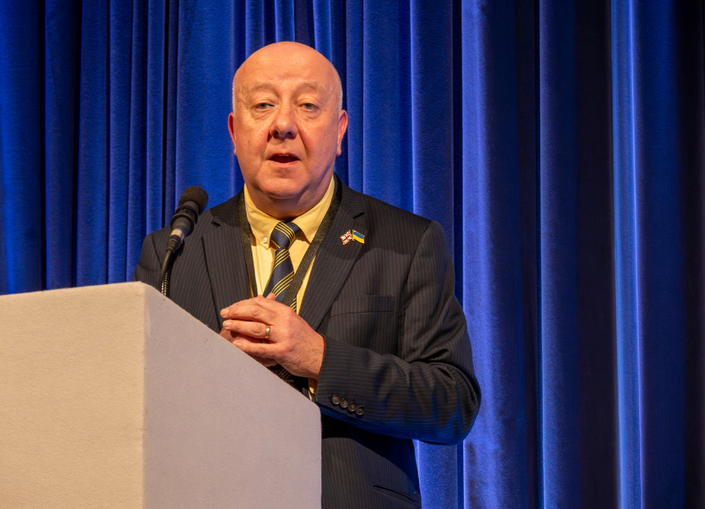

What’s Brewing is rounding up key moments from Members’ Weekend 2025 in Torquay, with video recordings and transcripts. Here we cover this year’s guest speaker Steve Darling MP (pictured). Watch the video of his speech and read the transcript plus an introduction from CAMRA chairman Ash Corbett-Collins. Ash Corbett-Collins: Now we will hear from our guest speaker, Steve Darling MP. There will be an opportunity for members in the hall, and those watching the livestream, to ask questions at the end.   Steve is the local MP for this area and was elected Liberal Democrat Member of Parliament for Torbay in July 2024.   He is the party’s spokesperson on Work and Pensions and serves on the House of Commons Work and Pensions Select Committee.   Steve has served for 30 years as a local councillor, including as leader of Torbay Council – who own this very building – from 2019 to 2023.   Locally, Steve has worked to support and promote Torquay, Paignton and the surrounding areas as a tourist destination in his efforts to make Torbay – the English Riviera – the UK’s premier tourist destination; and has raised concerns about plans to convert pubs like the Inn on the Green in Paignton.   His favourite pub is the Crown and Sceptre in St Marychurch, Torquay.  In parliament, Steve has spoken out about the impact of increases to Employers’ National Insurance Contributions, asking the government to think again and take action to alleviate the pressure on hospitality and tourism businesses like pubs.  Conference, please welcome Steve Darling MP. Steve Darling: Thank you, and it is a real pleasure to welcome CAMRA here for your Conference. Thank you for coming here. You clearly ordered the weather. You could have asked for it to be just a little bit warmer maybe, but the sun is shining on you. I’d really like to thank CAMRA for the work that you do in supporting our hubs of our communities, our pubs, because that is the place that you go and meet your friends, meet neighbours, and maybe sometimes try to avoid people. However, I must say Jenny, my guide dog, she loves going to pubs. She always thinks that she actually works the room better than a politician, actually engaging with people. And of course, dogs always are good bridges to have conversations with people. And so, welcome to the English Riviera. Welcome to the premier resort in the United Kingdom. It is my pleasure that since July, I’ve been the Member of Parliament for this area. I’m just wanting to unpack some of our characters, some of our pubs across Torbay, and then I’d also wanted to talk about some of the pressures and some of the more policy stuff at the end of my time with you. So, perhaps the Queen of crime is the person best known for us, Agatha Christie, and only this afternoon, about 4:30pm, we’re going to be having a statue unveiled at Torquay harbourside, which will double as a selfie spot for people later on today. I didn’t realise that she wrote her first book as a bet with her sister who said, “you could never do this”, and she did it and she went on to publish 130 books, which is an incredible legacy that she’s left here. Do think about coming and visiting us in September, when we have our Agatha Christie Festival, there’s lots of talks and really good focuses around that Queen of crime. And of course, she learned, disturbingly, her expertise around poisons when she was a nurse in the First World War here in Torquay and also working in the chemistry section of Torquay Hospital at the time. The other character that I always find that people know, whenever I jump into a taxi around the country and I say, “I’m from Torquay”, they’ll say, “Oh Basil Fawlty!” and that is both a pleasure, but for our hotel industry, is a bit of a curse as well. So I don’t know whether you have had any experiences of him, but of course it was based on a character, Donald Sinclair, who was a real-life person. Sadly, the hotel no longer exists, the Gleneagles Hotel, up at the Wellswood patch in Torquay. He was a retired naval officer who had a really bad attitude towards his guests. If you asked for when the next bus was going to be, it was more likely that he was going to throw the bus timetable at you than actually tell you the time. Eric Idle apparently had a suitcase that was ticking, and Donald Sinclair was afraid that it was a bomb, so he put it outside the other side of a wall. When Eric Idle couldn’t find his case, he explained it as such. However, I have a background of being brought up in a guest house. As an 18-month-old child, we moved down here from Birmingham and my favourite hobby when I was about four was to sit with the guests in the evening meal. My father thought this was a really bad idea. And so, one time when I was sitting with the guests, after they’ve assured them that it was fine and its fine if Steve’s with us, my father reached over, pulled me up and of course my sandal fell off into the bowl of soup and splattered everyone. My dad was actually a child trapped in a man’s body because he had a brilliant sense of humour. We had a telephone box just over the road and it’s still there now – my office is a stone’s throw away from there – where he would ring up and you would say, “excuse me, I’m from Candid Camera, (for the younger ones in the audience You’ve Been Framed), do you mind giving your girlfriend a piggyback up and down?” Or “could you do a handstand for us because there’s a camera in the back”, and people would perform, and Eric and his mates would have a good laugh at them. Another time, he pretended that he was from Paignton Zoo and there was a little woodland nearby, and he’d say “Oh, have you seen a little black monkey in the trees?” one time when he phoned the phone box, and this resulted in a crowd gathering and this was very funny for Eric and Penny, my mum, and their friends, until the police also turned up and started to mount a search in the woodland. So, I understand that they then just started crawling around on the floor in their house to avoid that anyone would see that they were actually in the house. Perhaps a character that you may not have heard of is Sir Richard Burton, not the actor but the explorer, and he helped find the source of the Nile. He’s also translated A Thousand and One Arabian Nights into English. Perhaps more interestingly for CAMRA members, he actually translated the Kama Sutra. The suggestion that our application would fall upon stony ground for selfie statues to go along with that translation is surely for the birds. Another character who Indiana Jones was actually modelled on is Sir Percy Fawcett, who comes from Torquay. He explored the Amazon repeatedly and was a photographer. But sadly, he and his son and his son’s best mate, who were both in their 20s, never came back from the Amazon, and I would just like to make it clear that any suggestions that it was because of the large bar tab that he left behind at the TQ Beerworks is a complete falsehood. I’d like to start talking about beer and pubs in Torbay because it is the heart of our communities, our pubs, and perhaps the first evidence of beer brewing in Torbay is only a stone’s throw away over at the Torre Abbey, that mediaeval abbey over there. At the 1700s we were only looking about five pubs in Torbay, but 200 years later we’ve had a 20-fold increase in the population and also a 20-fold increase in the number of pubs. I was surprised; I’d never heard of the Beer Act that came out in 1830 because beer is really healthy and good for you, well in those times clearly the water wasn’t the best for you and equally it was the time of gin. I’m sure many of us will recall the Hogarth cartoon of Gin Lane and Mother’s Ruin and Drunk for a Penny / Dead Drunk for two pence. So, I was really surprised the government about that time in 1830, were promoting the opening of beer houses as a healthy opportunity for our communities. The research I did in advance of today, it’s so sad and it’s something I know that’s really close to CAMRA’s world, is the slow decline of pubs across the United Kingdom. And I’d just like to focus on a few pubs, two of them are sadly no longer with us in Torquay. One of them is Coburg Arms, which used to be on Melville Street, and I didn’t realise that this was a stable in Victorian times and then in the afternoon they’d flip it over into a bar with frothing tankards all over the place ready for people there. That closed in 1971. Another one that’s well known, but sadly no longer with us in Torbay is the Post Horn and that’s a really good example of a pub that served postmen in Torquay town centre, very close to the main major post office there in Torquay. But again, closed in the 80s, and that was also part of an interesting thing that happened in the 80s where professional footballers really thought that they could bring their expertise into running a pub. And on 12 April 1969, which happens to be my birthday, there was a raid just up the road from here at the Rising Sun, now DT’s, and I was shocked to discover they had 70 members of the drug squad. I’m surprised they’ve got that many police officers in the whole of bloody Devon at the moment. This was Torquay’s attempt at catching up with the Swinging 60s because there were 17 hippies arrested for drug possession and one for obstructing the police as well. So that’s just a little bit of a reflection on those. Pubs tend to be at the heart of our communities, and I’d just like to thank you for all the work that you do to support them. But coming on to policy issues and whilst we’ve seen the growth of the supermarkets and their cheap alcohol that they have to sell, whether there should be standard unit prices to help out pubs is something that should be given serious consideration to. But the three areas I wanted to talk on was first of all business rates, because we’ve had a change in the way that the subsidy of business rates has sadly reduced, which means there’s higher business rates this year particularly and as Liberal Democrats, we feel that they should be actually completely scrapped and land value approach taken to this, so then it’s actually the profitability that’s being driven from those businesses that this plays out so that the out of town offers that you get, whether that’s a warehouse acting as a distribution centre is truly taken into account rather than the falsehood of the town centres because we have seen sadly again the slow decline of our town centres. So, reform around that world is really important to us. The other area where we want to see change, but sadly it is upon us, is the National Insurance hikes. I know in the West of England here it has been a cold hand gripping our heartbeat of our economy because it is very much the service sector, whether it’s Paignton Zoo, Splashdown, or hotels or pubs. They are all having to change the way they do things. Whether it’s service only by QR code and adding in automation there, but it’s effectively driving less and less staff by being really a jobs tax. We feel that should be scrapped and there should be more burden placed on online taxes and big banks where they’ve had cuts in their taxes and that National Insurance hikes have had a significant impact. Then the last area wanted to [talk about] is the joys of, I’m afraid I’m going to say don’t swear too much when I say, Donald Trump. But the tariffs are really scary, and we have launched last week in light of them a Buy British campaign, trying to say how can you be doing more local. Now clearly, we’re only catching up with CAMRA because in 2007 you launched your buy local ale campaign, LocAle campaign, where you’re championing the need for purchasing stuff no more than 20 or 30 miles away where the brewery is, and that is to be highly recommended. So, buying local, backing British is absolutely essential. And, of course, ironically enough, I was not sure whether I was going to be here this morning, because parliament has been recalled, but I know I’m left with the clear impression that the Treasury team that I’m a member of, were going to be backing the government about the steel works that is under discussion this afternoon. So we don’t need the numbers there, because we’re in hot support of what is going on up in there. So I was delighted I could keep my promise to be here today, but I just wanted to finish off by just making a couple of recommendations. Do have a little wonder up to St Marychurch to go and see the Crown and Sceptre or the Dolphin. There’s a couple of really good pubs up there as well. TQ Beerworks if you’re feeling less energetic, is only a few steps away from here and I’m sure some of you may have been over as I was last night to the beer festival over at Newton Abbot. They’ve got an outstanding tap house there right next door to it that is there throughout the year and have some really good quality beers on offer and well-kept all the time, which is what it should all be about. So, let us finish by raising a virtual glass to our pubs. Long may they pour, long may they prosper, and long may they be at the heart of our communities. Thank you.