Members’ Weekend 2025 Round Up Chairman’s Award

26/06/2025 by WB Reporter

Campaign

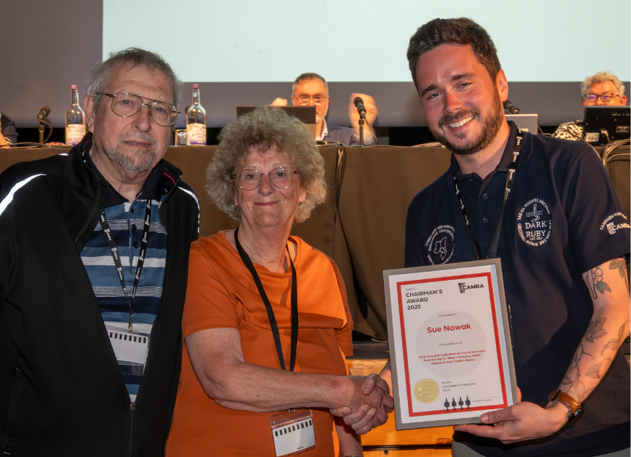

What’s Brewing is rounding up key moments from Members’ Weekend 2025 in Torquay, with videos of all the speeches, awards and debates. Watch the video below to see Sue and Fran Nowak accept their well-deserved Chairman’s Award and read CAMRA chairman Ash Corbett-Collins’ introduction. Ash Corbett-Collins: It’s with great pleasure that I make the Chairman’s Award this year to two members who, after decades of volunteering and work for the Campaign, have decided to retire from quite so much active involvement.  Both have been members for 40 years and have spent that time tirelessly campaigning to improve the quality and choice of food in the pubs we enjoy. You’ll soon guess who they are, so I’ll break the suspense by announcing that this year’s award goes to Sue and Fran Nowak.  Sue’s writing includes articles in What’s Brewing, BEER Magazine and editing six editions of the CAMRA Good Pub Food Guide, as well as writing for a range of national and local magazines and newspapers, getting the message out far and wide to promote pubs and pub grub.   Fran has been her partner in pub cuisine, accompanying her on an estimated 100,000 miles travelling the country seeking out the best food pubs, and providing photographs to go along with her copy.  Sue was the driving force behind the Good Pub Food Guide. Her and Fran weren’t looking for restaurant food in pubs, but wanted to celebrate good, traditional food made with local ingredients.  Initially a lone voice in the crusade for good pub food, Sue has been much mimicked since, but rarely bettered, according to BEER Magazine editor Tim Hampson.  In the forewords to early books, celebrity chefs Keith Floyd and Derek Cooper both said pub food had been awful until Sue and Fran came along to campaign to improve it through their work.  Sue’s writing and Fran’s photos made you want to visit the pubs they visited, without resorting to fancy prose or over-the-top descriptions.   And it was always worth a visit to one of their recommendations, with their guides to foodie pubs at each Members’ Weekend always eagerly awaited and followed by CAMRA members.  As Rob Walker, then CAMRA chairman said on the publication of the first Good Pub Food Guide: “Championing of good pub food was long overdue...we tended to overlook the fact that good beer, although vital, was not the only prerequisite of a good pub and Sue has helped to change that.” I’m sure Rob would have supported this award, and I’m delighted to invite Sue and Fran to join me to receive it in thanks for the contribution they have made.  Please welcome, Sue and Fran Nowak. Pictured: Sue (centre) and Fran (left) Nowak accept the Chairman’s Award from CAMRA chairman Ash Corbett-Collins’ (right)