Jennings back brewing

26/06/2025 by Len Wainwright

Industry

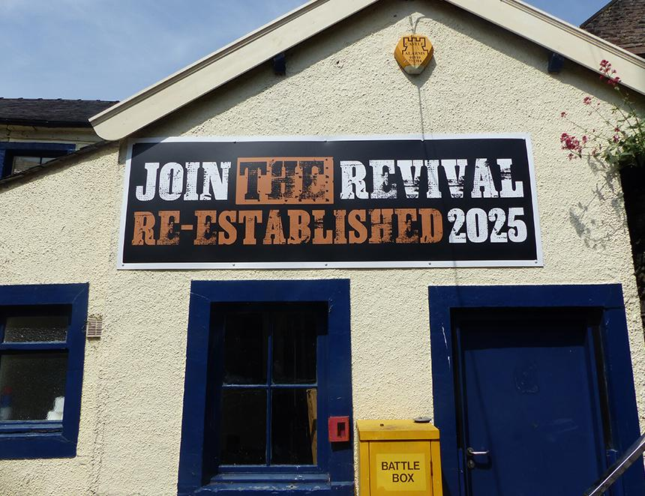

Rising phoenix-like from the ashes of Carlsberg Britvic ownership, from next month Jennings beer will once again be on sale. Initially it will be online and then, from 3 July, in the newly restored brewery taproom (pictured). Jennings was always much more than a brewery, it was integral to the soul of Cockermouth. When Carlsberg Britvic closed it in October 2022, it took away part of that soul. For more than two years the buildings lay empty, then earlier this year a local businessman bought the brewery, recipes and the intellectual property of Jennings. He went on to employ Chris France as MD and Buster Grant as head brewer, both with many years experience in the brewing trade. On the brewing side, having acquired a 10-barrel kit, they will initially brew four regular cask beers: Cocker Hoop a golden pale ale (4.6 per cent ABV), Sneck Lifter a strong dark ale (5.1 cent), Cumberland Ale (4.2 per cent) and Castle Bitter (3.4 per cent). There will also be two special beers Back Yam (4.1 per cent) and Derwent Mild (3.4 per cent). It is hoped Derwent Mild will become a regular brew. Back Yam is the first of a series of historic beers created separate to the main Jennings range and sold primarily in bottles under the Lorton Ales brand. Jennings started in the 19th century in the village of Lorton outside Cockermouth. Beside brewing beer, France and Grant are keen to develop the site as a community resource with brewery tours. The site includes the Grade II listed maltings dating from the 19th century which could be used for events, plus the taproom has a scenic riverside deck and there are plans for food vans at weekends.