Members’ Weekend 2025 Round Up Branch Website of the Year
25/06/2025 by WB Reporter
Campaign

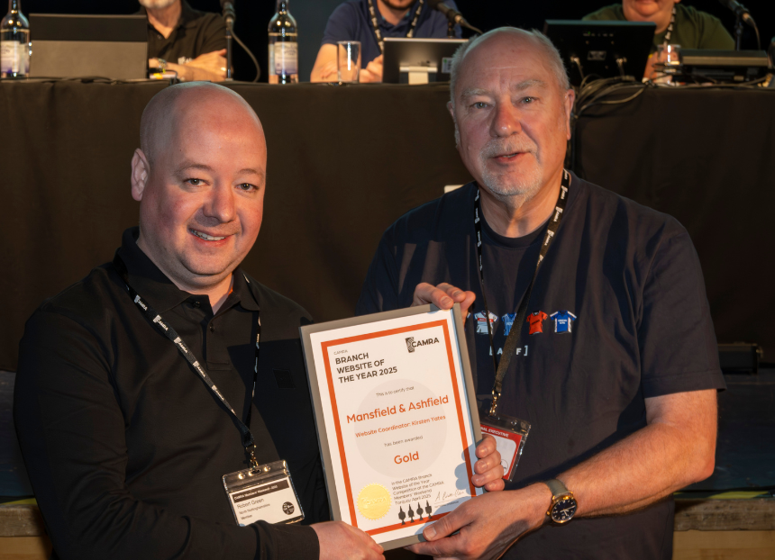

What’s Brewing is rounding up key moments from Members’ Weekend 2025 in Torquay, with videos of speeches, awards and debates at Conference. Watch the video below to see the Branch Website of the Year award ceremony and read CAMRA Campaigns and Communications director Nick Boley’s speech. View the PowerPoint presentation here. Nick Boley: It’s my pleasure to announce the results of our Branch Website of the Year competition. Branch websites are a staple part of your local communication tools. They are a shop window into your local volunteers, events and campaigning. A great branch website can bring in new members, activate volunteers and educate people on your local pubs, brewers and campaigning. It’s only right that we celebrate best practice, which is why it’s once again an honour to be revealing the winners to you from the Conference stage. Before we move on to the winners this year, I want to mention the dedicated team of judges that give up a considerable amount of their time each year to make this award happen. It’s a significant time commitment and doesn’t bring the benefits of judging other awards – which at least usually takes you out to local pubs and clubs or gives you a chance to taste beers. So, before I move on to the winners, please can we have a round of applause for the judging team, ably led by Andy Shaw: Mark Bates, Dudley Pritchard, Chris Hall, Mary Galliers, Bridget Edwards, Phil Bell, Stuart Leavitt, Huw John, Stephen Hawkins, Alan Cooke, Sue Burgess, Darren May, Steve Thompson, Seimon Williams, James Bennett, Matt Barker. Thanks to all of them, and to the team of volunteers that provide advice and support to branches on their websites all year round, including Bert Kenward for his ongoing work on BeerEngine. Now onto the winners. As always, could either the website coordinator or a branch or regional representative make their way up here to collect the award after each announcement. Runner Up
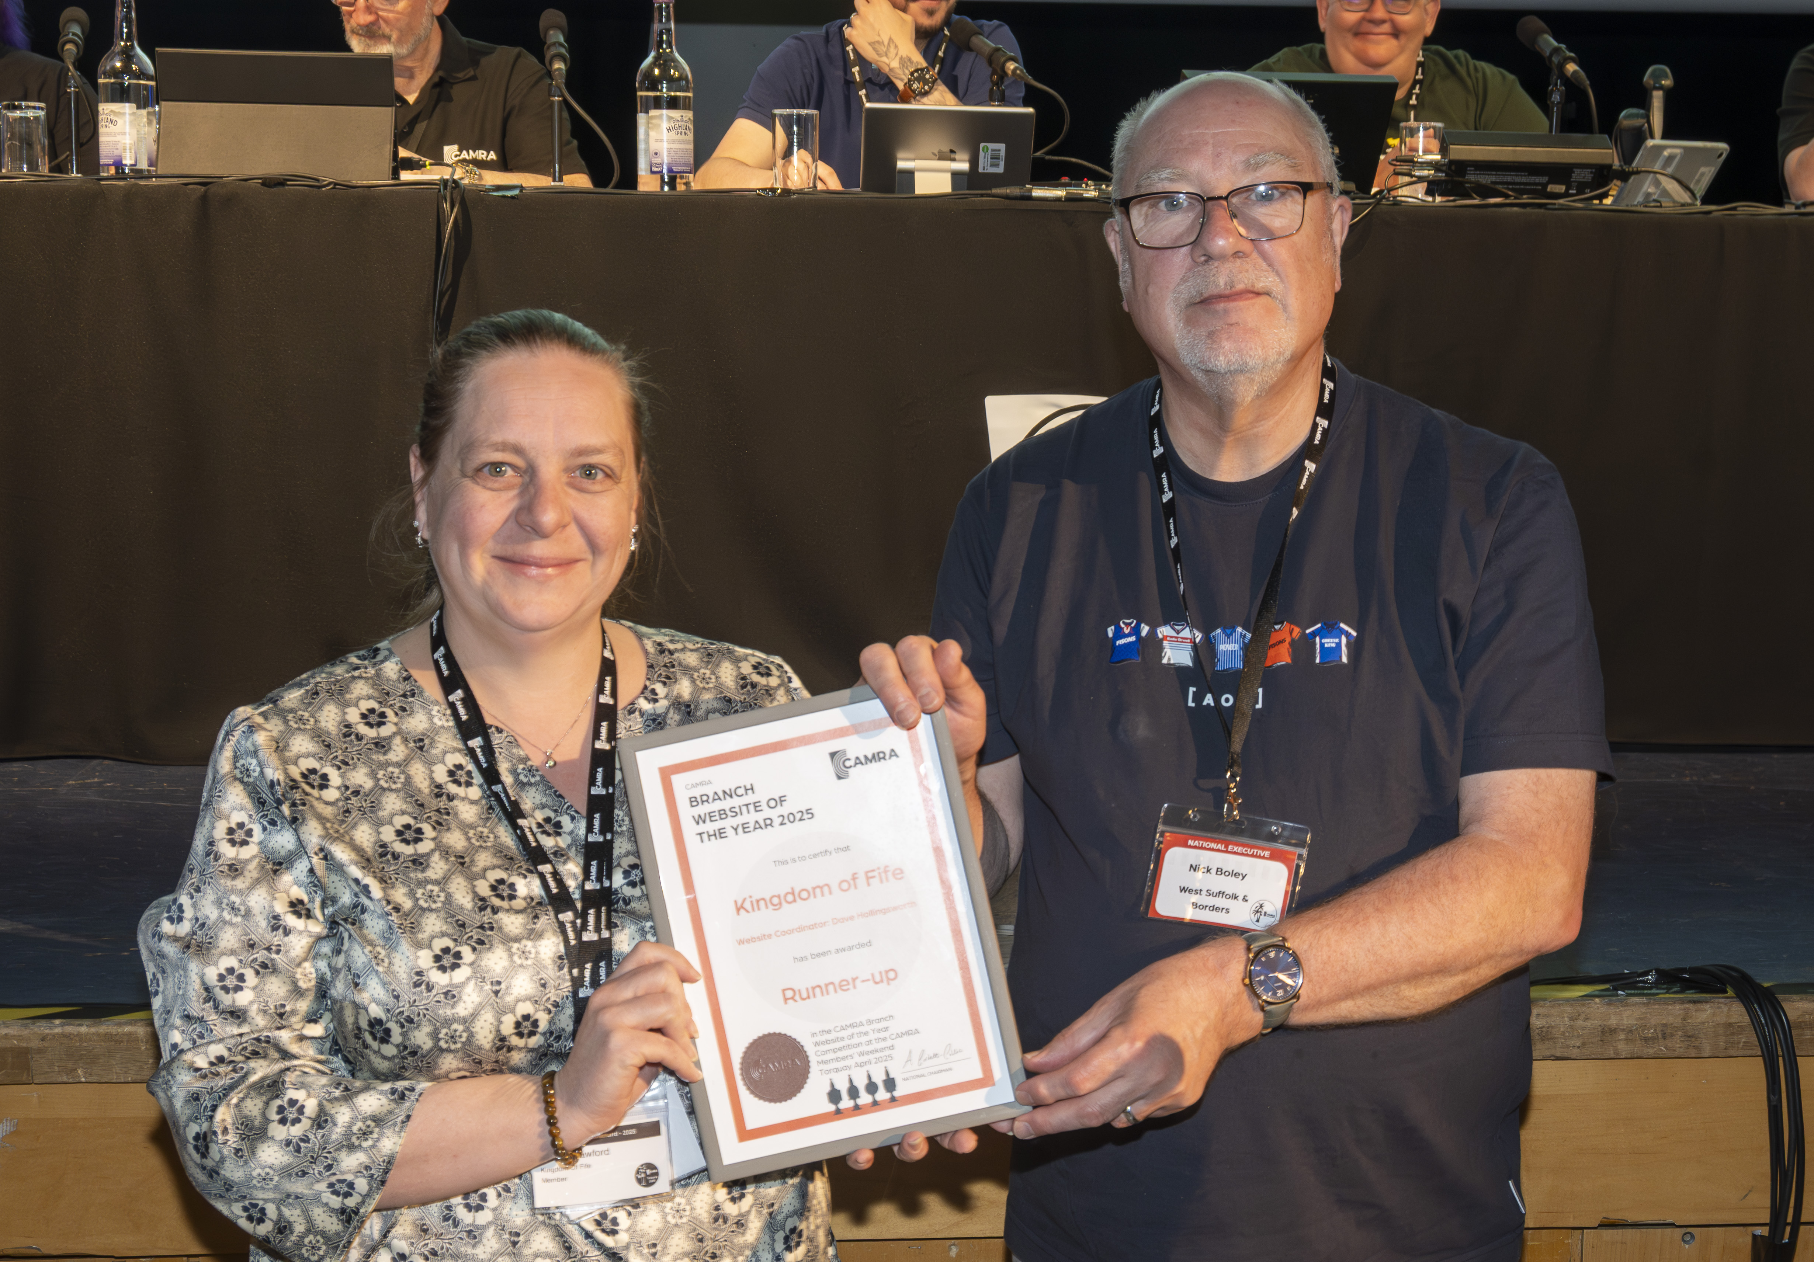
Pictured above: Sarah Crawford and Nick Boley First, our Runner Up. A close contender for the Bronze award which I will announce afterwards. Judges were impressed by the attractive design, use of photos and clear layout, with a particularly welcome balance of text, links and images, including a photo of a friendly group of members clearly having a great time in the pub – exactly what all branch socials should look like. It was highlighted as a great example of how to use the BeerEngine template, with lots of useful content for both members and visitors to the area. The clear branch map on the homepage was noted as being especially helpful. The Runner Up in the Branch Website of the Year is the Kingdom of Fife branch, with the website coordinated by Dave Hollingsworth. Bronze
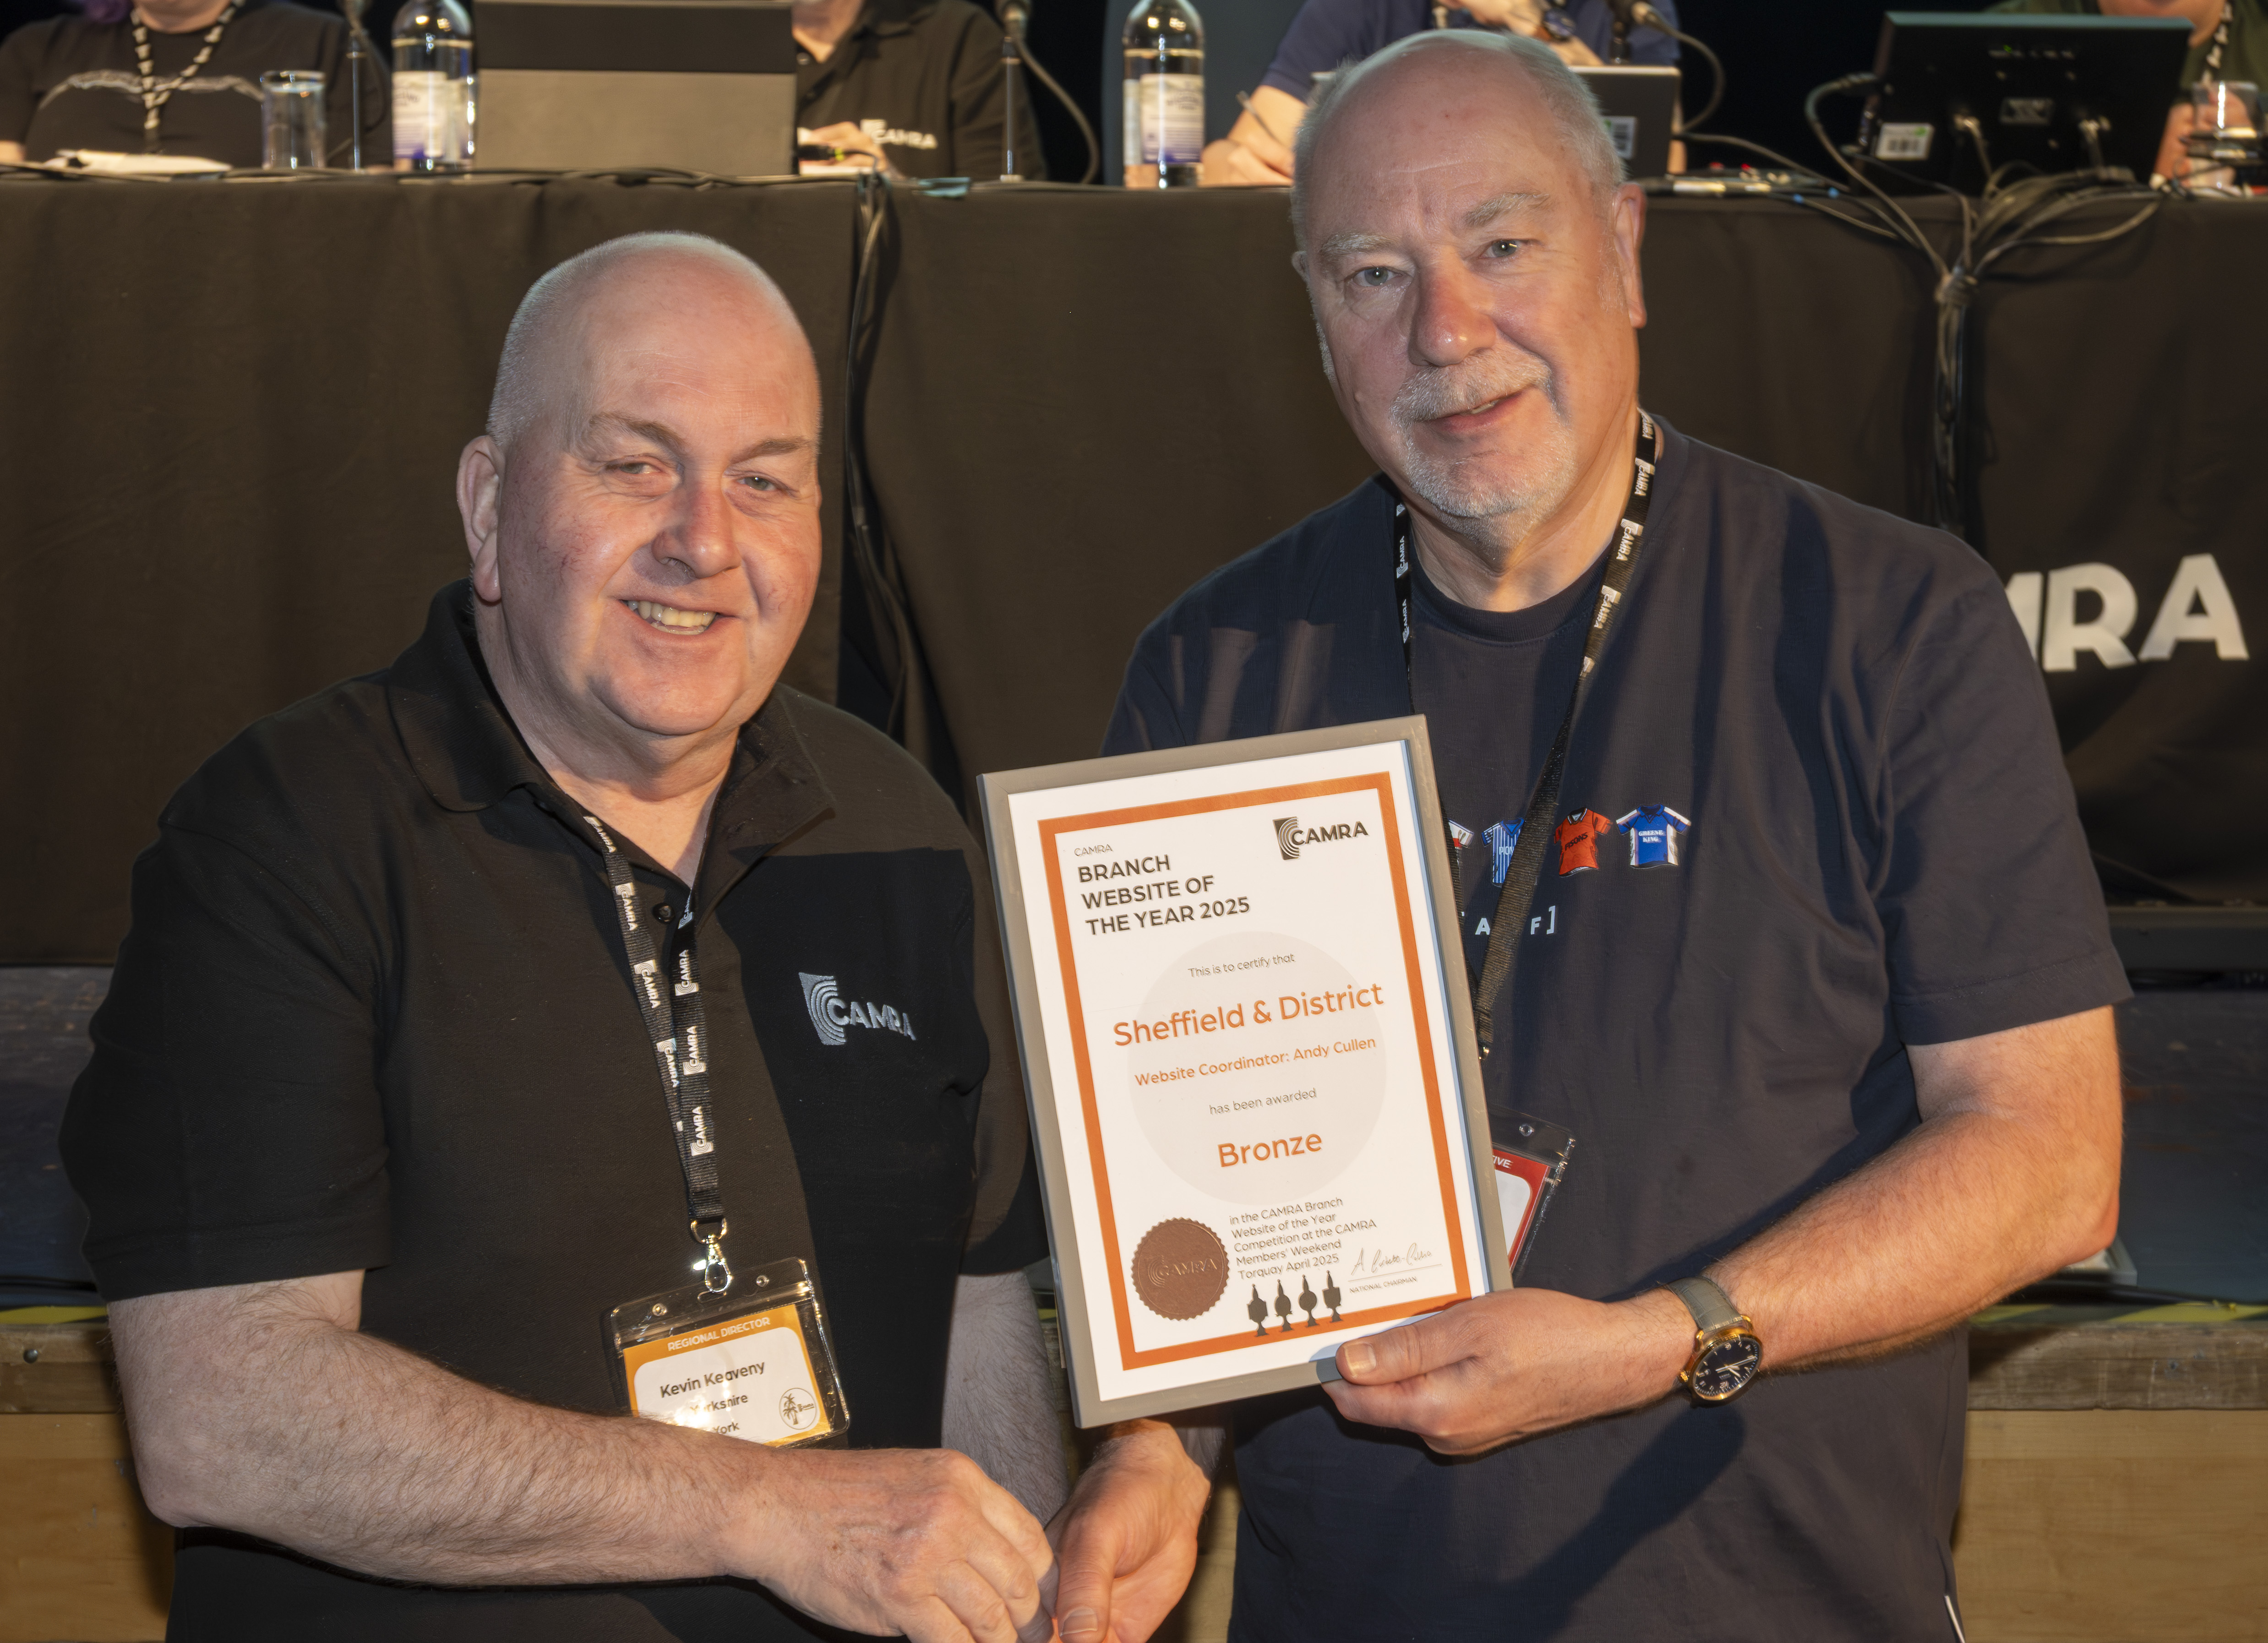
Pictured above: Kevin Keavney and Nick Boley Now our Bronze award winner. This website received high praise for its original design, and judges called it “an example for other branches to take note of”. The site is full of information with great use of images, and the pub guide and pub heritage sections were noted for being particularly comprehensive. It was clear that a lot of effort had been put into promoting festivals and events from other local branches. Our Bronze award winner is Sheffield and District branch, with the website coordinated by Andrew Cullen. Silver
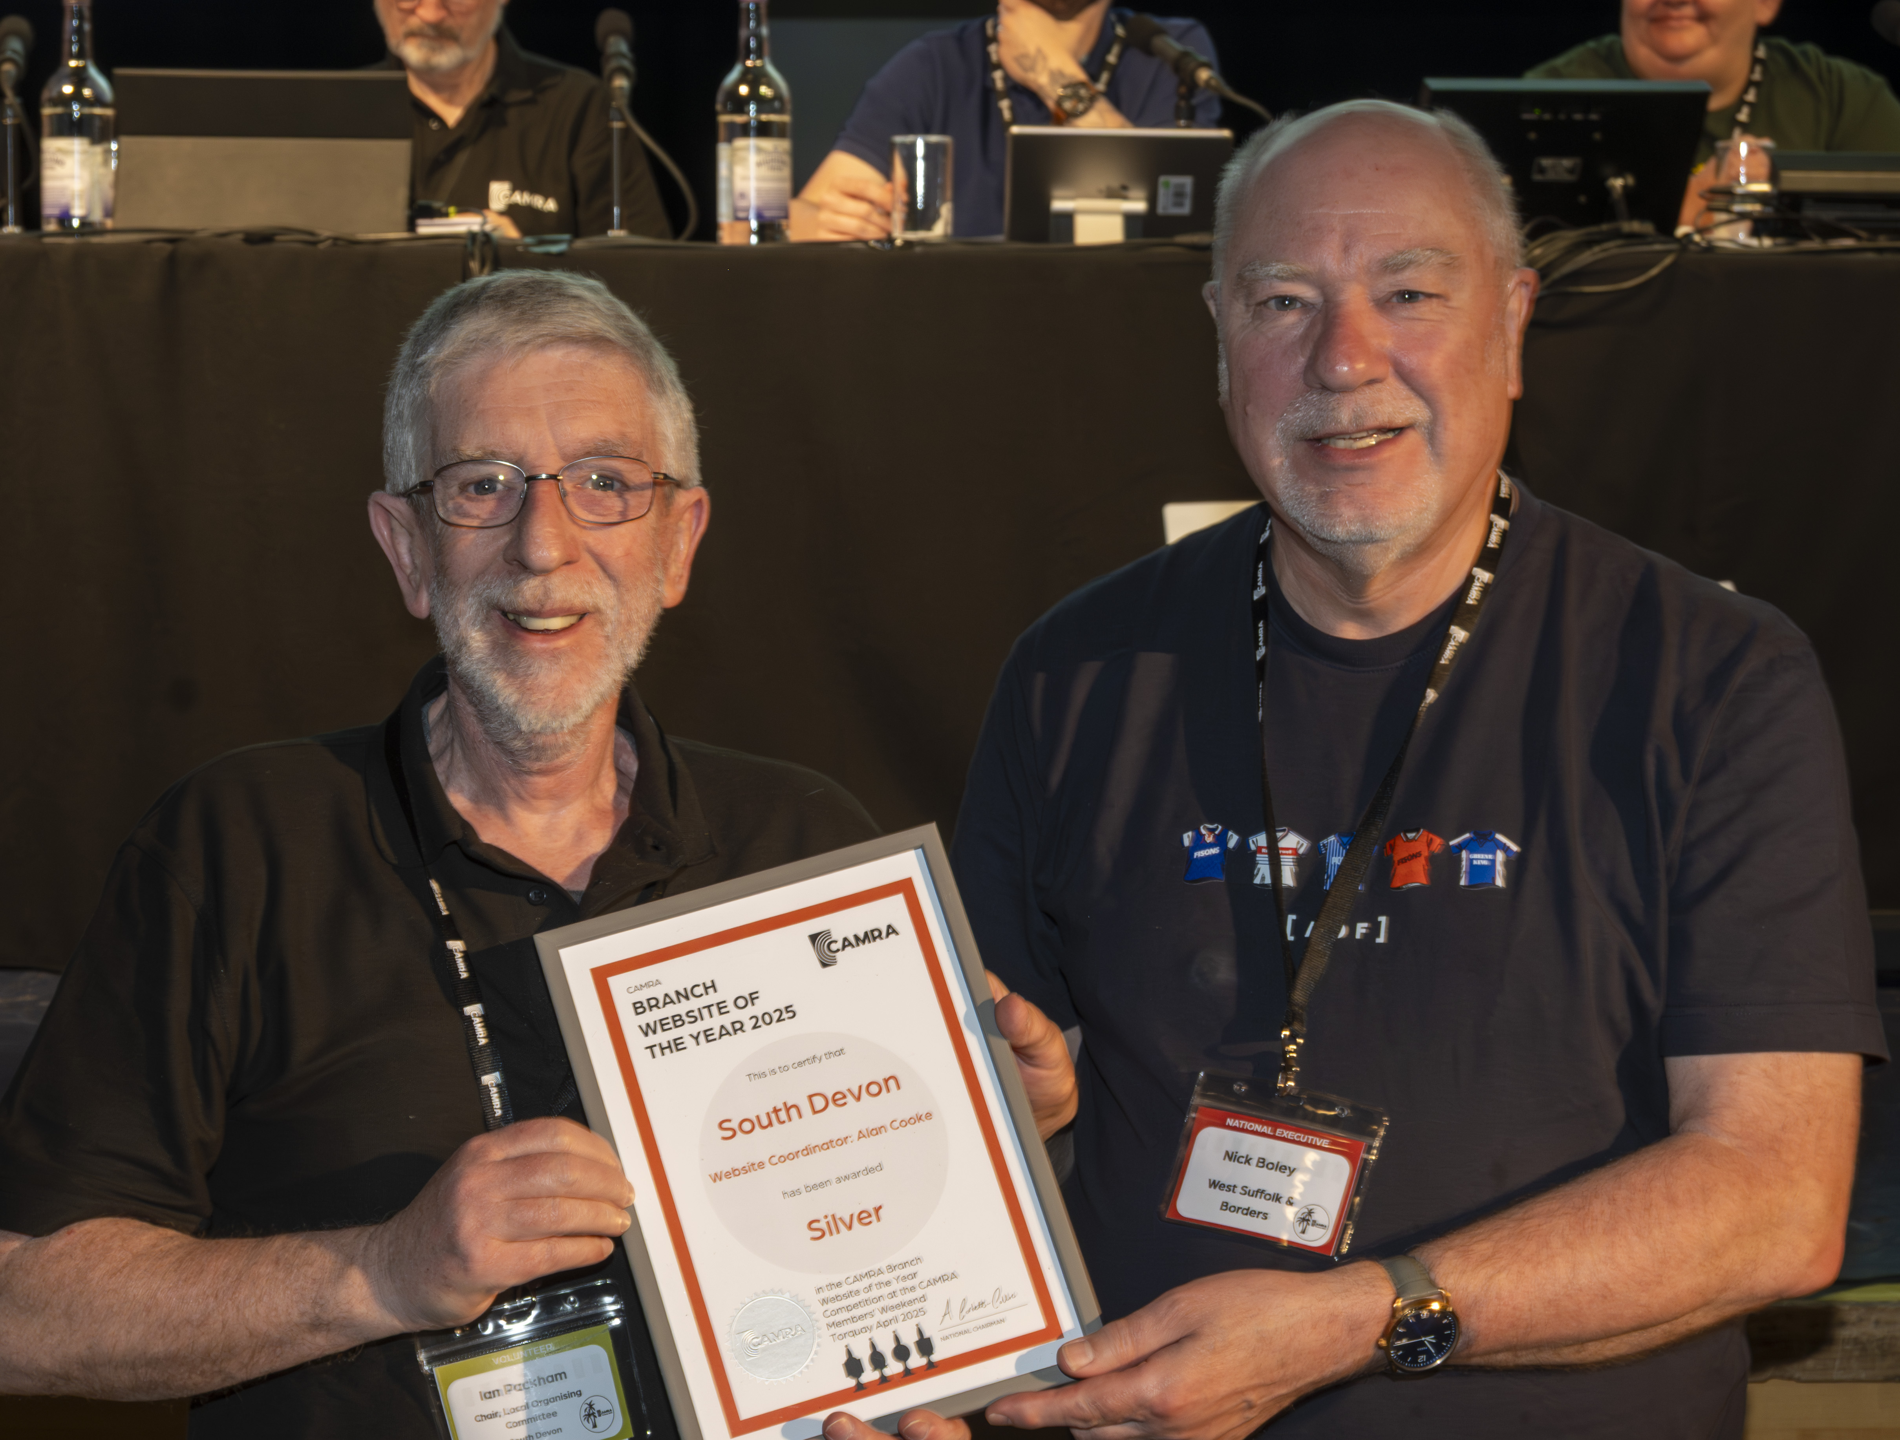
Pictured above: Ian Packham and Nick Boley Moving on to our Silver award. Judges were impressed with the variety of information provided, noting the Good Beer Guide selection information, National Beer Scoring Section and public transport information. The friendly welcome message from the branch chair was highlighted as a nice touch. The branch logo was also given an example of a great incorporation of the new CAMRA branding, and use of images in general was felt to be particularly strong. I’m very happy to announce that our Silver award goes to our local branch for this weekend, the South Devon branch, and their website coordinator Alan Cooke. Gold
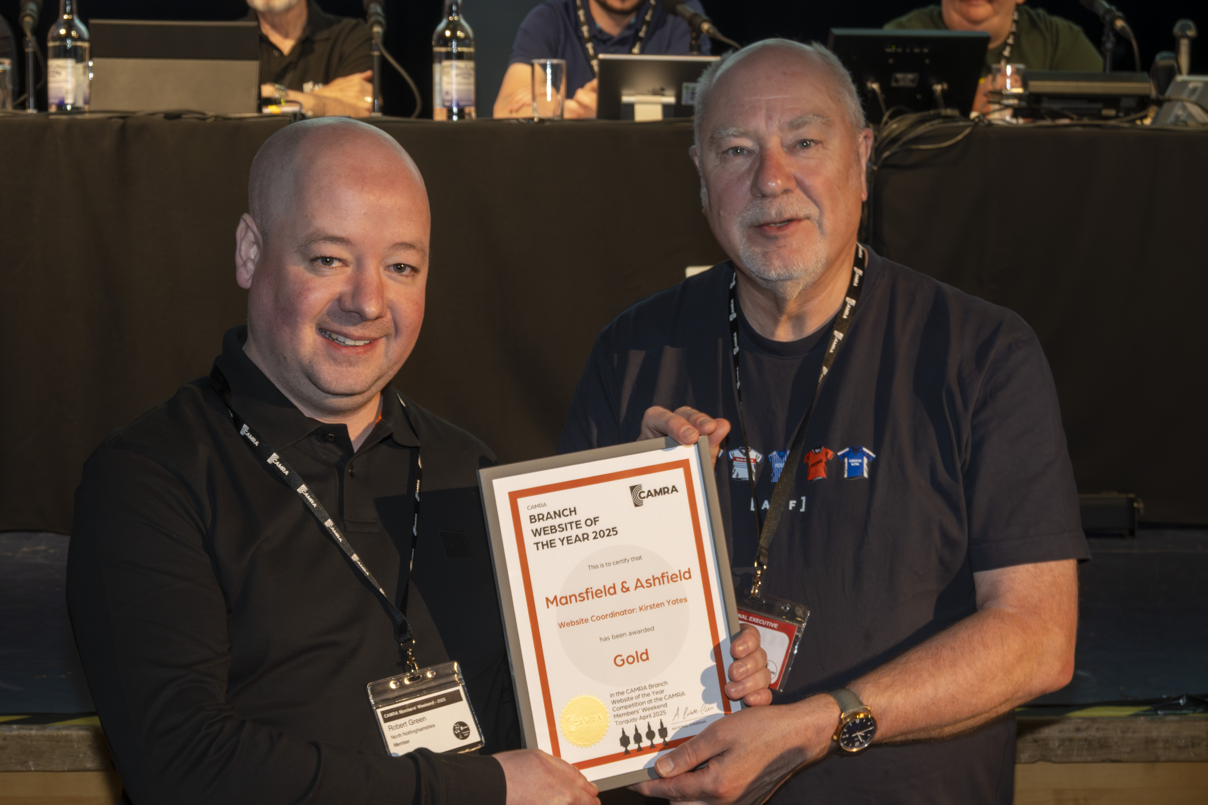
Pictured above: Robert Green and Nick Boley Now, our overall winner, the Gold award. Judges remarked that the site was very well populated, with incredibly professional looking promotion of beer festivals and a strong use of imagery across it. The site has thoughtful links to magazines produced by other local branches, and judges highlighted the local transport map as one of the most detailed and useful they had seen. Overall, the quality and quantity of information was very highly rated, with useful content including a jam-packed festivals page, local breweries, public transport, a volunteering page with simple ways to support the branch, and a campaigns page featuring Handpump Hijack. Our Gold award in the 2025 Branch Website of the Year competition goes to Mansfield and Ashfield branch, and their website coordinator Kirsten Yates.

