Chill out with cool seasonal brew

25/06/2025 by Timothy Hampson

Industry

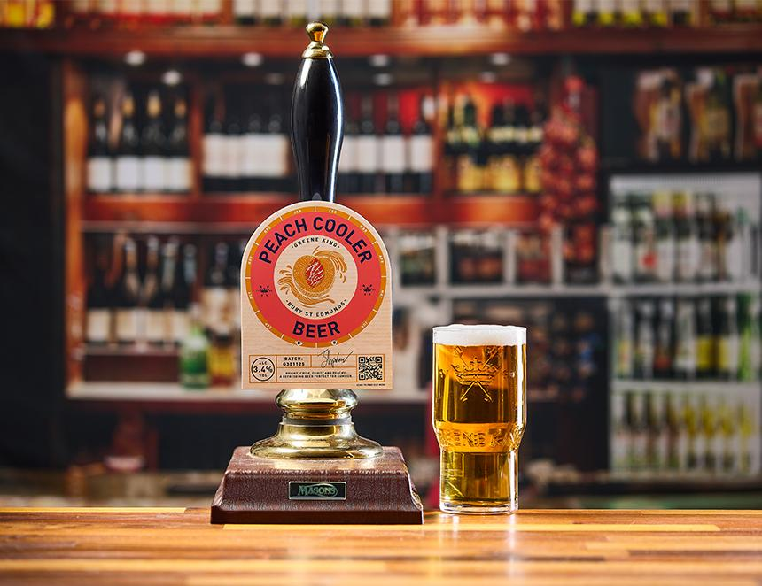

Greene King is playing it cool with its next seasonal brew – Peach Cooler, a 3.4 per cent ABV session ale with hints of honey, combined with stone fruit and peach characters. The fruity ale will be available to order across all outlets in July and August in both firkin and pin formats. Peach Cooler was created with the hottest season in mind, with the brewer’s brief being to create a flavour of summer in a cask. The brief was assigned to recently qualified brewer Simon Proctor, as part of his new product development in his apprenticeship. Proctor used pale, amber and light Munich malt to create a clean, crisp base. Alora hops deliver the dominant peach flavour and aroma in the fruity ale plus the recipe includes hints of melon and apricot. Proctor said: “I was thrilled to take on the brief for Peach Cooler and my first step was looking at several malt teas, a smaller and simplified version of the mashing process, to create the perfect base for the ale. “Once I was happy with the base, I then started exploring hop profiles and sampling various types of hops and how they worked together. “I used a small amount of First Gold for the bittering hops, followed by the late whirlpool addition of Alora hops. Alora hops are a relatively new, aroma-focused variety with amazing peach and apricot notes, which were ideal for the creation of this summer ale.”