Sheps likes to be beside the Creekside

25/06/2025 by Timothy Hampson

Industry

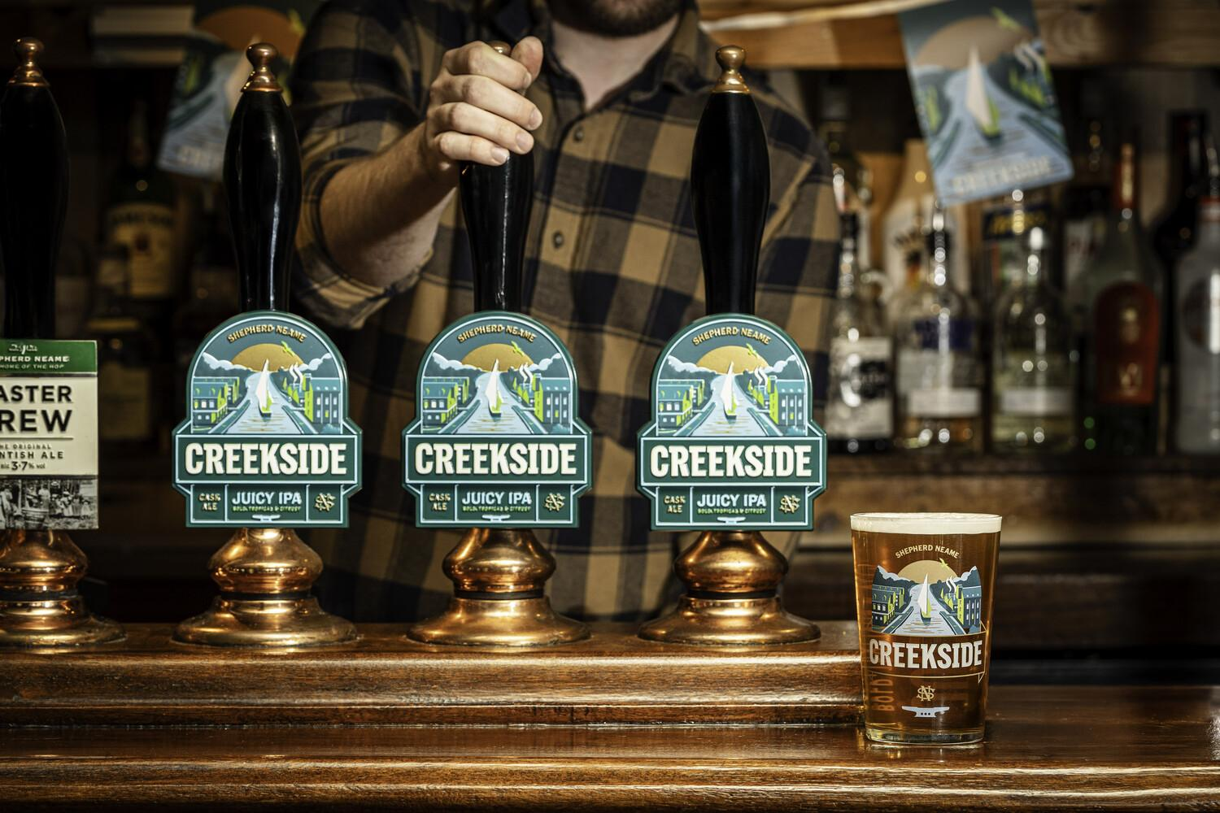

Shepherd Neame has introduced a new cask ale to its permanent range: Creekside Juicy IPA. The 4 per cent ABV beer takes its name from Faversham Creek which runs through the heart of the medieval market town which has been home to Shepherd Neame for more than 300 years. A pale, golden IPA, Creekside offers bursts of tropical fruits courtesy of a combination of four hops: Challenger, Mosaic, Jester and Amarillo. With hints of orange and peach, it has a light, refreshing finish. The pump clip design features a hand-drawn illustration depicting a boat sailing down Faversham Creek, surrounded by the town’s distinct blend of industrial surroundings and natural landscape. Shepherd Neame chief executive Jonathan Neame said: “Creekside is a fantastic new addition to our portfolio, and I am particularly delighted to honour the heritage of our hometown with its name and design. “Our brewing team has used its wealth of expertise to craft a refreshing beer which incorporates a collection of powerful hops while ensuring a well-balanced flavour and aroma. “This is an exciting time for Shepherd Neame, as we continue to invest in expanding our award-winning collection of beers, and we are confident that Creekside will prove popular with drinkers across our estate.”